###### A PROJECT REPORT ON

**LIVER DISEASE PREDICTION USING MACHINE LEARNING**

**Submitted to Osmania University**

**in partial fulfillment of the requirements for the award of**

###### MASTER OF SCIENCE IN

**STATISTICS**



**DEPARTMENT OF STATISTICS UNIVERSITY COLLEGE OF SCIENCE OSMANIA UNIVERSITY HYDERABAD – INDIA**

|  |  |  |
| --- | --- | --- |
|  | **By** |  |
| **AMRITHA JAIN** |  | **Roll No: 1007-18-507-002** |
| **L.HARITHA** |  | **Roll No: 1007-18-507-005** |
| **R.SHIRISHA** |  | **Roll No: 1007-18-507-010** |
| **P.POOJA** |  | **Roll No: 1007-18-507-026** |
| **V.SONY** |  | **Roll No: 1007-18-507-030** |
| **N.AKHILA** |  | **Roll No: 1007-18-507-034** |
| **B.ANUSHA** |  | **Roll No: 1007-18-507-039** |

Under the Supervision of **Ms. T. SANDHYA 2019**

###### A PROJECT REPORT ON

**LIVER DISEASE PREDICTION USING MACHINE LEARNING**

**Submitted to Osmania University**

**in partial fulfillment of the requirements for the award of**

###### MASTER OF SCIENCE IN

**STATISTICS**



**DEPARTMENT OF STATISTICS UNIVERSITY COLLEGE OF SCIENCE OSMANIA UNIVERSITY HYDERABAD – INDIA**

|  |  |  |
| --- | --- | --- |
|  | **By** |  |
| **AMRITHA JAIN** |  | **Roll No: 1007-18-507-002** |
| **L.HARITHA** |  | **Roll No: 1007-18-507-005** |
| **R.SHIRISHA** |  | **Roll No: 1007-18-507-010** |
| **P.POOJA** |  | **Roll No: 1007-18-507-026** |
| **V.SONY** |  | **Roll No: 1007-18-507-030** |
| **N.AKHILA** |  | **Roll No: 1007-18-507-034** |
| **B.ANUSHA** |  | **Roll No: 1007-18-507-039** |

**Under the Supervision of**

**Ms. T. SANDHYA**

**2019**

**CERTIFICATE**

This is to certify that

|  |  |  |
| --- | --- | --- |
| **AMRITHA JAIN** |  | **Roll No: 1007-18-507-002** |
| **L.HARITHA** |  | **Roll No: 1007-18-507-005** |
| **R.SHIRISHA** |  | **Roll No: 1007-18-507-010** |
| **P.POOJA** |  | **Roll No: 1007-18-507-026** |
| **V.SONY** |  | **Roll No: 1007-18-507-030** |
| **N.AKHILA** |  | **Roll No: 1007-18-507-034** |
| **B.ANUSHA** |  | **Roll No: 1007-18-507-039** |

have submitted the project titled in partial fulfilment for the degree of Master of Science in Statistics.

Head

Department of Statistics

Internal Examiner External Examiner

**DECLARATION**

The research presented in this project has been carried out in the **Department of Statistics, Osmania University, Hyderabad.** The work is original has not been submitted so far, in part or full, for any other degree of diploma of any university.

AMRITHA JAIN

L.SHIRISHA

R.SHIRISHA

P.POOJA

V.SONY N.AKHILA

B.ANUSHA

Department of Statistics Osmania University Hyderabad – 500007, T.S. INDIA

##### ACKNOWLEDGEMENT

I deem it a great pleasure to express my deep sense of gratitude and indebtedness to my research supervisor **Ms. T. SANDHYA,** Statistics department, University College of Science, Osmania University for her valuable guidance, and enlightening discussions throughout the progress of my project work.

I also express my sincere and heartfelt thanks to **Prof. G. JAYASREE, Head** of Department, Department of Statistics, Osmania University for providing the necessary support and facilities in the department for completion of this work successfully.

It is indeed with great pleasure I record my thanks to **Prof C. JAYALAKSHMI,** Chairperson, Board of Studies, Department of Statistics, Osmania University for having provided with all the facilities to carry out our work.

I thank Prof. N. Ch. BHATRACHARYULU, Prof. K. VANI, Prof. S.A. JYOTHI

**RANI, Prof. G. SIRISHA, Ms. J.L. PADMA SHREE, Prof. M.RAGHAVENDRA SARMA** for their encouragement and constant help during the research.

I would like to express my deepest gratitude to **Mr. M. VENUGOPALA RAO** and **Mrs.V.MANJULA** for their advice, guidance and involvement at various stages of this work, I would also like to thank them for their understanding and constant encouragement throughout this project.

I thank all Non-Teaching members of the Department of Statistics, who helped me during my thesis work.

I am thankful to the Osmania University for permitting me to carry out this work.

V

|  |  |  |
| --- | --- | --- |
|  | CONTENTS |  |
|  |  | Page No. |
| 1. INTRODUCTION AND SCOPE OF THE PROBLEM | | 01 -04 |
| 1.1. Scope of the Problem | | 02 |
| 1.2. Data Description | | 02-03 |
| 1.3. Review of chapters | | 04 |
| 2.REVIEW OF MACHINE LEARNING TECHINIQUES | | 05-22 |
| 2.0 Need of machine learning | | 06 |
| 2.1 Machine learning | | 06-08 |
| 2.1.1 | Business understanding. | 07 |
| 2.1.2 | Data understanding. | 07 |
| 2.1.3 | Data preparation. | 07 |
| 2.1.4 | Modeling. | 07-08 |
| 2.1.5 | Evaluation. | 08 |
| 2.1.6 | Deployment. | 08 |
| 2.2 Types of machine learning | | 08-11 |
| 2.2.1 | Supervised learning. | 9 |
| 2.2.2 | Unsupervised learning. | 10 |
| 2.2.3 | Reinforcement learning. | 11 |
| 2.3 Choosing the algorithm | | 12-15 |
| 2.3.1 | Types of Regression algorithm. | 12-13 |
| 2.3.2 | Types of Classification algorithm. | 13-14 |
| 2.3.3 | Types of Un supervised algorithm. | 14-15 |
| 2.4 Choosing and Comparing models through Pipelines. | | 15-17 |
| 2.4.1 | Model validation. | 16-17 |
| 2.5 Model diagnosis with overfitting and under fitting. | | 17-20 |
| 2.5.1 | Bias and variance. | 17-19 |
| 2.5.2 | Model performance matrix. | 19-21 |
| 2.6 overall process of machine learning. | | 22 |
| 3. Machine learning at Work | | 23-43 |

VI

|  |  |
| --- | --- |
| 4. Summary | 44-45 |
| 5. Appendix | 46-80 |
| R-code | 46-53 |
| Data set | 54-79 |
| 6. Bibliography | 80 |

VII

# CHAPTER 1

## SCOPE OF THE PROBLEM

#### SCOPE OF THE PROBLEM

The problem is related to classifying a person whether he has liver disease or not, using the various diagnostic values of liver functional components in blood.

##### Source:

The dataset was downloaded from,

UCI ML Repository : Lichman, M.(2013). UCI Machine Learning Repository [[http://archive.ics.uci.edu/ml]](http://archive.ics.uci.edu/ml). Irvine, CA:University of California, School of Information and Computer Science.

Broadly the objective of the problem are:

This dataset is used to evaluate prediction algorithms in an effort to reduce burden on doctors.

* The attributes that we use here besides age, gender are proteins and liver enzymes whose level controls the condition of liver.(Abnormally high or low level of presence of these enzymes or proteins indicates liver damage).
* Based on the attributes we need to perform algorithms to come up with an appropriate classification model for classifying whether a patient has liver disease or not.
* When a new data is given, we use the model obtained and predict whether the person needs to be diagnosed or not.

###### DATA DESCRIPTION:

The data is extracted from UCI repository, data has 1169 observations and 11 attributes. A brief description of the variables in the dataset:

* **age :** Integer value of age of patient (*Any patient whose age exceeds 90 is given as 90 years old*).
* **gender** : Female patient represented by 1 and male patient represented by 2.
* **total_brubin:** The amount of direct and indirect bilirubin in blood, measured in milligrams per deciliter (*Bilirubin isa substance made when the body breaks down old RBC*).
* **direct_brubin:** The amount of direct(*conjugated*) bilirubin in blood, measured in milligrams per deciliter.
* **alk_phos:** Amount of Alkaline Phosphotase(*It is a enzyme that breaks down proteins*) in blood, measured in International Units per liter.
* **alam_amin:** Amount of Alamine Aminotransferase (*It is an enzyme which helps to digest food*) in blood, measured in International Units per liter.
* **asp_amin:** Amount of Aspartate Aminotransferase (*It is a pyridoxal phosphate- dependent transaminase enzyme*) in blood, measured in International Units per liter.
* **total_proteins:** Amount of Total Proteins in blood, measured in grams per deciliter.
* **albumin:** Amount of Albumin (*It is the main protein produced in the liver whose main function is to regulate the oncotic pressure of blood*) in blood, measured in grams per deciliter.
* **alb_glob_ratio:** Albumin to Globulin Ratio.

###### Label:

**ldisease** : Field used to split the data into two sets

* 1 – represent person with liver disease.
* 2- represent person without liver disease.

##### Review of the Chapters

Chapter 2 gives the brief introduction about machine learning techniques like need of ML today, types of ML Algorithms and various models in each algorithm and what technique to use when and how to validate, Tune the ML algorithms and how to measure the performance of the ML model.

Section 3 describes the various results obtained for the problem.This section contains all the outputs generated through the ML algorithms applied on the data as well as validation and performance matrices.

Section 4 describes the summary and conclusions followed by Bibliography.

###### APPENDIX:

It describes the dataset and R code used.

# CHAPTER 2

**REVIEW OF MACHINE LEARNING PROCESS**

#### REVIEW OF MACHINE LEARNING PROCESS

###### NEED OF MACHINE LEARNING

In this age of modern technology, there is one resource that we have in abundance a large amount of structured and unstructured data. In the second half of the twentieth century, machine learning evolved as a subfield of artificial intelligence that involved the development of self-learning algorithms to gain knowledge from that data in order to make predictions. Instead of requiring humans to manually derive rules and build models from analyzing large amounts of data, machine learning offers a more efficient alternative for capturing the knowledge in data to gradually improve the performance of predictive models, and make data-Profiven decisions. Not only is machine learning becoming increasingly important in computer science research but it also plays an ever greater role in our everyday life.

###### Machine Learning Process

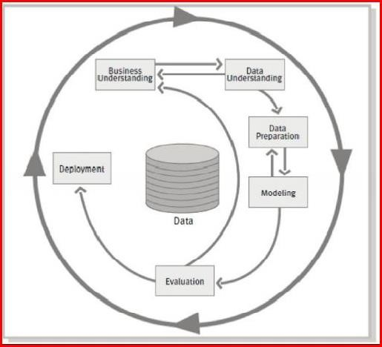The CRISP-DM (Cross-Industry Standard Process for Data Mining) Process was designed specifically for the data mining. However, it is flexible and thorough enough that it can be applied to any analytical project whether it is predictive analytics, data science, or Machine learning. The Process has the following six phases

* + - Business Understanding
    - Data Understanding
    - Data preparation
    - Modeling
    - Evaluation
    - Deployment

Fig. 2.1 CRISP-DM diagram

And, each phase has different steps covering important tasks which are mentioned below:

###### Business Understanding

It is very important step of the process in achieving the success. The purpose of this step is to identify the requirements of the business so that you can translate them into analytical objectives. It has the following tasks:

* + - 1. Identify the Business objective
      2. Assess the situation
      3. Determine the Analytical goals
      4. Produce a project plan

###### Data Understanding

After enduring the all-important pain of the first step, you can now get your hands on the data. The task in this process consist the following

* + - 1. Collect the data
      2. Describe the data
      3. Explore the data
      4. Verify the data Quality

###### Data Preparation

This step is relatively self-explanatory and in this step the goal is to get the data ready to input in the algorithms. This includes merging, feature engineering, and transformations. If imputation for missing values / outliers is needed then, it happens in this step. The key five tasks under this step are as follows:

* + - 1. Select the data
      2. Clean the data
      3. Construct the data
      4. Integrate the data
      5. Format the data

###### Modeling

Oddly, this process step includes the consideration that you already thought of and prepared for. In this, one will need at least a modicum of an idea about how they will be modeling. Remember, that this is flexible, iterative process and some strict linear flow chart such as an aircrew checklist.

Below are the tasks in this step:

* + - 1. Select a modeling technique
      2. Generate a test design
      3. Build a model
      4. Assess a Model

Both cross validation of the model (using train/test or K fold validation) and model assessment which involves comparing the models with the chosen criterion (RMSE, Accuracy, ROC) will be performed under this phase.

###### Evaluation

In the evaluation process, the main goal is to confirm that the work that has been done and the model selected at this point meets the business objective. Ask yourself and others, have we achieved the definition of success? And, here are the tasks in this step:

* + - 1. Evaluate the results
      2. Review the process
      3. Determine the next steps

###### Deployment

If everything is done according to the plan up to this point, it might come down to flipping a switch and your model goes live. Here are the tasks in this step:

1. Deploying the plan
2. Monitoring and maintenance of the plan
3. Producing the final report

###### Types of Machine Learning

Broadly, the Machine Learning Algorithms are classified into 3 type

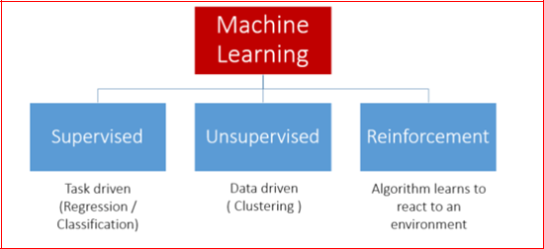

###### Fig. 2.2 Types of Machine Learning

* + 1. **Supervised Learning**

This algorithm consists of a target / outcome / dependent variable which is to be predicted from a given set of predictors / independent variables. Using these set of variables, we generate a function that maps inputs to desired output. The training process continues until the model achieves a desired level of accuracy on the training data.

The process of Supervised Learning model is illustrated in the below picture:

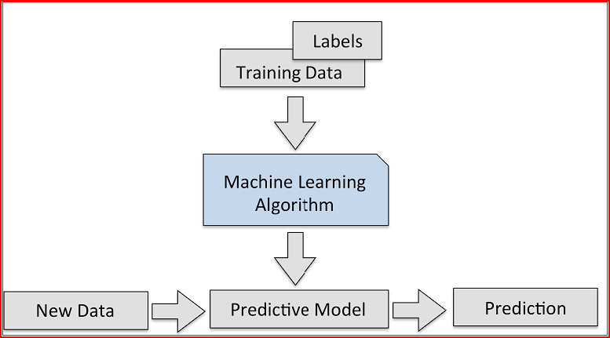

Fig. 2.2.1 Supervised Learning

Examples of Supervised Learning: Regression, Decision Tree, Random Forest, KNN, Logistic Regression,…etc

###### Classification Regression

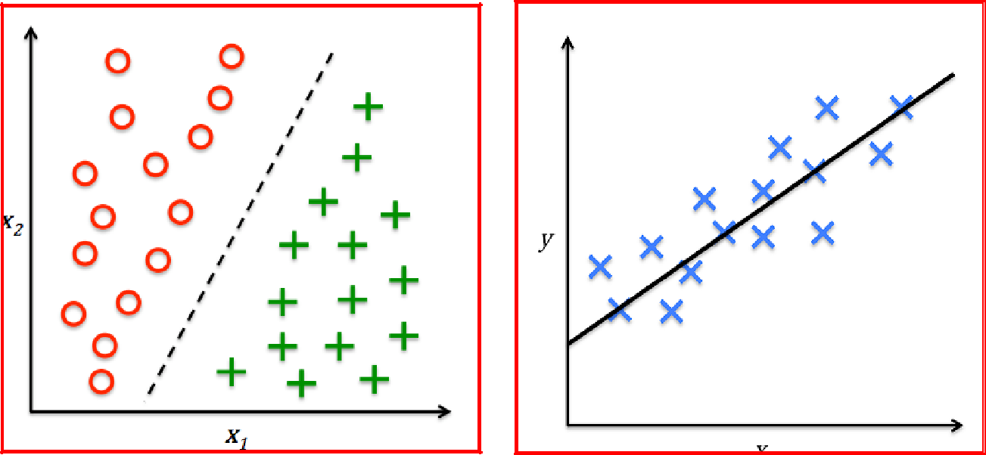

Fig.2.2.1 Classification Fig.2.2.1 Regression

* + 1. **Unsupervised Learning**

In this algorithm, we will not have any target or outcome variable to predict / estimate. It is used for clustering population into different groups, which is widely used for segmenting customers in different groups for specific intervention. (More of Exploratory Analysis)

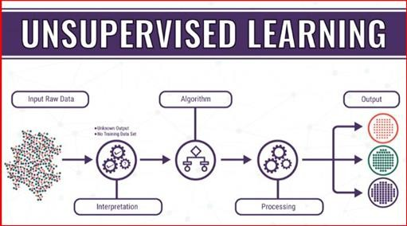

Fig.2.2.2 Unsupervised Learning

Examples of Unsupervised Learning: Data reduction techniques, Cluster Analysis, Market Basket Analysis,…etc

###### Cluster Analysis Data Reduction Techniques

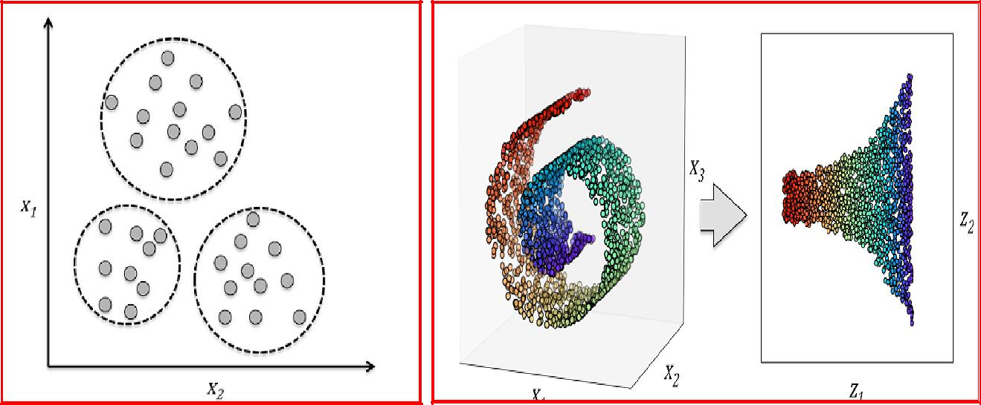

Fig.2.2.2 Cluster Analysis Fig. 2.2.2 Data Reduction Techniques

* + 1. **Reinforcement Learning**

Using this algorithm, the machine is trained to make specific decisions. It works this way: the machine is exposed to an environment where it trains itself continually using trial and error. This machine learns from past experience and tries to capture the best possible knowledge to make accurate business decisions.

The process of reinforcement learning is illustrated in the below picture:

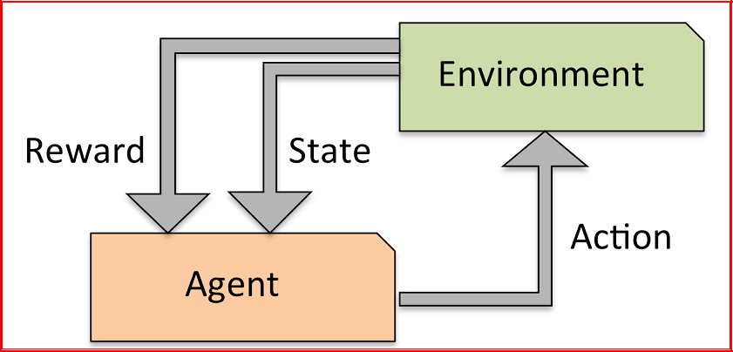

Fig.2.2.3 Reinforcement learning process

Examples of Reinforcement Learning: Markov Decision Process, Self- Profivingcars,...etc

###### Choosing the algorithm

Choosing the right algorithm will depend on the type of the problem we are solving and also depends on the scale of the dependent variable. In case of continuous target variable, we will use regression algorithms and in case of categorical target, we will use classification algorithms and for the model which doesn’t have target variable, we will use either cluster analysis / data reduction techniques.

Below picture describes the process of choosing the right algorithm:

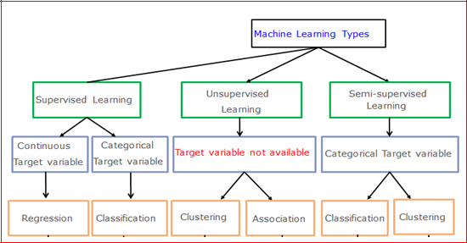

Fig.2.3 Choosing the algorithm

* + 1. **Types of Regression Algorithms**

There are many Regression algorithms in machine learning, which will be used in different regression applications. Some of the main regression algorithms are as follows:

* + - 1. **Simple Linear Regression:-**In simple linear regression, we predict scores of the variable from the data of second variable. The variable we are forecasting is called the criterion variable and referred to as Y. The variable we are basing our predictions on is called the predictor variable and denoted as X.
      2. **Multiple Linear Regression:-**Multiple linear regression is one of the algorithms of regression technique, and is the most common form of linear regression analysis. As a predictive analysis, the multiple linear regression is used to explain the relationship between one dependent variable with two or more independent variables. The independent variables can be either continuous or categorical.
      3. **Polynomial Regression:-**Polynomial regression is another form of regression in which the maximum power of the independent variable is more than 1.

In this regression technique, the best fit line is not a straight line instead it is in the form of a curve.

* + - 1. **Support Vector Machines:-**Support Vector Machines can be applied to regression problems as well as Classification. It contains all the features that characterizes maximum margin algorithm. Linear learning machine maps a non-linear function into high dimensional kernel-induced feature space. The system capacity will be controlled by parameters that do not depend on the dimensionality of feature space.
      2. **Decision Tree Regression:-**Decision tree builds regression models in the form of a tree structure. It breaks down the data into smaller subsets and while at the same time an associated decision tree is incrementally developed. The final result is a tree with decision nodes and leaf nodes.
      3. **Random Forest Regression:-**Random Forest is also one of the algorithms used in regression technique. It is very a flexible, easy to use machine learning algorithm that produces, even without hyper -parameter tuning, a great result most of the time. It is also one of the most widely used algorithms because of its simplicity and the fact that it can used for both regression and classification tasks. The forest it builds is an ensemble of Decision Trees, most of the time trained with the “bagging” method.

Other than these we have regularized regression models like **Ridge, LASSO** and **Elastic Netregression** which are used to select the key parameters and these is also **Bayesian regression** which works with the Bayes theorem.

###### Types of Classification Algorithms

There are many Classification algorithms in machine Learning, which can be used for different classification applications. Some of the main classification algorithms are as follows:

* + - 1. **Logistic Regression/Classification**:-Logistic regression falls under the category of supervised learning; it measures the relationship between the dependent variable which is categorical with one or more than one independent variables by estimating probabilities using a logistic/sigmoid function. Logistic regression can generally be used when the dependent variable is Binary or Dichotomous. It means that the dependent variable can take only two possible values like “Yes or No”, “Living or dead”.
      2. **K-Nearest Neighbors:-** k-NN algorithm is one of the most straight forward algorithms in classification, and it is one of the most used ML algorithms. An object is classified by a majority vote of its neighbors, with the object being assigned to the class most common among its k nearest neighbors. It can also use for regression- output is the value of the object (predicts continuous values). This value is the average (or median) of the values of its k nearest neighbors.
      3. **Naive Bayes:-**Naive Bayes is a type of Classification technique based on Bayes theorem, with an assumption of independence among predictors. In simple terms, a

Naive Bayes classifier assumes that the presence of a Particular feature in a class is unrelated to the presence of any other function. Naive Bayes model is accessible to build and particularly useful for extensive datasets.

* + - 1. **Decision Tree Classification:-**Decision tree builds classification models in the form of a tree structure. It breaks down a dataset into smaller and smaller subsets while at the same time an associated decision tree is incrementally developed. The final result is a tree with decision nodes and leaf nodes. A decision node has two or more branches. Leaf node represents a classification or decision. The first decision node in a tree which corresponds to the best predictor called root node. Decision trees can handle both categorical and numerical data.
      2. **Support Vector Machines:-**A Support Vector Machine is a type of Classifier, in which a discriminative classifier is formally defined by a separating hyperplane. The algorithm outputs an optimal hyperplane which categorizes new examples. In two dimensional space, this hyperplane is a line dividing a plane in two parts where in each class lay in either side.
      3. **Random Forest Classification:-**Random Forest is a supervised learning algorithm. It creates a forest and makes it somehow random. The forest it builds is an ensemble of Decision Trees, most of the times the decision tree algorithm trained with the “bagging” method. The general idea of the bagging method is that a combination of learning models increases the overall result. And Random Forest is also very powerful to find the variable importance in classification/ Regression problems.

###### Types of Unsupervised Learning

Clustering is the type of unsupervised learning in which an unlabelled data is used to profaw inferences. It is the process of grouping similar entities together. The goal of this unsupervised machine learning technique is to find similarities in the data points and group similar data points together and also to figure out which cluster should a new data point belong to.

**Types of Clustering Algorithms**:-There are many Clustering algorithms in machine learning, which can be used for different clustering applications. Some of the main clustering algorithms are as follows:

* + - 1. **Hierarchical Clustering:-**Hierarchical clustering is one of the algorithms of clustering technique, in which similar data is grouped in a cluster.

It is an algorithm that builds the hierarchy of clusters. This algorithm starts with all the data points assigned to a bunch of their own. Then, two nearest groups are merged into the same cluster. In the end, this algorithm terminates when there is only a single cluster left.

It starts by assigning each data point to its bunch. Finds the closest pair using Euclidean distance and merges them into one cluster. This process is continued until all data points are clustered into a single cluster.

* + - 1. **K–Means Clustering:-**K-Means clustering is one of the algorithms of clustering technique, in which similar data is grouped into a cluster. K-means is an iterative algorithm that aims to find local maxima in each iteration. It starts with K as the input which is the desired number of clusters. Input k centroids in random locations in your space. Now, with the use of the Euclidean distance method, calculates the distance between data points and centroids, and assign data point to the cluster which is close to its centroid. Re calculate the cluster centroids as a mean of data points attached to it. Repeat until no further changes occur.

**Types of Dimensionality Reduction Algorithms:-**There are many dimensionality reduction algorithms in machine learning, which are applied for different dimensionality reduction applications. One of the main dimensionality reduction techniques is Principal Component Analysis (PCA) / Factor Analysis.

**Principal Component Analysis (Factor Analysis):-**Principal Component Analysis is one of the algorithms of Dimensionality reduction. In this technique, it transforms data into a new set of variables from input variables, which are the linear combination of real variables. These Specific new set of variables are known as principal components. As a result of the transformation, the first primary component will have the most significant possible variance, and each following component in has the highest possible variance under the constraint that it is orthogonal to the above components. Keeping only the best m < n components, reduces the data dimensionality while retaining most of the data information.

###### Choosing and comparing models through Pipelines

When you work on machine learning project, you often end up with multiple good models to choose from. Each model will have different performance characteristics. Using resampling methods like k-fold cross validation; you can get an estimate of how accurate each model may be on unseen data. You need to be able to use these estimates to choose one or two best models from the suite of models that you have created.

###### Model Validation

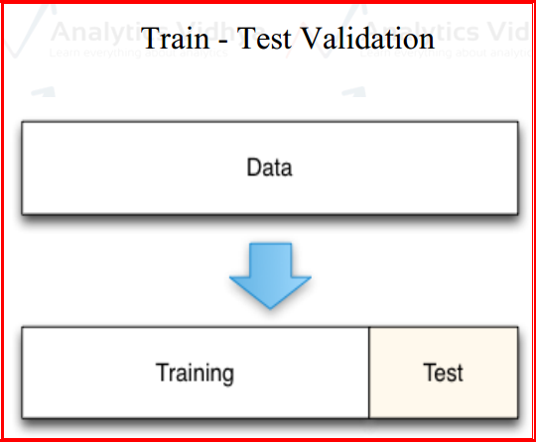When you are building a predictive model, you need to evaluate the capability or generalization power of the model on unseen data. This is typically done by estimating accuracy using data that was not used to train the model, often referred as cross validation.

Fig. 2.4.1 Model Validation

A few common methods used for Cross Validation:

###### The Validation set Approach (Holdout Cross validation)

In this approach, we reserve large portion of dataset for training and rest remaining portion of the data for model validation. Ideally people will use 70-30 or 80-20 percentages for training and validation purpose respectively.

A major disadvantage of this approach is that, since we are training a model on a randomly chosen portion of the dataset, there is a huge possibility that we might miss-out on some interesting information about the data which, will lead to a higher bias.

###### K-fold cross validation

As there is never enough data to train your model, removing a part of it for validation may lead to a problem of under fitting. By reducing the training data, we risk losing important patterns/ trends in data set, which in turn increases error induced by bias. So, what we require is a method that provides ample data for training the model and also leaves ample data for validation. K Fold cross validation does exactly that.

In K Fold cross validation, the data is divided into k subsets. Now the holdout method is repeated k times, such that each time, one of the k subsets is used as the test set/ validation set and the other k-1 subsets are put together to form a training set. The error estimation is averaged over all k trials to get total effectiveness of our model. As can be seen, every data point gets to be in a validation set exactly once, and gets to be in a training set k-1

times. This significantly reduces the bias as we are using most of the data for fitting and also significantly reduces variance as most of the data is also being used in validation

set. Interchanging the training and test sets also adds to the effectiveness of this method. As a general rule and empirical evidence, K = 5 or 10 is preferred, but nothing’s fixed and it can take any value.

###### Below are the steps for it:

Randomly split your entire dataset into k”folds”

* For each k-fold in your dataset, build your model on k – 1 folds of the dataset. Then, test the model to check the effectiveness for kth fold.
* Record the error you see on each of the predictions.
* Repeat this until each of the k-folds has served as the test set.
* The average of your k recorded errors is called the cross-validation error and will serve as your performance metric for the model.

Below is the visualization of a k-fold validation when k=5.

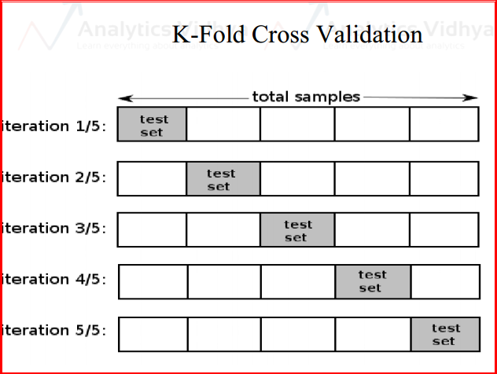

###### How to choose K:

Fig.2.4.1 K- Fold Crosss Validation

* Smaller dataset: 10-fold cross validation is better
* Moderate dataset: 5 or 6 fold cross validation works mostly
* Big dataset: Train – Val split for validation

Other than this, we have Leave one out cross validation (LOOCV), in which each record will be left over from the training and then, the same will be used for testing purpose. This process will be repeated across all the respondents.

###### Model Diagnosis with over fitting and under fitting

* + 1. **Bias and Variance**

A fundamental problem with supervised learning is the bias variance trade-off.

Ideally, a model should have two key characteristics

* + - 1. Sensitive enough to accurately capture the key patterns in the training dataset.
      2. Generalized enough to work well on any unseen dataset.

Unfortunately, while trying to achieve the above-mentioned first point, there is an ample chance of over-fitting to noisy or unrepresentative training data points leading to a failure of generalizing the model. On the other hand, trying to generalize a model may result in failing to capture important regularities.

If model accuracy is low on a training dataset as well as test dataset, the model is said to be under-fitting or that the model has high bias. The **Bias** refers to the simplifying assumptions made by the algorithm to make the problem easier to solve. To solve an under-fitting issue or to reduce bias, try including more meaningful features and try to increase the model complexity by trying higher-order interactions

The **Variance** refers to sensitivity of a model changes to the training data. A model is giving high accuracy on a training dataset, however on a test dataset the accuracy proofs prophetically then, the model is said to be over-fitting or a model that has high variance.

To solve the over-fitting issue try to reduce the number of features, that is, keep only the meaningful features or try regularization methods that will keep all the features. Ideal model will be the trade-off between Underfitting and over fitting like mentioned in the below picture.

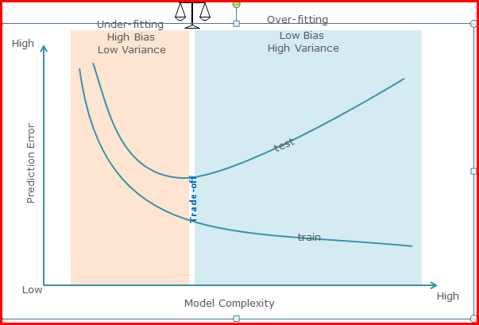

Fig. 2.5.1 Under-fitting vs Over –fitting

And, the Hyperparameters will be tuned in the below mentioned ways to reach the optimal solution:

* + - * 1. Grid Search
        2. Random Search
        3. Manual Tuning

###### Model Performance Matrix

Model evaluation is an integral part of the model development. Based on model evaluation and subsequent comparisons, we can take a call whether to continue our efforts in model enhancement or cease them and select the final model that should be used / deployed.

###### Evaluating Classification Models Confusion Matrix

Confusion matrix is one of the most popular ways to evaluate a classification model. A confusion matrix can be created for a binary classification as well as a multi-class classification model.

A confusion matrix is created by comparing the predicted class label of a data point with its actual class label. This comparison is repeated for the whole dataset and the results of this comparison are compiled in a matrix or tabular format.

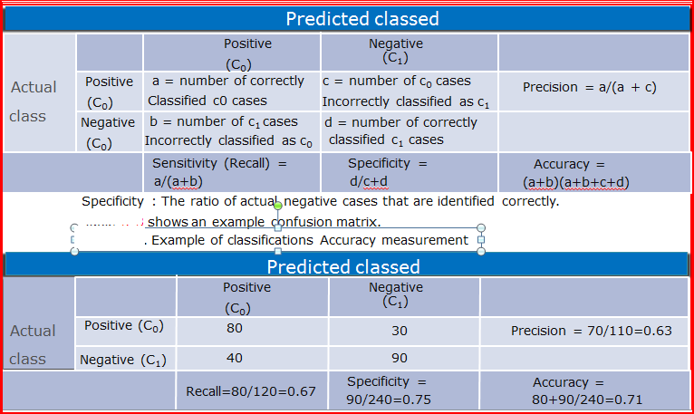Table: 2.5.2 Confusion Matrix

And, below are the various measures that will be used to assess the performance of the model based on the requirement of the problem and as well as data.

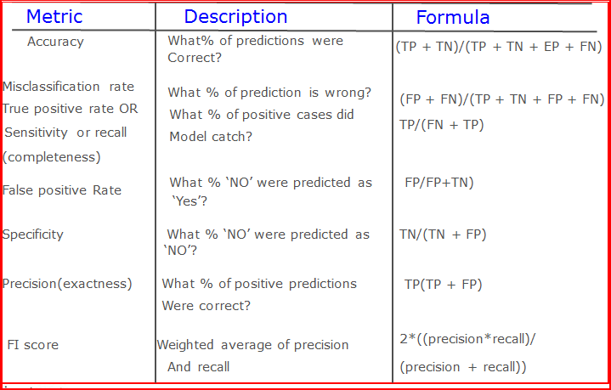

###### Regression Model Evaluation

A regression line predicts the y values for a given x value. Note that the values are around the average. The prediction error (called as root-mean-square error or RSME) is given by the following formula:

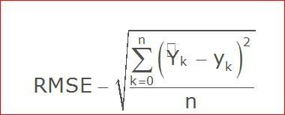

And, the regression will also assessed by R square (Co efficient of determination).

###### Evaluating Unsupervised Models

The Unsupervised algorithms will be assessed by the profile of the factors/ clusters which were derived through the models.

###### Overall Process of Machine Learning

To put overall process together, below is the picture that describes the road map for building ML Systems

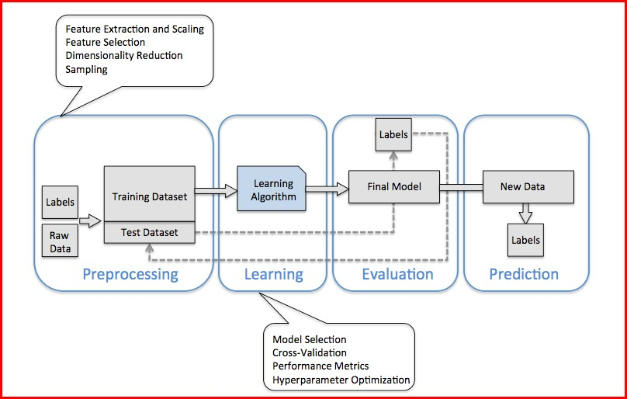

Fig.2.6 Overall Process of Machine learning

CHAPTER 3

**MACHINE LEARNING**

**AT WORK**

**MACHINE LEARNING AT WORK**

###### An Approach to the Problem:

In order to carry out the analysis, we have extracted 1169 records from the UCI ML Repository and the information of the same is mentioned in Chapter 1.

In this Chapter, we are going to discuss about the results of different Machine Learning methods used in order to obtain the solution for the problem mentioned in Chapter1.

As mentioned in Chapter 2, the first step of a ML Algorithm is Data cleaning and preparing data for the modeling. As a first step, we have to check whether the data was read properly and all the data types are as per the data.

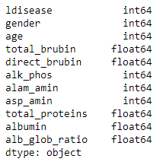

Output: 3.1.1 Data Types

**Understanding data using Descriptive Statistics:**

To understand the data, we will first look at the summary of the data.

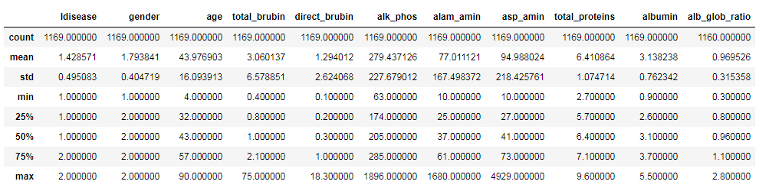

Output: 3.1.3 Summary of the data

From the summary, we can see that there are

* + - 241 females and 928 males
    - 668 are with liver disease and 501 are without liver disease

Also, we find mean, first quartile, median, third quartile, maximum and minimum values of all the continuous attributes.

###### Understanding data visually:

Also, look at the data visually to understand the relationships between and within the variables.

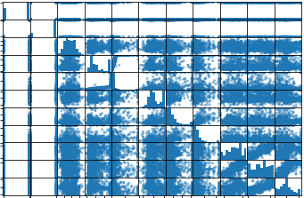

Output: 3.1.4 understanding data visually

**Checking for missing Values:**

We also need to check if the data contains any missing values, which can be done as below

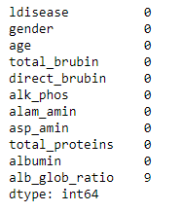

Output: 3.1.5 Checking for missing values

As we don’t have any missing values in remaining variables except that there are 0.7698888% i.e., 9 missing values in alb_glob_ratio.

The missing values for the continuous variables will be imputed using Mean / Median value of the valid records and the categorical variables will be imputed using Mode value

Since, alb_glob_ratio is a continuous variable, we impute the missing observations using mean.

###### Result after imputing missing values:

###### nonull.PNG

Output: 3.1.6 Result after imputing missing vales

Here we can see that there are no missing values in alb_glob_ratio after imputation.

###### Checking for Outliers:

We used Box-plots to check for Outliers in each of the continuous variables..

###### Boxplot for total_proteins:

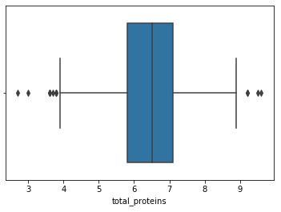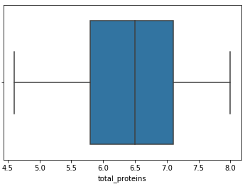

Output: 3.1.7 With outliers Output: 3.1.8 After replacing outliers

Here, for total_proteins, values more than 95th percentile are imputed using the 95th percentile value and the values less than 5th percentile are imputed using the 5th percentile value in order to remove outliers.

###### Boxplot for alk_phos:

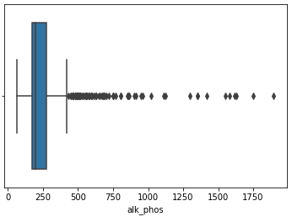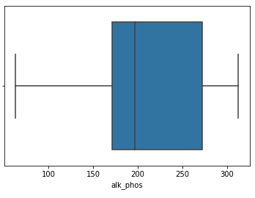

Output: 3.1.9 With outliers Output: 3.1.10 After replacing outliers

In alk_phos, values more than 85th percentile are imputed using the 85th percentile value in order to remove outliers.

###### Boxplot for age:

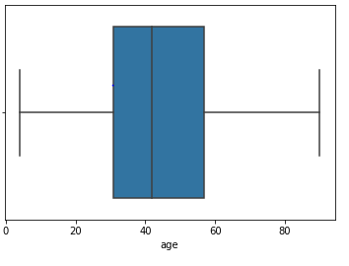

Output: 3.1.11 With no outliers

There are no outliers for age as we have taken a person’s age exceeding 90yrs as 90yrs.

###### Boxplot for total_brubin:

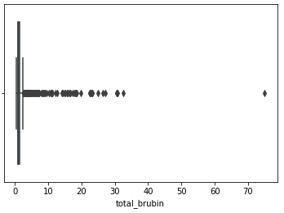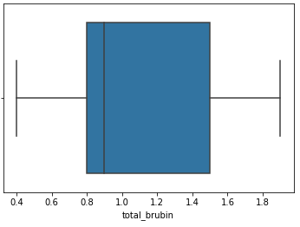

Output: 3.1.12 With outliers Output: 3.1.13 After replacing outliers

Here, in total_brubin values more than 80th percentile are imputed using the 80th percentile value in order to remove outliers.

###### Boxplot for direct_brubin:

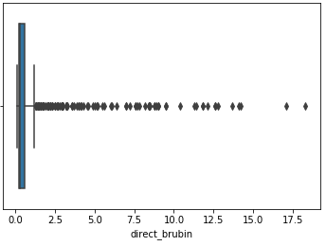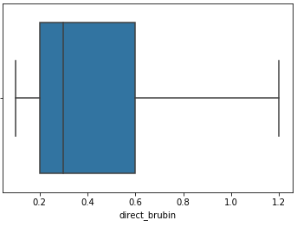

Output: 3.1.14 With outliers Output: 3.1.15 After replacing outliers

In direct_brubin, values more than 85th percentile are imputed using the 85th percentile value in order to remove outliers.

###### Boxplot for alam_amin:

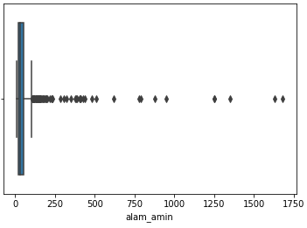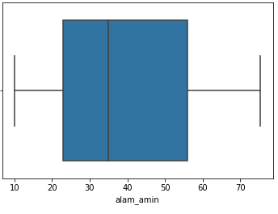

Output: 3.1.16 With outliers Output: 3.1.17 After replacing outliers

In alam_amin, values more than 85th percentile are imputed using the 85th percentile value in order to remove outliers.

###### Boxplot for asp_amin:

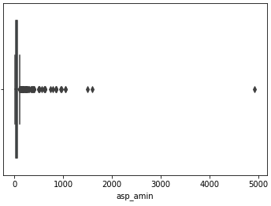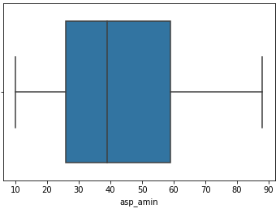

Output: 3.1.18 With outliers Output: 3.1.19 After replacing outliers

Here, in asp_amin, values more than 85th percentile are imputed using the 85th percentile value in order to remove outliers.

###### Boxplot for albumin:

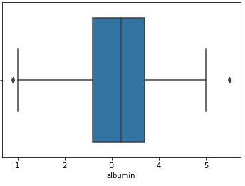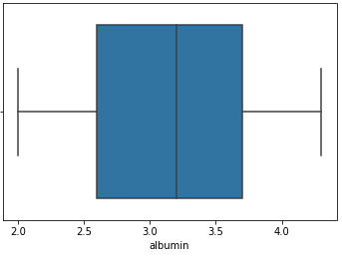

Output: 3.1.20 With outliers Output: 3.1.21 After replacing outliers

In albumin, values more than 95th percentile are imputed using the 95th percentile value and the values less than 5th percentile are imputed using the 5th percentile value in order to remove outliers.

###### Boxplot for alb_glob_ratio:

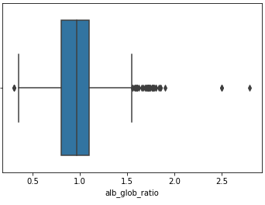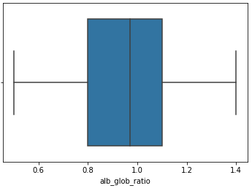

Output: 3.1.22 With outliers Output: 3.1.23 After replacing outliers

In alb_glob_ratio,values more than 90th percentile are imputed using the 90th percentile value and the values less than 5th percentile are using the 5th percentile value in order to remove outliers.

###### Understanding relationships between variables:

For the continuous variables, we will look at the Correlation plots to understand the relationships between variables.

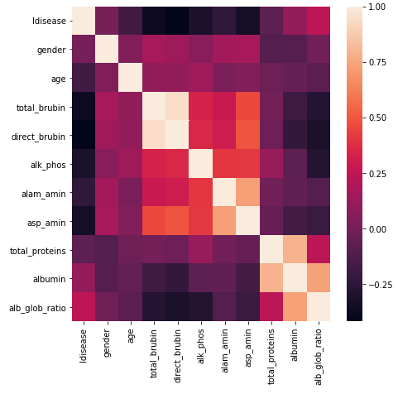

Output: 3.1.24 Correlation Plot

Here, the color refers to the direction of the relationship i.e., white color represents the positive correlation and black color represents negative correlation.

From the plot, we can see that (direct_brubin, total_brubin),(albumin, total_protein), (alb_glob_ratio, albumin) are highly positively correlated.

###### FEATURE PLOTS:

For the continuous Vs categorical variable, we will look at Feature plots to understand the relationships between variables.

###### Age Vs ldisease:

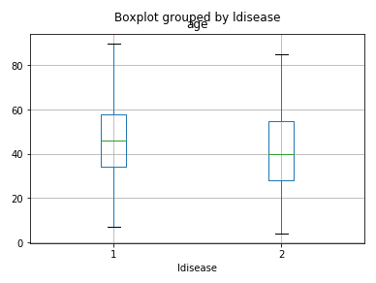

**Output: 3.1.25 feature plot for age vs. ldisease**

We can observe that there is no much difference between age and ldisease.

**total_brubin Vs ldisease:**

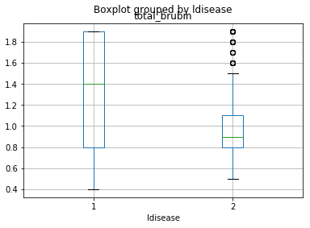

Output: 3.1.26 feature plot for total_brubin vs. ldisease

We can observe that there is no much difference between total brubin and ldisease.

###### direct brubin Vs ldisease:

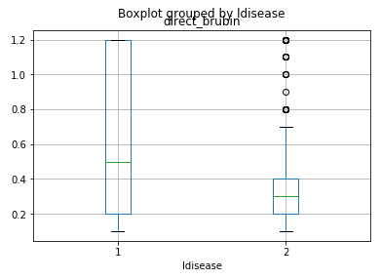

Output: 3.1.27 feature plot for direct_brubin vs. ldisease

We can observe that there is no much difference between direct _brubin and ldisease.

###### alk_phos Vs ldisease:

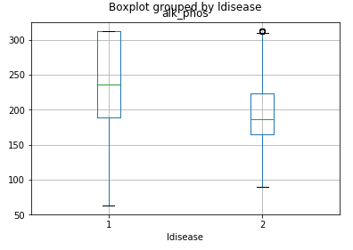

Output: 3.1.28 feature plot for alk_phos vs. ldisease

We can observe that there is no much difference between alk_phos and ldisease.

###### alam_amin Vs ldisease

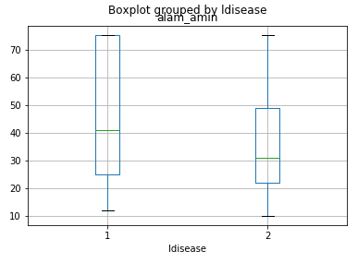

Output: 3.1.29 feature plot for alam_amin vs. ldisease

We can observe that there is no much difference between alam_amin and ldisease.

###### asp_amin Vs ldisease:

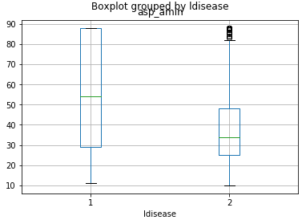

Output: 3.1.30 feature plot for asp_amin vs. ldisease

We can observe that there is slight difference between asp_amin and ldisease.

###### total_protein Vs ldisease:

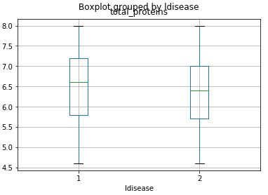

Output: 3.1.31 feature plot for total_protein vs. ldisease

We can observe that there is no much difference between total protein and ldisease.

###### albumin Vs ldisease:

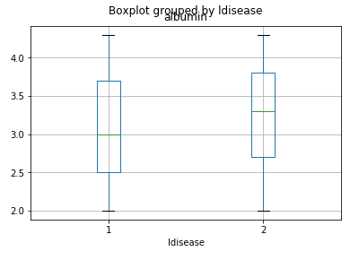

Output: 3.1.32 feature plot for albumin vs. ldisease

We can observe that there is slight difference between albumin and ldisease.

###### alb_glob_ratio Vs ldisease:

###### ratio vs ld.PNG

Output: 3.1.33 feature plot for alb_glob_ratio vs. ldisease

We can observe that there is slight difference between alb_glob_ratio and ldisease.

**Cross Validation:**

Here we’ll perform the train and test split cross validation techniques. So, as part of it, we need to split the original data into train and test considering 80:20 proportion respectively.

Here, we are randomly considering 80% of the original data as train data. And, the dimensions of the train and test data are:

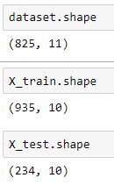

Output: 3.1.35 dimension of train and test data

Further we use k-fold validation for splitting train data into 10 folds as below

num_folds = 10

num_instances = len(X_train)

seed = 5

scoring = 'accuracy'

###### Running Pipeline using k-fold validation:

Here, we will use a pipeline of algorithms for classification to compare accuracies across different methods. As this is a classification problem, we will use Logistic Regression, Decision Tree, SVM, k-NN and Random Forest techniques as apart of the pipeline. And the result is as follows:

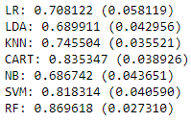

Output: 3.1.36 Finding best model using pipeline

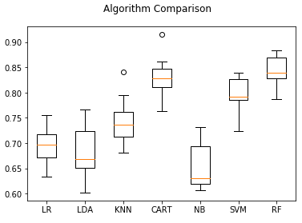

Output: 3.1.37 Comparing algorithms using boxplot

Here, we observe that Random Forest is the best model for the data.

Random Forest:

Tuning the parameters in Random Forest:

In Random Forest by using Grid Search Cross Validation we tune the hyperparameters to extract the best parameters. By using those best parameters we get the best accuracy.

The best parameters given are



In the result we get accuracy, precision, recall, f1-score by confusion matrix. The Confusion Matrix is given below the accuracy in the output.

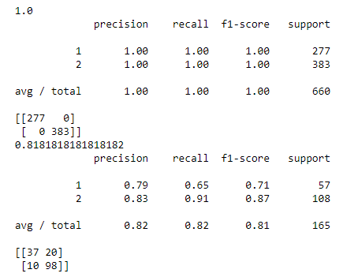

**Output: 3.1.38 Accuracy of Random Forest on train data and test data**

Here, 1.0 i.e., 100% is the accuracy of train data and 0.81818 i.e., 81.8% is the accuracy of test data. We observe that there is a much difference between the accuracy of train data and the test data. Thus, we can say that the data is over fitted. We conclude that the Random Forest Algorithm is not the best one.

**Finding key variables:**



The importance of features is given as array according to the data.

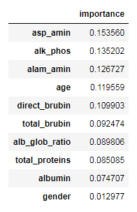

Here we can clearly see the importance of each feature. This importance is calculated automatically for each feature after training and scales the results so that the sum of all importance is equal to one.

The inceasing order of important feature is

Asp_amin>alk_phos>alam_amin>age>direct_brubin>total_brubin>alb_glob_ratio>

Total_proteins>albumin>gender.

Now, we use only top 5 features to get the accuracy.

**Logistic Regression:**

Now, we fit a logistic regression to the train data and pred y values by the test data.

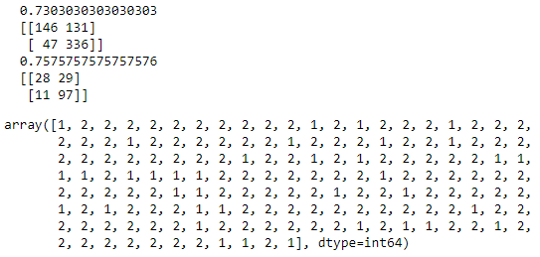

**Output:3.1.39 Accuracy of Logistic Regression on train data and the test data**

When Logistic Model is fitted for the train data, the accuracy obtained is 0.7303 i.e., 73%.

Under the accuracy we have confusion matrix of train data.

When Logistic Model is predicted on test data, the accuracy obtained is 0.757 i.e., 75.7%. Under the accuracy of test data we have Confusion matrix of test data.

The array given in the output is y predictions when the test data is fitted.

Here, the test data has more accuracy than the train data.

Support Vector Machines(SVM):

In SVM, by using Grid Search CV to find best parameters the input has given as follows:

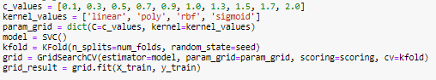

Then the best parameters are



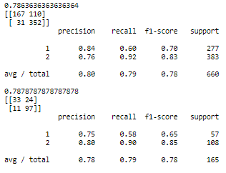

**Output: 3.1.40 Accuracy of SVM on train data and test data**

0.7863 accuracy level on train data is obtained when the Kernel is rbf and c=0.7 from a list of parameters using Support Vector Machines.0.7878 accuracy level on test data is obtained by SVM.

Here we can observe that accuracy of train data and test data is same. Thus, we can say that this is the best model for the data.

K – Nearest Neighbourhood:

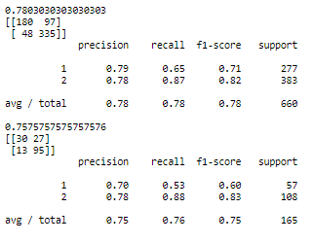

**Output: 3.1.39 k-NN output for train data**

Best Accuracy 0.7803 is obtained on train data when n_neighbours=12 is chosen given by K-NN method. Best accuracy 0.757 is obtained on test data by choosing same n_neighbours.

Here, we observe that the accuracy of train and test data is approximately nearer.

**Comparing all the models:**

|  |  |  |  |  |
| --- | --- | --- | --- | --- |
| **Model** | **Random Forest** | **Logistic Regression** | **S V M** | **K N N** |
| **Train Data** | 100% | 73.0% | 78.6% | 78% |
| **Test Data** | 81.8% | 75.7% | 78.7% | 75.7% |

**Conclusion**: After comparing all models, we have near similar accuracy values for S V M model on Train Data & Test Data.

# CHAPTER 4

## CONCLUSION

### CONCLUSION

In order to identify whether a person has liver disease or not, we developed an algorithm in which we applied pipeline techniques as well as Random Forest to choose the best model and key variables.

Once we identified the key variables, we run the model with only key variables using Train data set and validate the same using Test data set.

The accuracy of Train and Test data are 78.6% and 78.7% respectively.

Since, the accuracy of Train and Test data are almost same, we can say that our model belongs to SVM model.

Hence, we can apply our model for future predictions.

# APPENDIX

## R - CODE DATASET BIBLIOGRAPHY

**R Code:**

getwd() setwd("C:/Users/USER/Downloads") getwd()

##################################################################

#Loading required libraries to perform modeling ##################################################################

library(mice) library(randomForest) library(ggplot2) library(glmnet)

##################################################################

# reading data from Folder and checking for the data types ##################################################################

dataset <- read.csv(file.choose(), header = T) str(dataset)

table(dataset$ldisease)

dataset$ldisease <- as.factor(dataset$ldisease) dataset$gender <- as.factor(dataset$gender) str(dataset)

summary(dataset) dim(dataset) head(dataset) tail(dataset)

##################################################################

#Checking for Missing value ##################################################################

print(all(!is.na(dataset)))

#Missing value Proportion for all the variables

sapply(dataset, function(df) { (sum(is.na(df)==TRUE)/ length(df))*100;

})

##################################################################

# Missing values impute for small proportion of missing values ##################################################################

dataset$alb_glob_ratio[is.na(dataset$alb_glob_ratio)]< - mean(dataset$alb_glob_ratio,na.rm=T) sum(is.na(dataset))

dataset$alb_glob_ratio=as.numeric(dataset$alb_glob_ratio) str(dataset)

##################################################################

#Missing value Proportion for all the variables ##################################################################

sapply(dataset, function(df) { (sum(is.na(df)==TRUE)/ length(df))*100;

})

##################################################################

boxplot(dataset$total_proteins) boxplot(dataset$alk_phos) boxplot(dataset$age) boxplot(dataset$total_brubin) boxplot(dataset$direct_brubin) boxplot(dataset$alam_amin) boxplot(dataset$asp_amin) boxplot(dataset$albumin) boxplot(dataset$alb_glob_ratio)

dataset$total_proteins[dataset$total_proteins>quantile(dataset$total_proteins, 0.95)] < - quantile(dataset$total_proteins, 0.95) dataset$total_proteins[dataset$total_proteins<quantile(dataset$total_proteins, 0.05)] < - quantile(dataset$total_proteins, 0.05) dataset$alk_phos[dataset$alk_phos>quantile(dataset$alk_phos, 0.85)] < - quantile(dataset$alk_phos, 0.85) dataset$total_brubin[dataset$total_brubin>quantile(dataset$total_brubin, 0.85)] < - quantile(dataset$total_brubin, 0.85) dataset$direct_brubin[dataset$direct_brubin>quantile(dataset$direct_brubin, 0.85)] < - quantile(dataset$direct_brubin, 0.85) dataset$alam_amin[dataset$alam_amin>quantile(dataset$alam_amin, 0.85)] < - quantile(dataset$alam_amin, 0.85) dataset$asp_amin[dataset$asp_amin>quantile(dataset$asp_amin, 0.85)] < - quantile(dataset$asp_amin, 0.85) dataset$albumin[dataset$albumin>quantile(dataset$albumin, 0.95)] < - quantile(dataset$albumin, 0.95)

dataset$albumin[dataset$albumin<quantile(dataset$albumin, 0.05)] <-

quantile(dataset$albumin, 0.05) dataset$alb_glob_ratio[dataset$alb_glob_ratio>quantile(dataset$alb_glob_ratio, 0.90)] < - quantile(dataset$alb_glob_ratio, 0.90) dataset$alb_glob_ratio[dataset$alb_glob_ratio<quantile(dataset$alb_glob_ratio, 0.05)] < - quantile(dataset$alb_glob_ratio, 0.05)

boxplot(dataset$total_proteins) boxplot(dataset$alk_phos) boxplot(dataset$age) boxplot(dataset$total_brubin) boxplot(dataset$direct_brubin) boxplot(dataset$alam_amin) boxplot(dataset$asp_amin) boxplot(dataset$albumin) boxplot(dataset$alb_glob_ratio)

pairs(dataset) pre1=dataset[c(3:11)] install.packages("corrplot") library(corrplot)

pre1.cor = cor(pre1) corrplot(pre1.cor, method="circle")

##################################################################

# Continuous vs categories ##################################################################

library(caret)

x <- dataset[,3] y <- dataset[,1]

featurePlot(x=x, y=y, plot="box") x <- dataset[,4]

y <- dataset[,1]

featurePlot(x=x, y=y, plot="box") x <- dataset[,5]

y <- dataset[,1]

featurePlot(x=x, y=y, plot="box") x <- dataset[,6]

y <- dataset[,1]

featurePlot(x=x, y=y, plot="box") x <- dataset[,7]

y <- dataset[,1]

featurePlot(x=x, y=y, plot="box") x <- dataset[,8]

y <- dataset[,1]

featurePlot(x=x, y=y, plot="box")

x <- dataset[,9] y <- dataset[,1]

featurePlot(x=x, y=y, plot="box") x <- dataset[,10]

y <- dataset[,1]

featurePlot(x=x, y=y, plot="box") x <- dataset[,11]

y <- dataset[,1]

featurePlot(x=x, y=y, plot="box") str(dataset)

cont<-subset(dataset,select = -c(gender, ldisease)) str(cont)

##################################################################

# Normalizing input data ##################################################################

scale_training <- as.data.frame(scale(cont[,],

center = TRUE, scale = TRUE))

scale_training<-cbind(scale_training,dataset$ldisease,dataset$gender) str(scale_training)

##################################################################

# we can also set/change the variable names using colnames ##################################################################

colnames(scale_training) <- c("age","total_brubin","direct_brubin","alk_phos","alam_amin","asp_amin","total_proteins", "albumin","alb_glob_ratio","ldisease","gender")

names(scale_training) table(scale_training$ldisease) write.csv(scale_training,"scaledata.csv")

##################################################################

# Splting data ##################################################################

train_rows<- sample(1:nrow(scale_training), size=0.9*nrow(scale_training)) train_rows

training <- scale_training[train_rows, ] test <- scale_training[-train_rows, ] dim(scale_training)

dim(training) dim(test) head(test)

##################################################################

# Model Pipleline ##################################################################

library(caret)

# Run algorithms using 10-fold cross validation

control <- trainControl(method="repeatedcv", number=10, repeats=3)

# GLM

set.seed(7)

fit.glm <- train(ldisease~., data=dataset, method="glm", metric="Accuracy", trControl=control)

print(fit.glm)

# CART

set.seed(7)

grid <- expand.grid(.cp=c(0.01,0.05,0.1))

fit.cart <- train(ldisease~., data=training, method="rpart", metric="Accuracy", tuneGrid=grid, trControl=control)

print(fit.cart)

# SVM

set.seed(7)

grid <- expand.grid(.sigma=c(0.01,0.05,0.1), .C=c(1))

fit.svm <- train(ldisease~., data=training, method="svmRadial", metric="Accuracy", tuneGrid=grid, trControl=control)

print(fit.svm)

# kNN

set.seed(7)

grid <- expand.grid(.k=c(1,3,5,7))

fit.knn <- train(ldisease~., data=training, method="knn", metric="Accuracy", tuneGrid=grid, trControl=control)

print(fit.knn)

#RF

fit.rf <- train(ldisease~., data=training, method="rf", metric="Accuracy", trControl=control) print(fit.rf)

##################################################################

# Compare algorithms ##################################################################

results <- resamples(list(SVM=fit.svm, CART=fit.cart, kNN=fit.knn, glm=fit.glm, RF=fit.rf)) summary(results)

dotplot(results)

##################################################################

#Tuning Random Forest ##################################################################

customRF <- list(type = "Classification", library = "randomForest", loop = NULL) customRF$parameters <- data.frame(parameter = c("mtry", "ntree"), class = rep("numeric", 2), label = c("mtry", "ntree"))

customRF$grid <- function(x, y, len = NULL, search = "grid") {} customRF$fit <- function(x, y, wts, param, lev, last, weights, classProbs, ...) { randomForest(x, y, mtry = param$mtry, ntree=param$ntree, ...)

}

customRF$predict <- function(modelFit, newdata, preProc = NULL, submodels = NULL) predict(modelFit, newdata)

customRF$prob <- function(modelFit, newdata, preProc = NULL, submodels = NULL) predict(modelFit, newdata, type = "prob")

customRF$sort <- function(x) x[order(x[,1]),] customRF$levels <- function(x) x$classes

##################################################################

library(caret) library(randomForest)

control <- trainControl(method="repeatedcv", number=10, repeats=3) tunegrid <- expand.grid(.mtry=c(1:6), .ntree=c(100, 200, 300)) set.seed(100)

custom <- train(ldisease~., data=training,method=customRF, tuneGrid=tunegrid, trControl=control)

print(custom) ##################################################################

rf_model3 <- randomForest(ldisease ~ ., data =training, ntree=100, mtry=5)

varImpPlot(rf_model3, sort = T,

n.var = 10,

main = "Top 10 - Variable Importance") importance(rf_model3)

##################################################################

#$Final model With Logistic Regression ##################################################################

dim(training) dim(test)

trainControl <- trainControl(method="repeatedcv", number=10, repeats=3)

final.glm <-train (ldisease ~ asp_amin + alk_phos + total_brubin + alam_amin + age + direct_brubin, data=training, method="glm",

trControl=trainControl)

summary(final.glm) print (final.glm)

predslog <- predict(final.glm, data=training, type = "raw") tabtrain <- table(Predicted = predslog, Actual = training$ldisease ) caret::confusionMatrix(predslog,training$ldisease)

##################################################################

#On testing ##################################################################

dim(test) names(test)

p2 <- predict(final.glm,newdata=test,type="raw") tabtest <- table(Predicted = p2, Actual = test$ldisease) caret::confusionMatrix(p2,test$ldisease)

##################################################################

**Dataset:**

|  |  |  |  |  |  |  |  |  |  |  |
| --- | --- | --- | --- | --- | --- | --- | --- | --- | --- | --- |
| ldisea  se | gen  der | age | total_b  rubin | direct_br  ubin | alk_p  hos | alam_a  min | asp_a  min | total_pro  teins | albu  min | alb_glob  _ratio |
| 1 | 2 | 32 | 32.6 | 14.1 | 219 | 95 | 235 | 5.8 | 3.1 | 1.1 |
| 1 | 1 | 51 | 0.9 | 0.2 | 280 | 21 | 30 | 6.7 | 3.2 | 0.8 |
| 1 | 2 | 38 | 3.7 | 2.2 | 216 | 179 | 232 | 7.8 | 4.5 | 1.3 |
| 1 | 2 | 51 | 0.8 | 0.2 | 367 | 42 | 18 | 5.2 | 2 | 0.6 |
| 1 | 2 | 39 | 6.6 | 3 | 215 | 190 | 950 | 4 | 1.7 | 0.7 |
| 1 | 1 | 22 | 6.7 | 3.2 | 850 | 154 | 248 | 6.2 | 2.8 | 0.8 |
| 1 | 2 | 15 | 0.8 | 0.2 | 380 | 25 | 66 | 6.1 | 3.7 | 1.5 |
| 1 | 2 | 18 | 1.4 | 0.6 | 215 | 440 | 850 | 5 | 1.9 | 0.6 |
| 1 | 1 | 42 | 0.8 | 0.2 | 168 | 25 | 18 | 6.2 | 3.1 | 1 |
| 1 | 1 | 65 | 0.7 | 0.1 | 187 | 16 | 18 | 6.8 | 3.3 | 0.9 |
| 1 | 2 | 38 | 0.7 | 0.2 | 216 | 349 | 105 | 7 | 3.5 | 1 |
| 1 | 2 | 48 | 2.4 | 1.1 | 554 | 141 | 73 | 7.5 | 3.6 | 0.9 |
| 1 | 2 | 60 | 0.8 | 0.2 | 286 | 21 | 27 | 7.1 | 4 | 1.2 |
| 1 | 2 | 42 | 11.1 | 6.1 | 214 | 60 | 186 | 6.9 | 2.8 | 2.8 |
| 1 | 2 | 51 | 0.8 | 0.2 | 230 | 24 | 46 | 6.5 | 3.1 |  |
| 1 | 2 | 60 | 3.2 | 1.8 | 750 | 79 | 145 | 7.8 | 3.2 | 0.69 |
| 1 | 2 | 72 | 2.7 | 1.3 | 260 | 31 | 56 | 7.4 | 3 | 0.6 |
| 1 | 2 | 53 | 0.9 | 0.4 | 238 | 17 | 14 | 6.6 | 2.9 | 0.8 |
| 1 | 2 | 26 | 0.6 | 0.2 | 120 | 45 | 51 | 7.9 | 4 | 1 |
| 1 | 2 | 42 | 30.5 | 14.2 | 285 | 65 | 130 | 5.2 | 2.1 | 0.6 |
| 1 | 1 | 32 | 0.6 | 0.1 | 176 | 39 | 28 | 6 | 3 | 1 |
| 1 | 2 | 58 | 1 | 0.4 | 182 | 14 | 20 | 6.8 | 3.4 | 1 |
| 1 | 2 | 75 | 2.9 | 1.3 | 218 | 33 | 37 | 3 | 1.5 | 1 |
| 1 | 2 | 40 | 0.9 | 0.3 | 196 | 69 | 48 | 6.8 | 3.1 | 0.8 |
| 1 | 2 | 66 | 17.3 | 8.5 | 388 | 173 | 367 | 7.8 | 2.6 | 0.5 |
| 1 | 2 | 31 | 1.3 | 0.5 | 184 | 29 | 32 | 6.8 | 3.4 | 1 |
| 1 | 2 | 30 | 1.6 | 0.4 | 332 | 84 | 139 | 5.6 | 2.7 | 0.9 |
| 1 | 1 | 48 | 1 | 1.4 | 144 | 18 | 14 | 8.3 | 4.2 | 1 |
| 1 | 2 | 65 | 4.9 | 2.7 | 190 | 33 | 71 | 7.1 | 2.9 | 0.7 |
| 1 | 2 | 51 | 0.8 | 0.2 | 160 | 34 | 20 | 6.9 | 3.7 | 1.1 |
| 1 | 2 | 47 | 0.9 | 0.2 | 192 | 38 | 24 | 7.3 | 4.3 | 1.4 |
| 1 | 2 | 57 | 0.6 | 0.1 | 210 | 51 | 59 | 5.9 | 2.7 | 0.8 |
| 1 | 2 | 32 | 23 | 11.3 | 300 | 482 | 275 | 7.1 | 3.5 | 0.9 |
| 1 | 2 | 40 | 0.7 | 0.1 | 202 | 37 | 29 | 5 | 2.6 | 1 |
| 1 | 2 | 60 | 0.9 | 0.3 | 168 | 16 | 24 | 6.7 | 3 | 0.8 |
| 1 | 2 | 16 | 2.6 | 1.2 | 236 | 131 | 90 | 5.4 | 2.6 | 0.9 |
| 1 | 2 | 60 | 0.8 | 0.2 | 286 | 21 | 27 | 7.1 | 4 | 1.2 |
| 1 | 2 | 42 | 16.4 | 8.9 | 245 | 56 | 87 | 5.4 | 2 | 0.5 |
| 1 | 2 | 60 | 6.3 | 3.2 | 314 | 118 | 114 | 6.6 | 3.7 | 1.27 |
| 1 | 1 | 7 | 27.2 | 11.8 | 1420 | 790 | 1050 | 6.1 | 2 | 0.4 |
| 1 | 2 | 60 | 1.5 | 0.6 | 360 | 230 | 298 | 4.5 | 2 | 0.8 |
| 1 | 2 | 37 | 1.3 | 0.4 | 195 | 41 | 38 | 5.3 | 2.1 | 0.6 |

|  |  |  |  |  |  |  |  |  |  |  |
| --- | --- | --- | --- | --- | --- | --- | --- | --- | --- | --- |
| 1 | 1 | 34 | 0.8 | 0.2 | 192 | 15 | 12 | 8.6 | 4.7 | 1.2 |
| 1 | 2 | 54 | 0.8 | 0.2 | 218 | 20 | 19 | 6.3 | 2.5 | 0.6 |
| 1 | 2 | 78 | 1 | 0.3 | 152 | 28 | 70 | 6.3 | 3.1 | 0.9 |
| 1 | 2 | 55 | 14.1 | 7.6 | 750 | 35 | 63 | 5 | 1.6 | 0.47 |
| 1 | 2 | 73 | 1.8 | 0.9 | 220 | 20 | 43 | 6.5 | 3 | 0.8 |
| 1 | 2 | 32 | 15.6 | 9.5 | 134 | 54 | 125 | 5.6 | 4 | 2.5 |
| 1 | 2 | 37 | 0.7 | 0.2 | 176 | 28 | 34 | 5.6 | 2.6 | 0.8 |
| 1 | 1 | 54 | 5.5 | 3.2 | 350 | 67 | 42 | 7 | 3.2 | 0.8 |
| 1 | 2 | 54 | 2.2 | 1.2 | 195 | 55 | 95 | 6 | 3.7 | 1.6 |
| 1 | 1 | 36 | 0.8 | 0.2 | 650 | 70 | 138 | 6.6 | 3.1 | 0.8 |
| 1 | 2 | 46 | 0.6 | 0.2 | 290 | 26 | 21 | 6 | 3 | 1 |
| 1 | 2 | 30 | 0.8 | 0.2 | 174 | 21 | 47 | 4.6 | 2.3 | 1 |
| 1 | 2 | 55 | 4.4 | 2.9 | 230 | 14 | 25 | 7.1 | 2.1 | 0.4 |
| 1 | 2 | 58 | 1 | 0.4 | 182 | 14 | 20 | 6.8 | 3.4 | 1 |
| 1 | 1 | 68 | 0.6 | 0.1 | 1620 | 95 | 127 | 4.6 | 2.1 | 0.8 |
| 1 | 2 | 55 | 75 | 3.6 | 332 | 40 | 66 | 6.2 | 2.5 | 0.6 |
| 1 | 2 | 18 | 0.8 | 0.2 | 282 | 72 | 140 | 5.5 | 2.5 | 0.8 |
| 1 | 1 | 48 | 1 | 0.3 | 310 | 37 | 56 | 5.9 | 2.5 | 0.7 |
| 1 | 2 | 33 | 1.5 | 7 | 505 | 205 | 140 | 7.5 | 3.9 | 1 |
| 1 | 2 | 60 | 2.1 | 1 | 191 | 114 | 247 | 4 | 1.6 | 0.6 |
| 1 | 2 | 62 | 1.8 | 0.9 | 224 | 69 | 155 | 8.6 | 4 | 0.8 |
| 1 | 2 | 30 | 1.6 | 0.4 | 332 | 84 | 139 | 5.6 | 2.7 | 0.9 |
| 1 | 2 | 64 | 3 | 1.4 | 248 | 46 | 40 | 6.5 | 3.2 | 0.9 |
| 1 | 2 | 33 | 0.7 | 0.2 | 256 | 21 | 30 | 8.5 | 3.9 | 0.8 |
| 1 | 1 | 34 | 0.6 | 0.1 | 161 | 15 | 19 | 6.6 | 3.4 | 1 |
| 1 | 2 | 50 | 0.7 | 0.2 | 188 | 12 | 14 | 7 | 3.4 | 0.9 |
| 1 | 2 | 49 | 0.6 | 0.1 | 218 | 50 | 53 | 5 | 2.4 | 0.9 |
| 1 | 1 | 42 | 0.8 | 0.2 | 182 | 22 | 20 | 7.2 | 3.9 | 1.1 |
| 1 | 2 | 55 | 3.6 | 1.6 | 349 | 40 | 70 | 7.2 | 2.9 | 0.6 |
| 1 | 2 | 30 | 1.6 | 0.4 | 332 | 84 | 139 | 5.6 | 2.7 | 0.9 |
| 1 | 2 | 40 | 0.7 | 0.1 | 202 | 37 | 29 | 5 | 2.6 | 1 |
| 1 | 2 | 50 | 0.9 | 0.3 | 901 | 23 | 17 | 6.2 | 3.5 | 1.2 |
| 1 | 2 | 75 | 2.5 | 1.2 | 375 | 85 | 68 | 6.4 | 2.9 | 0.8 |
| 1 | 1 | 28 | 0.9 | 0.2 | 316 | 25 | 23 | 8.5 | 5.5 | 1.8 |
| 1 | 2 | 32 | 0.9 | 0.3 | 462 | 70 | 82 | 6.2 | 3.1 | 1 |
| 1 | 2 | 75 | 0.9 | 0.2 | 162 | 25 | 20 | 6.9 | 3.7 | 1.1 |
| 1 | 2 | 75 | 8 | 4.6 | 386 | 30 | 25 | 5.5 | 1.8 | 0.48 |
| 1 | 2 | 50 | 0.9 | 0.3 | 194 | 190 | 73 | 7.5 | 3.9 | 1 |
| 1 | 2 | 72 | 2.7 | 1.3 | 260 | 31 | 56 | 7.4 | 3 | 0.6 |
| 1 | 1 | 49 | 0.8 | 0.2 | 198 | 23 | 20 | 7 | 4.3 | 1.5 |
| 1 | 2 | 33 | 0.9 | 0.8 | 680 | 37 | 40 | 5.9 | 2.6 | 0.8 |
| 1 | 1 | 13 | 0.7 | 0.2 | 350 | 17 | 24 | 7.4 | 4 | 1.1 |
| 1 | 1 | 50 | 1.7 | 0.6 | 430 | 28 | 32 | 6.8 | 3.5 | 1 |
| 1 | 2 | 62 | 1.2 | 0.4 | 195 | 38 | 54 | 6.3 | 3.8 | 1.5 |
| 1 | 1 | 53 | 0.8 | 0.2 | 193 | 96 | 57 | 6.7 | 3.6 | 1.16 |
| 1 | 2 | 75 | 0.9 | 0.2 | 282 | 25 | 23 | 4.4 | 2.2 | 1 |

|  |  |  |  |  |  |  |  |  |  |  |
| --- | --- | --- | --- | --- | --- | --- | --- | --- | --- | --- |
| 1 | 1 | 48 | 0.8 | 0.2 | 150 | 25 | 23 | 7.5 | 3.9 | 1 |
| 1 | 2 | 33 | 3.4 | 1.6 | 186 | 779 | 844 | 7.3 | 3.2 | 0.7 |
| 1 | 2 | 55 | 0.7 | 0.2 | 290 | 53 | 58 | 6.8 | 3.4 | 1 |
| 1 | 2 | 42 | 11.1 | 6.1 | 214 | 60 | 186 | 6.9 | 2.8 | 2.8 |
| 1 | 1 | 42 | 0.8 | 0.2 | 168 | 25 | 18 | 6.2 | 3.1 | 1 |
| 1 | 2 | 66 | 15.2 | 7.7 | 356 | 321 | 562 | 6.5 | 2.2 | 0.4 |
| 1 | 2 | 58 | 1 | 0.5 | 158 | 37 | 43 | 7.2 | 3.6 | 1 |
| 1 | 1 | 40 | 0.9 | 0.2 | 285 | 32 | 27 | 7.7 | 3.5 | 0.8 |
| 1 | 2 | 29 | 0.7 | 0.2 | 165 | 55 | 87 | 7.5 | 4.6 | 1.58 |
| 1 | 2 | 49 | 1.1 | 0.5 | 159 | 30 | 31 | 7 | 4.3 | 1.5 |
| 1 | 2 | 32 | 0.7 | 0.2 | 276 | 102 | 190 | 6 | 2.9 | 0.93 |
| 1 | 2 | 45 | 1.7 | 0.8 | 315 | 12 | 38 | 6.3 | 2.1 | 0.5 |
| 1 | 2 | 33 | 2.1 | 1.3 | 480 | 38 | 22 | 6.5 | 3 | 0.8 |
| 1 | 2 | 50 | 1.7 | 0.8 | 331 | 36 | 53 | 7.3 | 3.4 | 0.9 |
| 1 | 2 | 42 | 8.9 | 4.5 | 272 | 31 | 61 | 5.8 | 2 | 0.5 |
| 1 | 2 | 33 | 3.4 | 1.6 | 186 | 779 | 844 | 7.3 | 3.2 | 0.7 |
| 1 | 2 | 35 | 0.7 | 0.2 | 198 | 42 | 30 | 6.8 | 3.4 | 1 |
| 1 | 2 | 26 | 1.7 | 0.6 | 210 | 62 | 56 | 5.4 | 2.2 | 0.6 |
| 1 | 2 | 48 | 1.4 | 0.6 | 263 | 38 | 66 | 5.8 | 2.2 | 0.61 |
| 1 | 2 | 57 | 0.7 | 0.2 | 208 | 35 | 97 | 5.1 | 2.1 | 0.7 |
| 1 | 1 | 35 | 0.9 | 0.3 | 158 | 20 | 16 | 8 | 4 | 1 |
| 1 | 1 | 28 | 0.8 | 0.2 | 309 | 55 | 23 | 6.8 | 4.1 | 1.51 |
| 1 | 2 | 55 | 3.6 | 1.6 | 349 | 40 | 70 | 7.2 | 2.9 | 0.6 |
| 1 | 2 | 46 | 10.2 | 4.2 | 232 | 58 | 140 | 7 | 2.7 | 0.6 |
| 1 | 2 | 60 | 5.7 | 2.8 | 214 | 412 | 850 | 7.3 | 3.2 | 0.78 |
| 1 | 2 | 40 | 1.1 | 0.3 | 230 | 1630 | 960 | 4.9 | 2.8 | 1.3 |
| 1 | 2 | 60 | 2.1 | 1 | 191 | 114 | 247 | 4 | 1.6 | 0.6 |
| 1 | 2 | 55 | 18.4 | 8.8 | 206 | 64 | 178 | 6.2 | 1.8 | 0.4 |
| 1 | 1 | 31 | 0.8 | 0.2 | 215 | 15 | 21 | 7.6 | 4 | 1.1 |
| 1 | 2 | 45 | 2.4 | 1.1 | 168 | 33 | 50 | 5.1 | 2.6 | 1 |
| 1 | 2 | 48 | 5.8 | 2.5 | 802 | 133 | 88 | 6 | 2.8 | 0.8 |
| 1 | 1 | 40 | 2.1 | 1 | 768 | 74 | 141 | 7.8 | 4.9 | 1.6 |
| 1 | 2 | 37 | 1.3 | 0.4 | 195 | 41 | 38 | 5.3 | 2.1 | 0.6 |
| 1 | 2 | 51 | 4 | 2.5 | 275 | 382 | 330 | 7.5 | 4 | 1.1 |
| 1 | 2 | 55 | 0.8 | 0.2 | 290 | 139 | 87 | 7 | 3 | 0.7 |
| 1 | 2 | 62 | 1.8 | 0.9 | 224 | 69 | 155 | 8.6 | 4 | 0.8 |
| 1 | 2 | 22 | 2.4 | 1 | 340 | 25 | 21 | 8.3 | 4.5 | 1.1 |
| 1 | 2 | 32 | 25 | 13.7 | 560 | 41 | 88 | 7.9 | 2.5 | 2.5 |
| 1 | 2 | 54 | 2.2 | 1.2 | 195 | 55 | 95 | 6 | 3.7 | 1.6 |
| 1 | 1 | 26 | 0.7 | 0.2 | 144 | 36 | 33 | 8.2 | 4.3 | 1.1 |
| 1 | 2 | 55 | 3.6 | 1.6 | 349 | 40 | 70 | 7.2 | 2.9 | 0.6 |
| 1 | 1 | 34 | 0.6 | 0.1 | 161 | 15 | 19 | 6.6 | 3.4 | 1 |
| 1 | 2 | 32 | 3.7 | 1.6 | 612 | 50 | 88 | 6.2 | 1.9 | 0.4 |
| 1 | 2 | 57 | 4.5 | 2.3 | 315 | 120 | 105 | 7 | 4 | 1.3 |
| 1 | 1 | 31 | 1.1 | 0.3 | 190 | 26 | 15 | 7.9 | 3.8 | 0.9 |
| 1 | 2 | 40 | 0.7 | 0.1 | 202 | 37 | 29 | 5 | 2.6 | 1 |

|  |  |  |  |  |  |  |  |  |  |  |
| --- | --- | --- | --- | --- | --- | --- | --- | --- | --- | --- |
| 1 | 2 | 64 | 3 | 1.4 | 248 | 46 | 40 | 6.5 | 3.2 | 0.9 |
| 1 | 1 | 19 | 0.7 | 0.2 | 186 | 166 | 397 | 5.5 | 3 | 1.2 |
| 1 | 2 | 68 | 0.7 | 0.1 | 145 | 20 | 22 | 5.8 | 2.9 | 1 |
| 1 | 2 | 31 | 0.9 | 0.2 | 518 | 189 | 17 | 5.3 | 2.3 | 0.7 |
| 1 | 2 | 30 | 1.6 | 0.4 | 332 | 84 | 139 | 5.6 | 2.7 | 0.9 |
| 1 | 2 | 60 | 5.8 | 2.7 | 599 | 43 | 66 | 5.4 | 1.8 | 0.5 |
| 1 | 2 | 31 | 0.8 | 0.2 | 198 | 43 | 31 | 7.3 | 4 | 1.2 |
| 1 | 1 | 58 | 2.4 | 1.1 | 915 | 60 | 142 | 4.7 | 1.8 | 0.6 |
| 1 | 2 | 52 | 0.8 | 0.2 | 245 | 48 | 49 | 6.4 | 3.2 | 1 |
| 1 | 2 | 60 | 11 | 4.9 | 750 | 140 | 350 | 5.5 | 2.1 | 0.6 |
| 1 | 2 | 27 | 1 | 0.2 | 205 | 137 | 145 | 6 | 3 | 1 |
| 1 | 2 | 50 | 0.6 | 0.2 | 137 | 15 | 16 | 4.8 | 2.6 | 1.1 |
| 1 | 1 | 46 | 0.8 | 0.2 | 185 | 24 | 15 | 7.9 | 3.7 | 0.8 |
| 1 | 2 | 65 | 0.9 | 0.2 | 170 | 33 | 66 | 7 | 3 | 0.75 |
| 1 | 2 | 35 | 26.3 | 12.1 | 108 | 168 | 630 | 9.2 | 2 | 0.3 |
| 1 | 2 | 47 | 0.9 | 0.2 | 265 | 40 | 28 | 8 | 4 | 1 |
| 1 | 1 | 48 | 0.8 | 0.2 | 150 | 25 | 23 | 7.5 | 3.9 | 1 |
| 1 | 1 | 13 | 0.7 | 0.1 | 182 | 24 | 19 | 8.9 | 4.9 | 1.2 |
| 1 | 2 | 60 | 6.8 | 3.2 | 308 | 404 | 794 | 6.8 | 3 | 0.7 |
| 1 | 2 | 62 | 10.9 | 5.5 | 699 | 64 | 100 | 7.5 | 3.2 | 0.74 |
| 1 | 1 | 45 | 0.9 | 0.3 | 189 | 23 | 33 | 6.6 | 3.9 |  |
| 1 | 2 | 42 | 16.4 | 8.9 | 245 | 56 | 87 | 5.4 | 2 | 0.5 |
| 1 | 2 | 39 | 3.8 | 1.5 | 298 | 102 | 630 | 7.1 | 3.3 | 0.8 |
| 1 | 2 | 33 | 1.5 | 7 | 505 | 205 | 140 | 7.5 | 3.9 | 1 |
| 1 | 2 | 40 | 30.8 | 18.3 | 285 | 110 | 186 | 7.9 | 2.7 | 0.5 |
| 1 | 2 | 37 | 1.8 | 0.8 | 145 | 62 | 58 | 5.7 | 2.9 | 1 |
| 1 | 2 | 25 | 0.8 | 0.1 | 130 | 23 | 42 | 8 | 4 | 1 |
| 1 | 2 | 65 | 0.7 | 0.1 | 392 | 20 | 30 | 5.3 | 2.8 | 1.1 |
| 1 | 2 | 18 | 1.8 | 0.7 | 178 | 35 | 36 | 6.8 | 3.6 | 1.1 |
| 1 | 1 | 22 | 2.2 | 1 | 215 | 159 | 51 | 5.5 | 2.5 | 0.8 |
| 1 | 2 | 45 | 2.2 | 0.8 | 209 | 25 | 20 | 8 | 4 | 1 |
| 1 | 2 | 50 | 0.7 | 0.2 | 188 | 12 | 14 | 7 | 3.4 | 0.9 |
| 1 | 1 | 7 | 27.2 | 11.8 | 1420 | 790 | 1050 | 6.1 | 2 | 0.4 |
| 1 | 2 | 22 | 0.8 | 0.2 | 198 | 20 | 26 | 6.8 | 3.9 | 1.3 |
| 1 | 2 | 75 | 0.9 | 0.2 | 206 | 44 | 33 | 6.2 | 2.9 | 0.8 |
| 1 | 1 | 31 | 0.8 | 0.2 | 158 | 21 | 16 | 6 | 3 | 1 |
| 1 | 2 | 38 | 0.9 | 0.3 | 310 | 15 | 25 | 5.5 | 2.7 | 1 |
| 1 | 2 | 47 | 0.9 | 0.2 | 265 | 40 | 28 | 8 | 4 | 1 |
| 1 | 2 | 32 | 18 | 8.2 | 298 | 1250 | 1050 | 5.4 | 2.6 | 0.9 |
| 1 | 2 | 38 | 3.7 | 2.2 | 216 | 179 | 232 | 7.8 | 4.5 | 1.3 |
| 1 | 2 | 40 | 0.7 | 0.1 | 202 | 37 | 29 | 5 | 2.6 | 1 |
| 1 | 2 | 60 | 2.9 | 1.3 | 230 | 32 | 44 | 5.6 | 2 | 0.5 |
| 1 | 2 | 69 | 0.9 | 0.2 | 215 | 32 | 24 | 6.9 | 3 | 0.7 |
| 1 | 1 | 42 | 0.8 | 0.2 | 195 | 18 | 15 | 6.7 | 3 | 0.8 |
| 1 | 2 | 49 | 0.6 | 0.1 | 218 | 50 | 53 | 5 | 2.4 | 0.9 |
| 1 | 2 | 51 | 2.9 | 1.3 | 482 | 22 | 34 | 7 | 2.4 | 0.5 |

|  |  |  |  |  |  |  |  |  |  |  |
| --- | --- | --- | --- | --- | --- | --- | --- | --- | --- | --- |
| 1 | 1 | 45 | 1 | 0.3 | 250 | 48 | 44 | 8.6 | 4.3 | 1 |
| 1 | 2 | 50 | 0.9 | 0.3 | 194 | 190 | 73 | 7.5 | 3.9 | 1 |
| 1 | 2 | 62 | 7.3 | 4.1 | 490 | 60 | 68 | 7 | 3.3 | 0.89 |
| 1 | 2 | 60 | 8.9 | 4 | 950 | 33 | 32 | 6.8 | 3.1 | 0.8 |
| 1 | 2 | 40 | 0.7 | 0.1 | 202 | 37 | 29 | 5 | 2.6 | 1 |
| 1 | 2 | 70 | 3.1 | 1.6 | 198 | 40 | 28 | 5.6 | 2 | 0.5 |
| 1 | 2 | 54 | 2.2 | 1.2 | 195 | 55 | 95 | 6 | 3.7 | 1.6 |
| 1 | 2 | 49 | 3.9 | 2.1 | 189 | 65 | 181 | 6.9 | 3 | 0.7 |
| 1 | 2 | 50 | 0.6 | 0.2 | 137 | 15 | 16 | 4.8 | 2.6 | 1.1 |
| 1 | 2 | 37 | 0.7 | 0.2 | 235 | 96 | 54 | 9.5 | 4.9 | 1 |
| 1 | 1 | 38 | 0.8 | 0.2 | 185 | 25 | 21 | 7 | 3 | 0.7 |
| 1 | 2 | 34 | 5.9 | 2.5 | 290 | 45 | 233 | 5.6 | 2.7 | 0.9 |
| 1 | 2 | 18 | 0.8 | 0.2 | 282 | 72 | 140 | 5.5 | 2.5 | 0.8 |
| 1 | 2 | 14 | 1.4 | 0.5 | 269 | 58 | 45 | 6.7 | 3.9 | 1.4 |
| 1 | 2 | 60 | 8.9 | 4 | 950 | 33 | 32 | 6.8 | 3.1 | 0.8 |
| 1 | 1 | 54 | 5.5 | 3.2 | 350 | 67 | 42 | 7 | 3.2 | 0.8 |
| 1 | 2 | 38 | 0.7 | 0.2 | 110 | 22 | 18 | 6.4 | 2.5 | 0.64 |
| 1 | 1 | 53 | 0.8 | 0.2 | 193 | 96 | 57 | 6.7 | 3.6 | 1.16 |
| 1 | 2 | 48 | 3.2 | 1.6 | 257 | 33 | 116 | 5.7 | 2.2 | 0.62 |
| 1 | 2 | 26 | 2 | 0.9 | 195 | 24 | 65 | 7.8 | 4.3 | 1.2 |
| 1 | 2 | 66 | 1 | 0.3 | 190 | 30 | 54 | 5.3 | 2.1 | 0.6 |
| 1 | 1 | 48 | 0.8 | 0.2 | 142 | 26 | 25 | 6 | 2.6 | 0.7 |
| 1 | 2 | 21 | 18.5 | 9.5 | 380 | 390 | 500 | 8.2 | 4.1 | 1 |
| 1 | 2 | 37 | 0.7 | 0.2 | 235 | 96 | 54 | 9.5 | 4.9 | 1 |
| 1 | 2 | 32 | 0.7 | 0.2 | 276 | 102 | 190 | 6 | 2.9 | 0.93 |
| 1 | 2 | 40 | 0.6 | 0.1 | 98 | 35 | 31 | 6 | 3.2 | 1.1 |
| 1 | 2 | 26 | 2 | 0.9 | 195 | 24 | 65 | 7.8 | 4.3 | 1.2 |
| 1 | 2 | 60 | 2.4 | 1 | 1124 | 30 | 54 | 5.2 | 1.9 | 0.5 |
| 1 | 1 | 42 | 0.8 | 0.2 | 182 | 22 | 20 | 7.2 | 3.9 | 1.1 |
| 1 | 2 | 37 | 0.7 | 0.2 | 176 | 28 | 34 | 5.6 | 2.6 | 0.8 |
| 1 | 2 | 38 | 1.1 | 0.3 | 198 | 86 | 150 | 6.3 | 3.5 | 1.2 |
| 1 | 2 | 45 | 2.3 | 1.3 | 282 | 132 | 368 | 7.3 | 4 | 1.2 |
| 1 | 2 | 38 | 1.1 | 0.3 | 198 | 86 | 150 | 6.3 | 3.5 | 1.2 |
| 1 | 1 | 42 | 0.8 | 0.2 | 195 | 18 | 15 | 6.7 | 3 | 0.8 |
| 1 | 2 | 42 | 0.8 | 0.2 | 127 | 29 | 30 | 4.9 | 2.7 | 1.2 |
| 1 | 1 | 35 | 1 | 0.3 | 805 | 133 | 103 | 7.9 | 3.3 | 0.7 |
| 1 | 1 | 74 | 0.9 | 0.3 | 234 | 16 | 19 | 7.9 | 4 | 1 |
| 1 | 1 | 34 | 0.6 | 0.1 | 161 | 15 | 19 | 6.6 | 3.4 | 1 |
| 1 | 2 | 45 | 2.5 | 1.2 | 163 | 28 | 22 | 7.6 | 4 | 1.1 |
| 1 | 2 | 32 | 3.7 | 1.6 | 612 | 50 | 88 | 6.2 | 1.9 | 0.4 |
| 1 | 2 | 72 | 0.6 | 0.1 | 102 | 31 | 35 | 6.3 | 3.2 | 1 |
| 1 | 2 | 75 | 1.4 | 0.4 | 215 | 50 | 30 | 5.9 | 2.6 | 0.7 |
| 1 | 2 | 41 | 1.2 | 0.5 | 246 | 34 | 42 | 6.9 | 3.4 | 0.97 |
| 1 | 1 | 32 | 0.6 | 0.1 | 176 | 39 | 28 | 6 | 3 | 1 |
| 1 | 2 | 42 | 0.8 | 0.2 | 127 | 29 | 30 | 4.9 | 2.7 | 1.2 |
| 1 | 2 | 70 | 0.6 | 0.1 | 862 | 76 | 180 | 6.3 | 2.7 | 0.75 |

|  |  |  |  |  |  |  |  |  |  |  |
| --- | --- | --- | --- | --- | --- | --- | --- | --- | --- | --- |
| 1 | 1 | 48 | 1.4 | 0.8 | 621 | 110 | 176 | 7.2 | 3.9 | 1.1 |
| 1 | 2 | 60 | 22.8 | 12.6 | 962 | 53 | 41 | 6.9 | 3.3 | 0.9 |
| 1 | 1 | 45 | 23.3 | 12.8 | 1550 | 425 | 511 | 7.7 | 3.5 | 0.8 |
| 1 | 2 | 58 | 1 | 0.5 | 158 | 37 | 43 | 7.2 | 3.6 | 1 |
| 1 | 1 | 30 | 0.7 | 0.2 | 63 | 31 | 27 | 5.8 | 3.4 | 1.4 |
| 1 | 1 | 46 | 14.2 | 7.8 | 374 | 38 | 77 | 4.3 | 2 | 0.8 |
| 1 | 1 | 51 | 0.9 | 0.2 | 280 | 21 | 30 | 6.7 | 3.2 | 0.8 |
| 1 | 1 | 48 | 1.4 | 0.8 | 621 | 110 | 176 | 7.2 | 3.9 | 1.1 |
| 1 | 2 | 33 | 7.1 | 3.7 | 196 | 622 | 497 | 6.9 | 3.6 | 1.09 |
| 1 | 2 | 18 | 0.8 | 0.2 | 282 | 72 | 140 | 5.5 | 2.5 | 0.8 |
| 1 | 2 | 38 | 1.7 | 0.7 | 859 | 89 | 48 | 6 | 3 | 1 |
| 1 | 1 | 26 | 0.9 | 0.2 | 154 | 16 | 12 | 7 | 3.5 | 1 |
| 1 | 2 | 55 | 0.9 | 0.2 | 190 | 25 | 28 | 5.9 | 2.7 | 0.8 |
| 1 | 2 | 70 | 3.1 | 1.6 | 198 | 40 | 28 | 5.6 | 2 | 0.5 |
| 1 | 2 | 70 | 2.7 | 1.2 | 365 | 62 | 55 | 6 | 2.4 | 0.6 |
| 1 | 2 | 75 | 8 | 4.6 | 386 | 30 | 25 | 5.5 | 1.8 | 0.48 |
| 1 | 2 | 32 | 3.7 | 1.6 | 612 | 50 | 88 | 6.2 | 1.9 | 0.4 |
| 1 | 2 | 37 | 0.8 | 0.2 | 147 | 27 | 46 | 5 | 2.5 | 1 |
| 1 | 2 | 33 | 2.1 | 1.3 | 480 | 38 | 22 | 6.5 | 3 | 0.8 |
| 1 | 2 | 49 | 0.6 | 0.1 | 218 | 50 | 53 | 5 | 2.4 | 0.9 |
| 1 | 2 | 32 | 32.6 | 14.1 | 219 | 95 | 235 | 5.8 | 3.1 | 1.1 |
| 1 | 2 | 22 | 0.6 | 0.2 | 202 | 78 | 41 | 8 | 3.9 | 0.9 |
| 1 | 2 | 54 | 2.2 | 1.2 | 195 | 55 | 95 | 6 | 3.7 | 1.6 |
| 1 | 2 | 40 | 0.7 | 0.1 | 202 | 37 | 29 | 5 | 2.6 | 1 |
| 1 | 1 | 7 | 27.2 | 11.8 | 1420 | 790 | 1050 | 6.1 | 2 | 0.4 |
| 1 | 2 | 26 | 6.8 | 3.2 | 140 | 37 | 19 | 3.6 | 0.9 | 0.3 |
| 1 | 2 | 65 | 4.9 | 2.7 | 190 | 33 | 71 | 7.1 | 2.9 | 0.7 |
| 1 | 2 | 37 | 0.8 | 0.2 | 125 | 41 | 39 | 6.4 | 3.4 | 1.1 |
| 1 | 2 | 34 | 6.2 | 3 | 240 | 1680 | 850 | 7.2 | 4 | 1.2 |
| 1 | 2 | 50 | 2.7 | 1.6 | 157 | 149 | 156 | 7.9 | 3.1 | 0.6 |
| 1 | 2 | 18 | 1.4 | 0.6 | 215 | 440 | 850 | 5 | 1.9 | 0.6 |
| 1 | 1 | 44 | 1.9 | 0.6 | 298 | 378 | 602 | 6.6 | 3.3 | 1 |
| 1 | 2 | 66 | 0.7 | 0.2 | 239 | 27 | 26 | 6.3 | 3.7 | 1.4 |
| 1 | 2 | 66 | 11.3 | 5.6 | 1110 | 1250 | 4929 | 7 | 2.4 | 0.5 |
| 1 | 2 | 55 | 3.6 | 1.6 | 349 | 40 | 70 | 7.2 | 2.9 | 0.6 |
| 1 | 1 | 54 | 22.6 | 11.4 | 558 | 30 | 37 | 7.8 | 3.4 | 0.8 |
| 1 | 2 | 37 | 0.8 | 0.2 | 147 | 27 | 46 | 5 | 2.5 | 1 |
| 1 | 1 | 42 | 0.5 | 0.1 | 162 | 155 | 108 | 8.1 | 4 | 0.9 |
| 1 | 2 | 31 | 0.6 | 0.1 | 175 | 48 | 34 | 6 | 3.7 | 1.6 |
| 1 | 2 | 75 | 6.7 | 3.6 | 458 | 198 | 143 | 6.2 | 3.2 | 1 |
| 1 | 2 | 52 | 0.6 | 0.1 | 171 | 22 | 16 | 6.6 | 3.6 | 1.2 |
| 1 | 2 | 47 | 0.9 | 0.2 | 265 | 40 | 28 | 8 | 4 | 1 |
| 1 | 2 | 52 | 0.6 | 0.1 | 171 | 22 | 16 | 6.6 | 3.6 | 1.2 |
| 1 | 2 | 45 | 2.8 | 1.7 | 263 | 57 | 65 | 5.1 | 2.3 | 0.8 |
| 1 | 2 | 32 | 32.6 | 14.1 | 219 | 95 | 235 | 5.8 | 3.1 | 1.1 |
| 1 | 2 | 30 | 1.6 | 0.4 | 332 | 84 | 139 | 5.6 | 2.7 | 0.9 |

|  |  |  |  |  |  |  |  |  |  |  |
| --- | --- | --- | --- | --- | --- | --- | --- | --- | --- | --- |
| 1 | 2 | 40 | 3.6 | 1.8 | 285 | 50 | 60 | 7 | 2.9 | 0.7 |
| 1 | 2 | 60 | 2.6 | 1.2 | 171 | 42 | 37 | 5.4 | 2.7 | 1 |
| 1 | 2 | 38 | 3.1 | 1.6 | 253 | 80 | 406 | 6.8 | 3.9 | 1.3 |
| 1 | 2 | 69 | 0.9 | 0.2 | 215 | 32 | 24 | 6.9 | 3 | 0.7 |
| 1 | 2 | 74 | 1 | 0.3 | 175 | 30 | 32 | 6.4 | 3.4 | 1.1 |
| 1 | 1 | 55 | 8.2 | 3.9 | 1350 | 52 | 65 | 6.7 | 2.9 | 0.7 |
| 1 | 2 | 51 | 4 | 2.5 | 275 | 382 | 330 | 7.5 | 4 | 1.1 |
| 1 | 2 | 70 | 2.7 | 1.2 | 365 | 62 | 55 | 6 | 2.4 | 0.6 |
| 1 | 2 | 33 | 1.2 | 0.3 | 498 | 28 | 25 | 7 | 3 | 0.7 |
| 1 | 2 | 34 | 5.9 | 2.5 | 290 | 45 | 233 | 5.6 | 2.7 | 0.9 |
| 1 | 1 | 26 | 0.7 | 0.2 | 144 | 36 | 33 | 8.2 | 4.3 | 1.1 |
| 1 | 2 | 55 | 75 | 3.6 | 332 | 40 | 66 | 6.2 | 2.5 | 0.6 |
| 1 | 2 | 55 | 4.4 | 2.9 | 230 | 14 | 25 | 7.1 | 2.1 | 0.4 |
| 1 | 2 | 52 | 1.8 | 0.8 | 97 | 85 | 78 | 6.4 | 2.7 | 0.7 |
| 1 | 2 | 40 | 3.5 | 1.6 | 298 | 68 | 200 | 7.1 | 3.4 | 0.9 |
| 1 | 2 | 40 | 1.1 | 0.3 | 230 | 1630 | 960 | 4.9 | 2.8 | 1.3 |
| 1 | 2 | 21 | 3.9 | 1.8 | 150 | 36 | 27 | 6.8 | 3.9 | 1.34 |
| 1 | 2 | 40 | 0.7 | 0.1 | 202 | 37 | 29 | 5 | 2.6 | 1 |
| 1 | 2 | 61 | 0.8 | 0.1 | 282 | 85 | 231 | 8.5 | 4.3 | 1 |
| 1 | 2 | 75 | 8 | 4.6 | 386 | 30 | 25 | 5.5 | 1.8 | 0.48 |
| 1 | 1 | 46 | 1.4 | 0.4 | 298 | 509 | 623 | 3.6 | 1 | 0.3 |
| 1 | 2 | 65 | 0.7 | 0.1 | 392 | 20 | 30 | 5.3 | 2.8 | 1.1 |
| 1 | 1 | 46 | 1.4 | 0.4 | 298 | 509 | 623 | 3.6 | 1 | 0.3 |
| 1 | 1 | 45 | 0.7 | 0.2 | 170 | 21 | 14 | 5.7 | 2.5 | 0.7 |
| 1 | 2 | 34 | 8.7 | 4 | 298 | 58 | 138 | 5.8 | 2.4 | 0.7 |
| 1 | 2 | 75 | 14.8 | 9 | 1020 | 71 | 42 | 5.3 | 2.2 | 0.7 |
| 1 | 2 | 37 | 0.8 | 0.2 | 125 | 41 | 39 | 6.4 | 3.4 | 1.1 |
| 1 | 2 | 75 | 0.9 | 0.2 | 162 | 25 | 20 | 6.9 | 3.7 | 1.1 |
| 1 | 2 | 74 | 1 | 0.3 | 175 | 30 | 32 | 6.4 | 3.4 | 1.1 |
| 1 | 2 | 70 | 0.6 | 0.1 | 862 | 76 | 180 | 6.3 | 2.7 | 0.75 |
| 1 | 2 | 43 | 22.5 | 11.8 | 143 | 22 | 143 | 6.6 | 2.1 | 0.46 |
| 1 | 2 | 18 | 0.6 | 0.1 | 265 | 97 | 161 | 5.9 | 3.1 | 1.1 |
| 1 | 2 | 40 | 3.6 | 1.8 | 285 | 50 | 60 | 7 | 2.9 | 0.7 |
| 1 | 2 | 58 | 0.4 | 0.1 | 100 | 59 | 126 | 4.3 | 2.5 | 1.4 |
| 1 | 2 | 32 | 12.7 | 8.4 | 190 | 28 | 47 | 5.4 | 2.6 | 0.9 |
| 1 | 2 | 28 | 0.9 | 0.2 | 215 | 50 | 28 | 8 | 4 | 1 |
| 1 | 2 | 49 | 1.1 | 0.5 | 159 | 30 | 31 | 7 | 4.3 | 1.5 |
| 1 | 2 | 49 | 1 | 0.3 | 230 | 48 | 58 | 8.4 | 4.2 | 1 |
| 1 | 1 | 31 | 0.8 | 0.2 | 215 | 15 | 21 | 7.6 | 4 | 1.1 |
| 1 | 2 | 50 | 1.6 | 0.8 | 218 | 18 | 20 | 5.9 | 2.9 | 0.96 |
| 1 | 1 | 48 | 0.9 | 0.2 | 173 | 26 | 27 | 6.2 | 3.1 | 1 |
| 1 | 2 | 58 | 0.4 | 0.1 | 100 | 59 | 126 | 4.3 | 2.5 | 1.4 |
| 1 | 2 | 56 | 17.7 | 8.8 | 239 | 43 | 185 | 5.6 | 2.4 | 0.7 |
| 1 | 1 | 58 | 1.7 | 0.8 | 1896 | 61 | 83 | 8 | 3.9 | 0.95 |
| 1 | 2 | 50 | 0.9 | 0.2 | 202 | 20 | 26 | 7.2 | 4.5 | 1.66 |
| 1 | 2 | 53 | 0.9 | 0.4 | 238 | 17 | 14 | 6.6 | 2.9 | 0.8 |

|  |  |  |  |  |  |  |  |  |  |  |
| --- | --- | --- | --- | --- | --- | --- | --- | --- | --- | --- |
| 1 | 2 | 46 | 0.8 | 0.2 | 160 | 31 | 40 | 7.3 | 3.8 | 1.1 |
| 1 | 2 | 34 | 4.1 | 2 | 289 | 875 | 731 | 5 | 2.7 | 1.1 |
| 1 | 2 | 38 | 1.1 | 0.3 | 198 | 86 | 150 | 6.3 | 3.5 | 1.2 |
| 1 | 2 | 42 | 0.8 | 0.2 | 127 | 29 | 30 | 4.9 | 2.7 | 1.2 |
| 1 | 2 | 65 | 1.1 | 0.5 | 686 | 16 | 46 | 5.7 | 1.5 | 0.35 |
| 1 | 2 | 33 | 1.8 | 0.8 | 196 | 25 | 22 | 8 | 4 | 1 |
| 1 | 2 | 75 | 0.9 | 0.2 | 282 | 25 | 23 | 4.4 | 2.2 | 1 |
| 1 | 2 | 55 | 0.8 | 0.2 | 290 | 139 | 87 | 7 | 3 | 0.7 |
| 1 | 1 | 34 | 0.6 | 0.1 | 161 | 15 | 19 | 6.6 | 3.4 | 1 |
| 1 | 2 | 37 | 1.3 | 0.4 | 195 | 41 | 38 | 5.3 | 2.1 | 0.6 |
| 1 | 2 | 26 | 6.8 | 3.2 | 140 | 37 | 19 | 3.6 | 0.9 | 0.3 |
| 1 | 2 | 38 | 0.8 | 0.2 | 208 | 25 | 50 | 7.1 | 3.7 | 1 |
| 1 | 2 | 12 | 1 | 0.2 | 719 | 157 | 108 | 7.2 | 3.7 | 1 |
| 1 | 2 | 48 | 5 | 2.6 | 555 | 284 | 190 | 6.5 | 3.3 | 1 |
| 1 | 1 | 66 | 4.2 | 2.1 | 159 | 15 | 30 | 7.1 | 2.2 | 0.4 |
| 1 | 2 | 34 | 4.1 | 2 | 289 | 875 | 731 | 5 | 2.7 | 1.1 |
| 1 | 1 | 55 | 10.9 | 5.1 | 1350 | 48 | 57 | 6.4 | 2.3 | 0.5 |
| 1 | 2 | 26 | 0.6 | 0.2 | 120 | 45 | 51 | 7.9 | 4 | 1 |
| 1 | 2 | 78 | 1 | 0.3 | 152 | 28 | 70 | 6.3 | 3.1 | 0.9 |
| 1 | 1 | 40 | 0.9 | 0.2 | 285 | 32 | 27 | 7.7 | 3.5 | 0.8 |
| 1 | 2 | 32 | 0.9 | 0.3 | 462 | 70 | 82 | 6.2 | 3.1 | 1 |
| 1 | 2 | 34 | 6.2 | 3 | 240 | 1680 | 850 | 7.2 | 4 | 1.2 |
| 1 | 2 | 56 | 17.7 | 8.8 | 239 | 43 | 185 | 5.6 | 2.4 | 0.7 |
| 1 | 2 | 52 | 0.8 | 0.2 | 245 | 48 | 49 | 6.4 | 3.2 | 1 |
| 1 | 2 | 57 | 4 | 1.9 | 190 | 45 | 111 | 5.2 | 1.5 | 0.4 |
| 1 | 2 | 49 | 1.1 | 0.5 | 159 | 30 | 31 | 7 | 4.3 | 1.5 |
| 1 | 2 | 36 | 2.8 | 1.5 | 305 | 28 | 76 | 5.9 | 2.5 | 0.7 |
| 1 | 2 | 18 | 0.7 | 0.1 | 312 | 308 | 405 | 6.9 | 3.7 | 1.1 |
| 1 | 2 | 74 | 1 | 0.3 | 175 | 30 | 32 | 6.4 | 3.4 | 1.1 |
| 1 | 2 | 69 | 0.9 | 0.2 | 215 | 32 | 24 | 6.9 | 3 | 0.7 |
| 1 | 2 | 22 | 0.6 | 0.2 | 202 | 78 | 41 | 8 | 3.9 | 0.9 |
| 1 | 2 | 45 | 2.2 | 1.6 | 320 | 37 | 48 | 6.8 | 3.4 | 1 |
| 1 | 2 | 58 | 0.8 | 0.2 | 298 | 33 | 59 | 6.2 | 3.1 | 1 |
| 1 | 2 | 51 | 0.8 | 0.2 | 175 | 48 | 22 | 8.1 | 4.6 | 1.3 |
| 1 | 2 | 75 | 2.5 | 1.2 | 375 | 85 | 68 | 6.4 | 2.9 | 0.8 |
| 1 | 2 | 37 | 0.8 | 0.2 | 125 | 41 | 39 | 6.4 | 3.4 | 1.1 |
| 1 | 2 | 62 | 6.8 | 3 | 542 | 116 | 66 | 6.4 | 3.1 | 0.9 |
| 1 | 2 | 73 | 1.9 | 0.7 | 1750 | 102 | 141 | 5.5 | 2 | 0.5 |
| 1 | 2 | 26 | 2 | 0.9 | 157 | 54 | 68 | 6.1 | 2.7 | 0.8 |
| 1 | 2 | 60 | 2.3 | 0.6 | 272 | 79 | 51 | 6.6 | 3.5 | 1.1 |
| 1 | 2 | 32 | 12.1 | 6 | 515 | 48 | 92 | 6.6 | 2.4 | 0.5 |
| 1 | 1 | 26 | 0.7 | 0.2 | 144 | 36 | 33 | 8.2 | 4.3 | 1.1 |
| 1 | 2 | 65 | 1.1 | 0.5 | 686 | 16 | 46 | 5.7 | 1.5 | 0.35 |
| 1 | 1 | 40 | 0.9 | 0.3 | 293 | 232 | 245 | 6.8 | 3.1 | 0.8 |
| 1 | 1 | 19 | 0.7 | 0.2 | 186 | 166 | 397 | 5.5 | 3 | 1.2 |
| 1 | 2 | 66 | 0.7 | 0.2 | 239 | 27 | 26 | 6.3 | 3.7 | 1.4 |

|  |  |  |  |  |  |  |  |  |  |  |
| --- | --- | --- | --- | --- | --- | --- | --- | --- | --- | --- |
| 1 | 2 | 62 | 1.8 | 0.9 | 224 | 69 | 155 | 8.6 | 4 | 0.8 |
| 1 | 2 | 70 | 1.3 | 0.4 | 358 | 19 | 14 | 6.1 | 2.8 | 0.8 |
| 1 | 2 | 72 | 0.6 | 0.1 | 102 | 31 | 35 | 6.3 | 3.2 | 1 |
| 1 | 1 | 10 | 0.8 | 0.1 | 395 | 25 | 75 | 7.6 | 3.6 | 0.9 |
| 1 | 2 | 33 | 7.1 | 3.7 | 196 | 622 | 497 | 6.9 | 3.6 | 1.09 |
| 1 | 2 | 26 | 1.3 | 0.4 | 173 | 38 | 62 | 8 | 4 | 1 |
| 1 | 2 | 70 | 1.3 | 0.3 | 690 | 93 | 40 | 3.6 | 2.7 | 0.7 |
| 1 | 2 | 65 | 7.9 | 4.3 | 282 | 50 | 72 | 6 | 3 | 1 |
| 1 | 2 | 31 | 0.8 | 0.2 | 198 | 43 | 31 | 7.3 | 4 | 1.2 |
| 1 | 1 | 29 | 0.8 | 0.2 | 205 | 30 | 23 | 8.2 | 4.1 | 1 |
| 1 | 1 | 68 | 0.6 | 0.1 | 1620 | 95 | 127 | 4.6 | 2.1 | 0.8 |
| 1 | 2 | 18 | 0.8 | 0.2 | 282 | 72 | 140 | 5.5 | 2.5 | 0.8 |
| 1 | 2 | 48 | 1.4 | 0.6 | 263 | 38 | 66 | 5.8 | 2.2 | 0.61 |
| 1 | 2 | 50 | 1.6 | 0.8 | 218 | 18 | 20 | 5.9 | 2.9 | 0.96 |
| 1 | 2 | 55 | 0.9 | 0.2 | 190 | 25 | 28 | 5.9 | 2.7 | 0.8 |
| 1 | 1 | 55 | 8.2 | 3.9 | 1350 | 52 | 65 | 6.7 | 2.9 | 0.7 |
| 1 | 2 | 75 | 1.8 | 0.8 | 405 | 79 | 50 | 6.1 | 2.9 | 0.9 |
| 1 | 2 | 32 | 18 | 8.2 | 298 | 1250 | 1050 | 5.4 | 2.6 | 0.9 |
| 1 | 2 | 18 | 0.6 | 0.2 | 538 | 33 | 34 | 7.5 | 3.2 | 0.7 |
| 1 | 2 | 49 | 0.6 | 0.1 | 218 | 50 | 53 | 5 | 2.4 | 0.9 |
| 1 | 2 | 32 | 25 | 13.7 | 560 | 41 | 88 | 7.9 | 2.5 | 2.5 |
| 1 | 2 | 16 | 2.6 | 1.2 | 236 | 131 | 90 | 5.4 | 2.6 | 0.9 |
| 1 | 2 | 34 | 3.7 | 2.1 | 490 | 115 | 91 | 6.5 | 2.8 | 0.7 |
| 1 | 1 | 7 | 27.2 | 11.8 | 1420 | 790 | 1050 | 6.1 | 2 | 0.4 |
| 1 | 1 | 48 | 1.1 | 0.7 | 527 | 178 | 250 | 8 | 4.2 | 1.1 |
| 1 | 2 | 30 | 1.3 | 0.4 | 482 | 102 | 80 | 6.9 | 3.3 | 0.9 |
| 1 | 1 | 46 | 4.7 | 2.2 | 310 | 62 | 90 | 6.4 | 2.5 | 0.6 |
| 1 | 2 | 37 | 0.8 | 0.2 | 125 | 41 | 39 | 6.4 | 3.4 | 1.1 |
| 1 | 2 | 75 | 2.9 | 1.3 | 218 | 33 | 37 | 3 | 1.5 | 1 |
| 1 | 2 | 65 | 4.9 | 2.7 | 190 | 33 | 71 | 7.1 | 2.9 | 0.7 |
| 1 | 2 | 60 | 2.1 | 1 | 191 | 114 | 247 | 4 | 1.6 | 0.6 |
| 1 | 1 | 48 | 0.8 | 0.2 | 142 | 26 | 25 | 6 | 2.6 | 0.7 |
| 1 | 1 | 45 | 3.5 | 1.5 | 189 | 63 | 87 | 5.6 | 2.9 | 1 |
| 1 | 2 | 38 | 0.7 | 0.2 | 216 | 349 | 105 | 7 | 3.5 | 1 |
| 1 | 2 | 57 | 4 | 1.9 | 190 | 45 | 111 | 5.2 | 1.5 | 0.4 |
| 1 | 2 | 41 | 1.2 | 0.5 | 246 | 34 | 42 | 6.9 | 3.4 | 0.97 |
| 1 | 1 | 68 | 0.6 | 0.1 | 1620 | 95 | 127 | 4.6 | 2.1 | 0.8 |
| 1 | 1 | 31 | 0.8 | 0.2 | 215 | 15 | 21 | 7.6 | 4 | 1.1 |
| 1 | 2 | 50 | 4.2 | 2.3 | 450 | 69 | 50 | 7 | 3 | 0.7 |
| 1 | 2 | 46 | 15.8 | 7.2 | 227 | 67 | 220 | 6.9 | 2.6 | 0.6 |
| 1 | 2 | 48 | 4.5 | 2.3 | 282 | 13 | 74 | 7 | 2.4 | 0.52 |
| 1 | 2 | 57 | 1.3 | 0.4 | 259 | 40 | 86 | 6.5 | 2.5 | 0.6 |
| 1 | 1 | 58 | 0.7 | 0.1 | 172 | 27 | 22 | 6.7 | 3.2 | 0.9 |
| 1 | 1 | 22 | 2.2 | 1 | 215 | 159 | 51 | 5.5 | 2.5 | 0.8 |
| 1 | 2 | 55 | 0.8 | 0.2 | 290 | 139 | 87 | 7 | 3 | 0.7 |
| 1 | 2 | 46 | 0.6 | 0.2 | 290 | 26 | 21 | 6 | 3 | 1 |

|  |  |  |  |  |  |  |  |  |  |  |
| --- | --- | --- | --- | --- | --- | --- | --- | --- | --- | --- |
| 1 | 2 | 51 | 2.9 | 1.2 | 189 | 80 | 125 | 6.2 | 3.1 | 1 |
| 1 | 1 | 28 | 0.9 | 0.2 | 316 | 25 | 23 | 8.5 | 5.5 | 1.8 |
| 1 | 1 | 20 | 16.7 | 8.4 | 200 | 91 | 101 | 6.9 | 3.5 | 1.02 |
| 1 | 2 | 22 | 0.6 | 0.2 | 202 | 78 | 41 | 8 | 3.9 | 0.9 |
| 1 | 2 | 33 | 0.7 | 0.1 | 168 | 35 | 33 | 7 | 3.7 | 1.1 |
| 1 | 2 | 50 | 1.6 | 0.8 | 218 | 18 | 20 | 5.9 | 2.9 | 0.96 |
| 1 | 1 | 64 | 0.8 | 0.2 | 178 | 17 | 18 | 6.3 | 3.1 | 0.9 |
| 1 | 2 | 40 | 30.8 | 18.3 | 285 | 110 | 186 | 7.9 | 2.7 | 0.5 |
| 1 | 2 | 31 | 0.8 | 0.2 | 198 | 43 | 31 | 7.3 | 4 | 1.2 |
| 1 | 2 | 66 | 1.1 | 0.5 | 167 | 13 | 56 | 7.1 | 4.1 | 1.36 |
| 1 | 2 | 21 | 3.9 | 1.8 | 150 | 36 | 27 | 6.8 | 3.9 | 1.34 |
| 1 | 2 | 21 | 18.5 | 9.5 | 380 | 390 | 500 | 8.2 | 4.1 | 1 |
| 1 | 1 | 58 | 0.7 | 0.1 | 172 | 27 | 22 | 6.7 | 3.2 | 0.9 |
| 1 | 2 | 60 | 6.3 | 3.2 | 314 | 118 | 114 | 6.6 | 3.7 | 1.27 |
| 1 | 1 | 54 | 22.6 | 11.4 | 558 | 30 | 37 | 7.8 | 3.4 | 0.8 |
| 1 | 2 | 34 | 4.1 | 2 | 289 | 875 | 731 | 5 | 2.7 | 1.1 |
| 1 | 2 | 34 | 4.1 | 2 | 289 | 875 | 731 | 5 | 2.7 | 1.1 |
| 1 | 2 | 38 | 3.1 | 1.6 | 253 | 80 | 406 | 6.8 | 3.9 | 1.3 |
| 1 | 2 | 60 | 5.8 | 2.7 | 204 | 220 | 400 | 7 | 3 | 0.7 |
| 1 | 2 | 18 | 0.6 | 0.1 | 265 | 97 | 161 | 5.9 | 3.1 | 1.1 |
| 1 | 1 | 38 | 0.8 | 0.2 | 185 | 25 | 21 | 7 | 3 | 0.7 |
| 1 | 1 | 31 | 0.8 | 0.2 | 158 | 21 | 16 | 6 | 3 | 1 |
| 1 | 2 | 46 | 0.6 | 0.2 | 115 | 14 | 11 | 6.9 | 3.4 | 0.9 |
| 1 | 1 | 42 | 0.5 | 0.1 | 162 | 155 | 108 | 8.1 | 4 | 0.9 |
| 1 | 2 | 75 | 10.6 | 5 | 562 | 37 | 29 | 5.1 | 1.8 | 0.5 |
| 1 | 2 | 26 | 1.7 | 0.6 | 210 | 62 | 56 | 5.4 | 2.2 | 0.6 |
| 1 | 2 | 38 | 3.1 | 1.6 | 253 | 80 | 406 | 6.8 | 3.9 | 1.3 |
| 1 | 2 | 60 | 11 | 4.9 | 750 | 140 | 350 | 5.5 | 2.1 | 0.6 |
| 1 | 2 | 51 | 0.8 | 0.2 | 230 | 24 | 46 | 6.5 | 3.1 |  |
| 1 | 2 | 75 | 8 | 4.6 | 386 | 30 | 25 | 5.5 | 1.8 | 0.48 |
| 1 | 2 | 66 | 17.3 | 8.5 | 388 | 173 | 367 | 7.8 | 2.6 | 0.5 |
| 1 | 2 | 50 | 2.7 | 1.6 | 157 | 149 | 156 | 7.9 | 3.1 | 0.6 |
| 1 | 2 | 37 | 0.7 | 0.2 | 235 | 96 | 54 | 9.5 | 4.9 | 1 |
| 1 | 2 | 60 | 5.8 | 3 | 257 | 107 | 104 | 6.6 | 3.5 | 1.12 |
| 1 | 1 | 58 | 1.7 | 0.8 | 1896 | 61 | 83 | 8 | 3.9 | 0.95 |
| 1 | 2 | 56 | 17.7 | 8.8 | 239 | 43 | 185 | 5.6 | 2.4 | 0.7 |
| 1 | 2 | 45 | 2.2 | 1.6 | 320 | 37 | 48 | 6.8 | 3.4 | 1 |
| 1 | 2 | 40 | 0.6 | 0.1 | 171 | 20 | 17 | 5.4 | 2.5 | 0.8 |
| 1 | 2 | 60 | 6.3 | 3.2 | 314 | 118 | 114 | 6.6 | 3.7 | 1.27 |
| 1 | 2 | 32 | 30.5 | 17.1 | 218 | 39 | 79 | 5.5 | 2.7 | 0.9 |
| 1 | 2 | 57 | 1.4 | 0.7 | 470 | 62 | 88 | 5.6 | 2.5 | 0.8 |
| 1 | 2 | 45 | 3.2 | 1.4 | 512 | 50 | 58 | 6 | 2.7 | 0.8 |
| 1 | 2 | 51 | 0.7 | 0.1 | 180 | 25 | 27 | 6.1 | 3.1 | 1 |
| 1 | 2 | 52 | 1.8 | 0.8 | 97 | 85 | 78 | 6.4 | 2.7 | 0.7 |
| 1 | 2 | 18 | 0.6 | 0.1 | 265 | 97 | 161 | 5.9 | 3.1 | 1.1 |
| 1 | 2 | 72 | 2.7 | 1.3 | 260 | 31 | 56 | 7.4 | 3 | 0.6 |

|  |  |  |  |  |  |  |  |  |  |  |
| --- | --- | --- | --- | --- | --- | --- | --- | --- | --- | --- |
| 1 | 2 | 68 | 1.8 | 0.5 | 151 | 18 | 22 | 6.5 | 4 | 1.6 |
| 1 | 1 | 54 | 23.2 | 12.6 | 574 | 43 | 47 | 7.2 | 3.5 | 0.9 |
| 1 | 2 | 33 | 2 | 1 | 258 | 194 | 152 | 5.4 | 3 | 1.25 |
| 1 | 2 | 70 | 0.6 | 0.1 | 862 | 76 | 180 | 6.3 | 2.7 | 0.75 |
| 1 | 2 | 60 | 2.4 | 1 | 1124 | 30 | 54 | 5.2 | 1.9 | 0.5 |
| 1 | 1 | 66 | 4.2 | 2.1 | 159 | 15 | 30 | 7.1 | 2.2 | 0.4 |
| 1 | 2 | 52 | 0.9 | 0.2 | 156 | 35 | 44 | 4.9 | 2.9 | 1.4 |
| 1 | 2 | 45 | 2.9 | 1.4 | 210 | 74 | 68 | 7.2 | 3.6 | 1 |
| 1 | 1 | 22 | 6.7 | 3.2 | 850 | 154 | 248 | 6.2 | 2.8 | 0.8 |
| 1 | 2 | 28 | 0.8 | 0.3 | 190 | 20 | 14 | 4.1 | 2.4 | 1.4 |
| 1 | 2 | 21 | 18.5 | 9.5 | 380 | 390 | 500 | 8.2 | 4.1 | 1 |
| 1 | 2 | 60 | 22.8 | 12.6 | 962 | 53 | 41 | 6.9 | 3.3 | 0.9 |
| 1 | 2 | 55 | 0.6 | 0.2 | 220 | 24 | 32 | 5.1 | 2.4 | 0.88 |
| 1 | 2 | 28 | 0.9 | 0.2 | 215 | 50 | 28 | 8 | 4 | 1 |
| 1 | 1 | 54 | 22.6 | 11.4 | 558 | 30 | 37 | 7.8 | 3.4 | 0.8 |
| 1 | 2 | 62 | 10.9 | 5.5 | 699 | 64 | 100 | 7.5 | 3.2 | 0.74 |
| 1 | 2 | 22 | 0.8 | 0.2 | 198 | 20 | 26 | 6.8 | 3.9 | 1.3 |
| 1 | 2 | 42 | 8.9 | 4.5 | 272 | 31 | 61 | 5.8 | 2 | 0.5 |
| 1 | 2 | 60 | 11 | 4.9 | 750 | 140 | 350 | 5.5 | 2.1 | 0.6 |
| 1 | 2 | 38 | 0.9 | 0.3 | 310 | 15 | 25 | 5.5 | 2.7 | 1 |
| 1 | 2 | 57 | 1.3 | 0.4 | 259 | 40 | 86 | 6.5 | 2.5 | 0.6 |
| 1 | 1 | 32 | 0.6 | 0.1 | 176 | 39 | 28 | 6 | 3 | 1 |
| 1 | 2 | 34 | 8.7 | 4 | 298 | 58 | 138 | 5.8 | 2.4 | 0.7 |
| 1 | 2 | 62 | 1.8 | 0.9 | 224 | 69 | 155 | 8.6 | 4 | 0.8 |
| 1 | 2 | 26 | 7.1 | 3.3 | 258 | 80 | 113 | 6.2 | 2.9 | 0.8 |
| 1 | 2 | 32 | 0.6 | 0.1 | 237 | 45 | 31 | 7.5 | 4.3 | 1.34 |
| 1 | 1 | 58 | 2.8 | 1.3 | 670 | 48 | 79 | 4.7 | 1.6 | 0.5 |
| 1 | 2 | 34 | 5.9 | 2.5 | 290 | 45 | 233 | 5.6 | 2.7 | 0.9 |
| 1 | 2 | 30 | 0.7 | 0.2 | 262 | 15 | 18 | 9.6 | 4.7 | 1.2 |
| 1 | 2 | 38 | 1.7 | 0.7 | 859 | 89 | 48 | 6 | 3 | 1 |
| 1 | 1 | 68 | 0.6 | 0.1 | 1620 | 95 | 127 | 4.6 | 2.1 | 0.8 |
| 1 | 2 | 75 | 2.8 | 1.3 | 250 | 23 | 29 | 2.7 | 0.9 | 0.5 |
| 1 | 2 | 75 | 0.9 | 0.2 | 206 | 44 | 33 | 6.2 | 2.9 | 0.8 |
| 1 | 1 | 31 | 1.1 | 0.3 | 190 | 26 | 15 | 7.9 | 3.8 | 0.9 |
| 1 | 2 | 29 | 0.7 | 0.2 | 165 | 55 | 87 | 7.5 | 4.6 | 1.58 |
| 1 | 2 | 39 | 3.8 | 1.5 | 298 | 102 | 630 | 7.1 | 3.3 | 0.8 |
| 1 | 1 | 28 | 0.9 | 0.2 | 316 | 25 | 23 | 8.5 | 5.5 | 1.8 |
| 1 | 2 | 31 | 0.6 | 0.1 | 175 | 48 | 34 | 6 | 3.7 | 1.6 |
| 1 | 2 | 26 | 7.1 | 3.3 | 258 | 80 | 113 | 6.2 | 2.9 | 0.8 |
| 1 | 2 | 32 | 18 | 8.2 | 298 | 1250 | 1050 | 5.4 | 2.6 | 0.9 |
| 1 | 2 | 32 | 18 | 8.2 | 298 | 1250 | 1050 | 5.4 | 2.6 | 0.9 |
| 1 | 2 | 62 | 1.8 | 0.9 | 224 | 69 | 155 | 8.6 | 4 | 0.8 |
| 1 | 2 | 74 | 0.6 | 0.1 | 272 | 24 | 98 | 5 | 2 | 0.6 |
| 1 | 2 | 49 | 0.6 | 0.1 | 218 | 50 | 53 | 5 | 2.4 | 0.9 |
| 1 | 2 | 52 | 0.6 | 0.1 | 171 | 22 | 16 | 6.6 | 3.6 | 1.2 |
| 1 | 2 | 18 | 0.9 | 0.3 | 300 | 30 | 48 | 8 | 4 | 1 |

|  |  |  |  |  |  |  |  |  |  |  |
| --- | --- | --- | --- | --- | --- | --- | --- | --- | --- | --- |
| 1 | 1 | 13 | 0.7 | 0.1 | 182 | 24 | 19 | 8.9 | 4.9 | 1.2 |
| 1 | 1 | 74 | 0.9 | 0.3 | 234 | 16 | 19 | 7.9 | 4 | 1 |
| 1 | 1 | 32 | 0.7 | 0.1 | 240 | 12 | 15 | 7 | 3 | 0.7 |
| 1 | 2 | 40 | 1.2 | 0.6 | 204 | 23 | 27 | 7.6 | 4 | 1.1 |
| 1 | 1 | 40 | 0.9 | 0.2 | 285 | 32 | 27 | 7.7 | 3.5 | 0.8 |
| 1 | 2 | 46 | 0.8 | 0.2 | 160 | 31 | 40 | 7.3 | 3.8 | 1.1 |
| 1 | 2 | 39 | 3.8 | 1.5 | 298 | 102 | 630 | 7.1 | 3.3 | 0.8 |
| 1 | 2 | 75 | 0.9 | 0.2 | 162 | 25 | 20 | 6.9 | 3.7 | 1.1 |
| 1 | 2 | 22 | 0.8 | 0.2 | 198 | 20 | 26 | 6.8 | 3.9 | 1.3 |
| 1 | 2 | 64 | 1.4 | 0.5 | 298 | 31 | 83 | 7.2 | 2.6 | 0.5 |
| 1 | 2 | 32 | 0.6 | 0.1 | 237 | 45 | 31 | 7.5 | 4.3 | 1.34 |
| 1 | 1 | 50 | 1 | 0.5 | 239 | 16 | 39 | 7.5 | 3.7 | 0.9 |
| 1 | 2 | 75 | 2.8 | 1.3 | 250 | 23 | 29 | 2.7 | 0.9 | 0.5 |
| 1 | 2 | 47 | 2.7 | 1.3 | 275 | 123 | 73 | 6.2 | 3.3 | 1.1 |
| 1 | 2 | 45 | 2.3 | 1.3 | 282 | 132 | 368 | 7.3 | 4 | 1.2 |
| 1 | 2 | 64 | 3 | 1.4 | 248 | 46 | 40 | 6.5 | 3.2 | 0.9 |
| 1 | 2 | 67 | 2.2 | 1.1 | 198 | 42 | 39 | 7.2 | 3 | 0.7 |
| 1 | 2 | 73 | 1.8 | 0.9 | 220 | 20 | 43 | 6.5 | 3 | 0.8 |
| 1 | 2 | 65 | 0.8 | 0.2 | 162 | 30 | 90 | 3.8 | 1.4 | 0.5 |
| 1 | 2 | 24 | 1 | 0.2 | 189 | 52 | 31 | 8 | 4.8 | 1.5 |
| 1 | 2 | 55 | 14.1 | 7.6 | 750 | 35 | 63 | 5 | 1.6 | 0.47 |
| 1 | 2 | 60 | 6.3 | 3.2 | 314 | 118 | 114 | 6.6 | 3.7 | 1.27 |
| 1 | 2 | 55 | 3.3 | 1.5 | 214 | 54 | 152 | 5.1 | 1.8 | 0.5 |
| 1 | 2 | 72 | 0.7 | 0.1 | 196 | 20 | 35 | 5.8 | 2 | 0.5 |
| 1 | 1 | 22 | 6.7 | 3.2 | 850 | 154 | 248 | 6.2 | 2.8 | 0.8 |
| 1 | 1 | 47 | 3 | 1.5 | 292 | 64 | 67 | 5.6 | 1.8 | 0.47 |
| 1 | 2 | 60 | 2.6 | 1.2 | 171 | 42 | 37 | 5.4 | 2.7 | 1 |
| 1 | 1 | 40 | 0.9 | 0.2 | 285 | 32 | 27 | 7.7 | 3.5 | 0.8 |
| 1 | 1 | 46 | 4.7 | 2.2 | 310 | 62 | 90 | 6.4 | 2.5 | 0.6 |
| 1 | 1 | 42 | 2.3 | 1.1 | 292 | 29 | 39 | 4.1 | 1.8 | 0.7 |
| 1 | 2 | 16 | 2.6 | 1.2 | 236 | 131 | 90 | 5.4 | 2.6 | 0.9 |
| 1 | 1 | 22 | 6.7 | 3.2 | 850 | 154 | 248 | 6.2 | 2.8 | 0.8 |
| 1 | 2 | 72 | 2.7 | 1.3 | 260 | 31 | 56 | 7.4 | 3 | 0.6 |
| 1 | 2 | 48 | 0.7 | 0.2 | 326 | 29 | 17 | 8.7 | 5.5 | 1.7 |
| 1 | 1 | 35 | 1 | 0.3 | 805 | 133 | 103 | 7.9 | 3.3 | 0.7 |
| 1 | 2 | 54 | 0.8 | 0.2 | 218 | 20 | 19 | 6.3 | 2.5 | 0.6 |
| 1 | 2 | 47 | 2.7 | 1.3 | 275 | 123 | 73 | 6.2 | 3.3 | 1.1 |
| 1 | 1 | 50 | 1 | 0.5 | 239 | 16 | 39 | 7.5 | 3.7 | 0.9 |
| 1 | 2 | 42 | 0.8 | 0.2 | 127 | 29 | 30 | 4.9 | 2.7 | 1.2 |
| 1 | 2 | 50 | 0.9 | 0.3 | 901 | 23 | 17 | 6.2 | 3.5 | 1.2 |
| 1 | 1 | 31 | 1.1 | 0.3 | 190 | 26 | 15 | 7.9 | 3.8 | 0.9 |
| 1 | 2 | 30 | 0.8 | 0.2 | 174 | 21 | 47 | 4.6 | 2.3 | 1 |
| 1 | 2 | 62 | 7.3 | 4.1 | 490 | 60 | 68 | 7 | 3.3 | 0.89 |
| 1 | 2 | 72 | 1.7 | 0.8 | 200 | 28 | 37 | 6.2 | 3 | 0.93 |
| 1 | 2 | 40 | 0.6 | 0.1 | 98 | 35 | 31 | 6 | 3.2 | 1.1 |
| 1 | 2 | 60 | 2.6 | 1.2 | 171 | 42 | 37 | 5.4 | 2.7 | 1 |

|  |  |  |  |  |  |  |  |  |  |  |
| --- | --- | --- | --- | --- | --- | --- | --- | --- | --- | --- |
| 1 | 2 | 60 | 0.8 | 0.2 | 286 | 21 | 27 | 7.1 | 4 | 1.2 |
| 1 | 2 | 45 | 2.5 | 1.2 | 163 | 28 | 22 | 7.6 | 4 | 1.1 |
| 1 | 2 | 68 | 1.8 | 0.5 | 151 | 18 | 22 | 6.5 | 4 | 1.6 |
| 1 | 2 | 55 | 3.6 | 1.6 | 349 | 40 | 70 | 7.2 | 2.9 | 0.6 |
| 1 | 2 | 40 | 1.9 | 1 | 231 | 16 | 55 | 4.3 | 1.6 | 0.6 |
| 1 | 1 | 45 | 1 | 0.3 | 250 | 48 | 44 | 8.6 | 4.3 | 1 |
| 1 | 2 | 18 | 1.8 | 0.7 | 178 | 35 | 36 | 6.8 | 3.6 | 1.1 |
| 1 | 2 | 24 | 1 | 0.2 | 189 | 52 | 31 | 8 | 4.8 | 1.5 |
| 1 | 2 | 31 | 0.8 | 0.2 | 198 | 43 | 31 | 7.3 | 4 | 1.2 |
| 1 | 2 | 48 | 0.7 | 0.1 | 1630 | 74 | 149 | 5.3 | 2 | 0.6 |
| 1 | 2 | 40 | 14.5 | 6.4 | 358 | 50 | 75 | 5.7 | 2.1 | 0.5 |
| 1 | 1 | 44 | 1.9 | 0.6 | 298 | 378 | 602 | 6.6 | 3.3 | 1 |
| 1 | 2 | 75 | 2.5 | 1.2 | 375 | 85 | 68 | 6.4 | 2.9 | 0.8 |
| 1 | 2 | 35 | 0.7 | 0.2 | 198 | 42 | 30 | 6.8 | 3.4 | 1 |
| 1 | 2 | 45 | 2.8 | 1.7 | 263 | 57 | 65 | 5.1 | 2.3 | 0.8 |
| 1 | 2 | 44 | 0.8 | 0.2 | 335 | 148 | 86 | 5.6 | 3 | 1.1 |
| 1 | 2 | 48 | 3.2 | 1.6 | 257 | 33 | 116 | 5.7 | 2.2 | 0.62 |
| 1 | 2 | 60 | 8.9 | 4 | 950 | 33 | 32 | 6.8 | 3.1 | 0.8 |
| 1 | 2 | 40 | 1.2 | 0.6 | 204 | 23 | 27 | 7.6 | 4 | 1.1 |
| 1 | 2 | 75 | 2.8 | 1.3 | 250 | 23 | 29 | 2.7 | 0.9 | 0.5 |
| 1 | 2 | 54 | 0.8 | 0.2 | 218 | 20 | 19 | 6.3 | 2.5 | 0.6 |
| 1 | 1 | 66 | 4.2 | 2.1 | 159 | 15 | 30 | 7.1 | 2.2 | 0.4 |
| 1 | 1 | 46 | 0.8 | 0.2 | 182 | 20 | 40 | 6 | 2.9 | 0.9 |
| 1 | 2 | 57 | 4.5 | 2.3 | 315 | 120 | 105 | 7 | 4 | 1.3 |
| 1 | 2 | 46 | 18.4 | 8.5 | 450 | 119 | 230 | 7.5 | 3.3 | 0.7 |
| 1 | 2 | 55 | 0.6 | 0.2 | 220 | 24 | 32 | 5.1 | 2.4 | 0.88 |
| 1 | 1 | 45 | 23.3 | 12.8 | 1550 | 425 | 511 | 7.7 | 3.5 | 0.8 |
| 1 | 2 | 57 | 1.3 | 0.4 | 259 | 40 | 86 | 6.5 | 2.5 | 0.6 |
| 1 | 2 | 40 | 3.6 | 1.8 | 285 | 50 | 60 | 7 | 2.9 | 0.7 |
| 1 | 2 | 50 | 0.7 | 0.2 | 188 | 12 | 14 | 7 | 3.4 | 0.9 |
| 1 | 2 | 45 | 2.2 | 0.8 | 209 | 25 | 20 | 8 | 4 | 1 |
| 1 | 2 | 32 | 30.5 | 17.1 | 218 | 39 | 79 | 5.5 | 2.7 | 0.9 |
| 1 | 2 | 66 | 1 | 0.3 | 190 | 30 | 54 | 5.3 | 2.1 | 0.6 |
| 1 | 2 | 60 | 2.9 | 1.3 | 230 | 32 | 44 | 5.6 | 2 | 0.5 |
| 1 | 2 | 32 | 15.9 | 7 | 280 | 1350 | 1600 | 5.6 | 2.8 | 1 |
| 1 | 1 | 58 | 2.4 | 1.1 | 915 | 60 | 142 | 4.7 | 1.8 | 0.6 |
| 1 | 2 | 56 | 17.7 | 8.8 | 239 | 43 | 185 | 5.6 | 2.4 | 0.7 |
| 1 | 2 | 55 | 75 | 3.6 | 332 | 40 | 66 | 6.2 | 2.5 | 0.6 |
| 1 | 2 | 64 | 1.1 | 0.4 | 201 | 18 | 19 | 6.9 | 4.1 | 1.4 |
| 1 | 2 | 72 | 3.9 | 2 | 195 | 27 | 59 | 7.3 | 2.4 | 0.4 |
| 1 | 1 | 50 | 1.7 | 0.6 | 430 | 28 | 32 | 6.8 | 3.5 | 1 |
| 1 | 2 | 58 | 1 | 0.5 | 158 | 37 | 43 | 7.2 | 3.6 | 1 |
| 1 | 1 | 74 | 1.1 | 0.4 | 214 | 22 | 30 | 8.1 | 4.1 | 1 |
| 1 | 2 | 60 | 22.8 | 12.6 | 962 | 53 | 41 | 6.9 | 3.3 | 0.9 |
| 1 | 2 | 50 | 0.6 | 0.2 | 137 | 15 | 16 | 4.8 | 2.6 | 1.1 |
| 1 | 2 | 75 | 2.9 | 1.3 | 218 | 33 | 37 | 3 | 1.5 | 1 |

|  |  |  |  |  |  |  |  |  |  |  |
| --- | --- | --- | --- | --- | --- | --- | --- | --- | --- | --- |
| 1 | 2 | 48 | 3.2 | 1.6 | 257 | 33 | 116 | 5.7 | 2.2 | 0.62 |
| 1 | 1 | 35 | 1 | 0.3 | 805 | 133 | 103 | 7.9 | 3.3 | 0.7 |
| 1 | 2 | 90 | 1.1 | 0.3 | 215 | 46 | 134 | 6.9 | 3 | 0.7 |
| 1 | 2 | 75 | 1.4 | 0.4 | 215 | 50 | 30 | 5.9 | 2.6 | 0.7 |
| 1 | 2 | 18 | 0.9 | 0.3 | 300 | 30 | 48 | 8 | 4 | 1 |
| 1 | 2 | 57 | 0.7 | 0.2 | 208 | 35 | 97 | 5.1 | 2.1 | 0.7 |
| 1 | 1 | 42 | 0.8 | 0.2 | 168 | 25 | 18 | 6.2 | 3.1 | 1 |
| 1 | 2 | 37 | 0.8 | 0.2 | 125 | 41 | 39 | 6.4 | 3.4 | 1.1 |
| 1 | 1 | 36 | 0.8 | 0.2 | 650 | 70 | 138 | 6.6 | 3.1 | 0.8 |
| 1 | 2 | 49 | 1 | 0.3 | 230 | 48 | 58 | 8.4 | 4.2 | 1 |
| 1 | 2 | 57 | 0.6 | 0.1 | 210 | 51 | 59 | 5.9 | 2.7 | 0.8 |
| 1 | 2 | 45 | 2.3 | 1.3 | 282 | 132 | 368 | 7.3 | 4 | 1.2 |
| 1 | 1 | 54 | 22.6 | 11.4 | 558 | 30 | 37 | 7.8 | 3.4 | 0.8 |
| 1 | 2 | 61 | 0.7 | 0.2 | 145 | 53 | 41 | 5.8 | 2.7 | 0.87 |
| 1 | 2 | 66 | 0.8 | 0.2 | 165 | 22 | 32 | 4.4 | 2 | 0.8 |
| 1 | 2 | 62 | 7.3 | 4.1 | 490 | 60 | 68 | 7 | 3.3 | 0.89 |
| 1 | 2 | 60 | 0.9 | 0.3 | 168 | 16 | 24 | 6.7 | 3 | 0.8 |
| 1 | 2 | 57 | 4.5 | 2.3 | 315 | 120 | 105 | 7 | 4 | 1.3 |
| 1 | 2 | 60 | 8.6 | 4 | 298 | 412 | 850 | 7.4 | 3 | 0.6 |
| 1 | 2 | 75 | 0.9 | 0.2 | 162 | 25 | 20 | 6.9 | 3.7 | 1.1 |
| 1 | 2 | 49 | 0.6 | 0.1 | 218 | 50 | 53 | 5 | 2.4 | 0.9 |
| 1 | 2 | 55 | 1.8 | 9 | 272 | 22 | 79 | 6.1 | 2.7 | 0.7 |
| 1 | 2 | 32 | 30.5 | 17.1 | 218 | 39 | 79 | 5.5 | 2.7 | 0.9 |
| 1 | 2 | 47 | 0.9 | 0.2 | 192 | 38 | 24 | 7.3 | 4.3 | 1.4 |
| 1 | 2 | 35 | 26.3 | 12.1 | 108 | 168 | 630 | 9.2 | 2 | 0.3 |
| 1 | 2 | 72 | 0.7 | 0.1 | 196 | 20 | 35 | 5.8 | 2 | 0.5 |
| 1 | 2 | 60 | 5.8 | 2.7 | 204 | 220 | 400 | 7 | 3 | 0.7 |
| 1 | 2 | 42 | 8.9 | 4.5 | 272 | 31 | 61 | 5.8 | 2 | 0.5 |
| 1 | 2 | 46 | 9.4 | 5.2 | 268 | 21 | 63 | 6.4 | 2.8 | 0.8 |
| 1 | 2 | 13 | 1.5 | 0.5 | 575 | 29 | 24 | 7.9 | 3.9 | 0.9 |
| 1 | 2 | 60 | 3.2 | 1.8 | 750 | 79 | 145 | 7.8 | 3.2 | 0.69 |
| 1 | 2 | 55 | 75 | 3.6 | 332 | 40 | 66 | 6.2 | 2.5 | 0.6 |
| 1 | 2 | 50 | 0.9 | 0.3 | 901 | 23 | 17 | 6.2 | 3.5 | 1.2 |
| 1 | 2 | 32 | 25 | 13.7 | 560 | 41 | 88 | 7.9 | 2.5 | 2.5 |
| 1 | 1 | 28 | 0.9 | 0.2 | 316 | 25 | 23 | 8.5 | 5.5 | 1.8 |
| 1 | 2 | 37 | 0.8 | 0.2 | 147 | 27 | 46 | 5 | 2.5 | 1 |
| 1 | 2 | 60 | 1.5 | 0.6 | 360 | 230 | 298 | 4.5 | 2 | 0.8 |
| 1 | 2 | 70 | 0.6 | 0.1 | 862 | 76 | 180 | 6.3 | 2.7 | 0.75 |
| 1 | 2 | 33 | 0.9 | 0.8 | 680 | 37 | 40 | 5.9 | 2.6 | 0.8 |
| 1 | 2 | 50 | 0.9 | 0.2 | 202 | 20 | 26 | 7.2 | 4.5 | 1.66 |
| 1 | 2 | 40 | 3.9 | 1.7 | 350 | 950 | 1500 | 6.7 | 3.8 | 1.3 |
| 1 | 2 | 50 | 4.2 | 2.3 | 450 | 69 | 50 | 7 | 3 | 0.7 |
| 1 | 2 | 30 | 1.6 | 0.4 | 332 | 84 | 139 | 5.6 | 2.7 | 0.9 |
| 1 | 2 | 64 | 1.1 | 0.4 | 201 | 18 | 19 | 6.9 | 4.1 | 1.4 |
| 1 | 2 | 33 | 2 | 1 | 258 | 194 | 152 | 5.4 | 3 | 1.25 |
| 1 | 2 | 72 | 0.8 | 0.2 | 148 | 23 | 35 | 6 | 3 | 1 |

|  |  |  |  |  |  |  |  |  |  |  |
| --- | --- | --- | --- | --- | --- | --- | --- | --- | --- | --- |
| 1 | 2 | 53 | 19.8 | 10.4 | 238 | 39 | 221 | 8.1 | 2.5 | 0.4 |
| 1 | 2 | 37 | 1.3 | 0.4 | 195 | 41 | 38 | 5.3 | 2.1 | 0.6 |
| 1 | 2 | 56 | 17.7 | 8.8 | 239 | 43 | 185 | 5.6 | 2.4 | 0.7 |
| 1 | 1 | 32 | 0.7 | 0.1 | 240 | 12 | 15 | 7 | 3 | 0.7 |
| 1 | 2 | 32 | 18 | 8.2 | 298 | 1250 | 1050 | 5.4 | 2.6 | 0.9 |
| 1 | 1 | 42 | 0.5 | 0.1 | 162 | 155 | 108 | 8.1 | 4 | 0.9 |
| 1 | 1 | 34 | 0.8 | 0.2 | 192 | 15 | 12 | 8.6 | 4.7 | 1.2 |
| 1 | 1 | 7 | 27.2 | 11.8 | 1420 | 790 | 1050 | 6.1 | 2 | 0.4 |
| 1 | 2 | 40 | 14.5 | 6.4 | 358 | 50 | 75 | 5.7 | 2.1 | 0.5 |
| 1 | 2 | 32 | 0.7 | 0.2 | 276 | 102 | 190 | 6 | 2.9 | 0.93 |
| 1 | 2 | 29 | 1 | 0.3 | 75 | 25 | 26 | 5.1 | 2.9 | 1.3 |
| 1 | 2 | 26 | 7.1 | 3.3 | 258 | 80 | 113 | 6.2 | 2.9 | 0.8 |
| 1 | 2 | 75 | 10.6 | 5 | 562 | 37 | 29 | 5.1 | 1.8 | 0.5 |
| 1 | 2 | 26 | 7.1 | 3.3 | 258 | 80 | 113 | 6.2 | 2.9 | 0.8 |
| 1 | 1 | 34 | 0.6 | 0.1 | 161 | 15 | 19 | 6.6 | 3.4 | 1 |
| 1 | 2 | 65 | 1.1 | 0.5 | 686 | 16 | 46 | 5.7 | 1.5 | 0.35 |
| 1 | 2 | 26 | 1.3 | 0.4 | 173 | 38 | 62 | 8 | 4 | 1 |
| 1 | 2 | 57 | 0.7 | 0.2 | 208 | 35 | 97 | 5.1 | 2.1 | 0.7 |
| 1 | 2 | 28 | 0.9 | 0.2 | 215 | 50 | 28 | 8 | 4 | 1 |
| 1 | 2 | 60 | 22.8 | 12.6 | 962 | 53 | 41 | 6.9 | 3.3 | 0.9 |
| 1 | 2 | 70 | 2.7 | 1.2 | 365 | 62 | 55 | 6 | 2.4 | 0.6 |
| 1 | 2 | 37 | 0.8 | 0.2 | 125 | 41 | 39 | 6.4 | 3.4 | 1.1 |
| 1 | 2 | 34 | 4.1 | 2 | 289 | 875 | 731 | 5 | 2.7 | 1.1 |
| 1 | 2 | 46 | 0.7 | 0.2 | 224 | 40 | 23 | 7.1 | 3 | 0.7 |
| 1 | 2 | 37 | 0.7 | 0.2 | 235 | 96 | 54 | 9.5 | 4.9 | 1 |
| 1 | 2 | 41 | 2.7 | 1.3 | 580 | 142 | 68 | 8 | 4 | 1 |
| 1 | 2 | 18 | 0.7 | 0.1 | 312 | 308 | 405 | 6.9 | 3.7 | 1.1 |
| 1 | 2 | 66 | 16.6 | 7.6 | 315 | 233 | 384 | 6.9 | 2 | 0.4 |
| 2 | 2 | 17 | 0.9 | 0.3 | 202 | 22 | 19 | 7.4 | 4.1 | 1.2 |
| 2 | 2 | 64 | 0.9 | 0.3 | 310 | 61 | 58 | 7 | 3.4 | 0.9 |
| 2 | 2 | 25 | 0.6 | 0.1 | 183 | 91 | 53 | 5.5 | 2.3 | 0.7 |
| 2 | 2 | 33 | 1.6 | 0.5 | 165 | 15 | 23 | 7.3 | 3.5 | 0.92 |
| 2 | 2 | 63 | 0.9 | 0.2 | 194 | 52 | 45 | 6 | 3.9 | 1.85 |
| 2 | 2 | 20 | 1.1 | 0.5 | 128 | 20 | 30 | 3.9 | 1.9 | 0.95 |
| 2 | 1 | 84 | 0.7 | 0.2 | 188 | 13 | 21 | 6 | 3.2 | 1.1 |
| 2 | 2 | 57 | 1 | 0.3 | 187 | 19 | 23 | 5.2 | 2.9 | 1.2 |
| 2 | 1 | 38 | 2.6 | 1.2 | 410 | 59 | 57 | 5.6 | 3 | 0.8 |
| 2 | 1 | 38 | 2.6 | 1.2 | 410 | 59 | 57 | 5.6 | 3 | 0.8 |
| 2 | 1 | 17 | 0.7 | 0.2 | 145 | 18 | 36 | 7.2 | 3.9 | 1.18 |
| 2 | 2 | 62 | 0.6 | 0.1 | 160 | 42 | 110 | 4.9 | 2.6 | 1.1 |
| 2 | 2 | 42 | 6.8 | 3.2 | 630 | 25 | 47 | 6.1 | 2.3 | 0.6 |
| 2 | 1 | 85 | 1 | 0.3 | 208 | 17 | 15 | 7 | 3.6 | 1 |
| 2 | 2 | 35 | 1.8 | 0.6 | 275 | 48 | 178 | 6.5 | 3.2 | 0.9 |
| 2 | 2 | 33 | 0.8 | 0.2 | 198 | 26 | 23 | 8 | 4 | 1 |
| 2 | 1 | 48 | 0.9 | 0.2 | 175 | 24 | 54 | 5.5 | 2.7 | 0.9 |
| 2 | 2 | 64 | 1.1 | 0.5 | 145 | 20 | 24 | 5.5 | 3.2 | 1.39 |

|  |  |  |  |  |  |  |  |  |  |  |
| --- | --- | --- | --- | --- | --- | --- | --- | --- | --- | --- |
| 2 | 2 | 60 | 0.8 | 0.2 | 215 | 24 | 17 | 6.3 | 3 | 0.9 |
| 2 | 1 | 29 | 0.7 | 0.1 | 162 | 52 | 41 | 5.2 | 2.5 | 0.9 |
| 2 | 2 | 70 | 1.4 | 0.6 | 146 | 12 | 24 | 6.2 | 3.8 | 1.58 |
| 2 | 2 | 49 | 0.7 | 0.1 | 148 | 14 | 12 | 5.4 | 2.8 | 1 |
| 2 | 2 | 13 | 0.6 | 0.1 | 320 | 28 | 56 | 7.2 | 3.6 | 1 |
| 2 | 2 | 27 | 0.6 | 0.2 | 161 | 27 | 28 | 3.7 | 1.6 | 0.76 |
| 2 | 2 | 27 | 0.7 | 0.2 | 243 | 21 | 23 | 5.3 | 2.3 | 0.7 |
| 2 | 1 | 55 | 0.8 | 0.2 | 225 | 14 | 23 | 6.1 | 3.3 | 1.2 |
| 2 | 2 | 36 | 5.3 | 2.3 | 145 | 32 | 92 | 5.1 | 2.6 | 1 |
| 2 | 2 | 36 | 5.3 | 2.3 | 145 | 32 | 92 | 5.1 | 2.6 | 1 |
| 2 | 2 | 36 | 0.8 | 0.2 | 158 | 29 | 39 | 6 | 2.2 | 0.5 |
| 2 | 2 | 36 | 0.8 | 0.2 | 158 | 29 | 39 | 6 | 2.2 | 0.5 |
| 2 | 2 | 36 | 0.9 | 0.1 | 486 | 25 | 34 | 5.9 | 2.8 | 0.9 |
| 2 | 1 | 24 | 0.7 | 0.2 | 188 | 11 | 10 | 5.5 | 2.3 | 0.71 |
| 2 | 2 | 27 | 1.2 | 0.4 | 179 | 63 | 39 | 6.1 | 3.3 | 1.1 |
| 2 | 2 | 50 | 5.8 | 3 | 661 | 181 | 285 | 5.7 | 2.3 | 0.67 |
| 2 | 2 | 50 | 7.3 | 3.6 | 1580 | 88 | 64 | 5.6 | 2.3 | 0.6 |
| 2 | 2 | 58 | 1.7 | 0.8 | 188 | 60 | 84 | 5.9 | 3.5 | 1.4 |
| 2 | 2 | 28 | 0.6 | 0.1 | 177 | 36 | 29 | 6.9 | 4.1 | 1.4 |
| 2 | 2 | 60 | 1.8 | 0.5 | 201 | 45 | 25 | 3.9 | 1.7 | 0.7 |
| 2 | 1 | 70 | 0.7 | 0.2 | 237 | 18 | 28 | 5.8 | 2.5 | 0.75 |
| 2 | 1 | 18 | 0.8 | 0.2 | 199 | 34 | 31 | 6.5 | 3.5 | 1.16 |
| 2 | 2 | 60 | 0.6 | 0.1 | 186 | 20 | 21 | 6.2 | 3.3 | 1.1 |
| 2 | 2 | 65 | 0.8 | 0.2 | 201 | 18 | 22 | 5.4 | 2.9 | 1.1 |
| 2 | 2 | 56 | 1.1 | 0.5 | 180 | 30 | 42 | 6.9 | 3.8 | 1.2 |
| 2 | 2 | 52 | 0.6 | 0.1 | 178 | 26 | 27 | 6.5 | 3.6 | 1.2 |
| 2 | 2 | 65 | 1.9 | 0.8 | 170 | 36 | 43 | 3.8 | 1.4 | 0.58 |
| 2 | 2 | 38 | 1.5 | 0.4 | 298 | 60 | 103 | 6 | 3 | 1 |
| 2 | 1 | 48 | 0.8 | 0.2 | 218 | 32 | 28 | 5.2 | 2.5 | 0.9 |
| 2 | 2 | 49 | 1.3 | 0.4 | 206 | 30 | 25 | 6 | 3.1 | 1.06 |
| 2 | 2 | 49 | 2 | 0.6 | 209 | 48 | 32 | 5.7 | 3 | 1.1 |
| 2 | 2 | 41 | 0.9 | 0.2 | 169 | 22 | 18 | 6.1 | 3 | 0.9 |
| 2 | 1 | 38 | 0.8 | 0.2 | 145 | 19 | 23 | 6.1 | 3.1 | 1.03 |
| 2 | 2 | 21 | 1 | 0.3 | 142 | 27 | 21 | 6.4 | 3.5 | 1.2 |
| 2 | 2 | 21 | 0.7 | 0.2 | 135 | 27 | 26 | 6.4 | 3.3 | 1 |
| 2 | 2 | 22 | 2.7 | 1 | 160 | 82 | 127 | 5.5 | 3.1 | 1.2 |
| 2 | 2 | 66 | 0.6 | 0.2 | 100 | 17 | 148 | 5 | 3.3 | 1.9 |
| 2 | 2 | 55 | 0.9 | 0.2 | 116 | 36 | 16 | 6.2 | 3.2 | 1 |
| 2 | 2 | 6 | 0.6 | 0.1 | 289 | 38 | 30 | 4.8 | 2 | 0.7 |
| 2 | 2 | 50 | 1.1 | 0.3 | 175 | 20 | 19 | 7.1 | 4.5 | 1.7 |
| 2 | 1 | 65 | 1 | 0.3 | 202 | 26 | 13 | 5.3 | 2.6 | 0.9 |
| 2 | 2 | 61 | 1.5 | 0.6 | 196 | 61 | 85 | 6.7 | 3.8 | 1.3 |
| 2 | 2 | 22 | 0.8 | 0.2 | 300 | 57 | 40 | 7.9 | 3.8 | 0.9 |
| 2 | 1 | 35 | 0.9 | 0.2 | 190 | 40 | 35 | 7.3 | 4.7 | 1.8 |
| 2 | 2 | 48 | 0.7 | 0.2 | 165 | 32 | 30 | 8 | 4 | 1 |
| 2 | 2 | 65 | 1.1 | 0.3 | 258 | 48 | 40 | 7 | 3.9 | 1.2 |

|  |  |  |  |  |  |  |  |  |  |  |
| --- | --- | --- | --- | --- | --- | --- | --- | --- | --- | --- |
| 2 | 1 | 35 | 0.6 | 0.2 | 180 | 12 | 15 | 5.2 | 2.7 |  |
| 2 | 1 | 38 | 0.7 | 0.1 | 152 | 90 | 21 | 7.1 | 4.2 | 1.4 |
| 2 | 2 | 36 | 0.8 | 0.2 | 182 | 31 | 34 | 6.4 | 3.8 | 1.4 |
| 2 | 2 | 38 | 0.8 | 0.2 | 247 | 55 | 92 | 7.4 | 4.3 | 1.38 |
| 2 | 2 | 4 | 0.9 | 0.2 | 348 | 30 | 34 | 8 | 4 | 1 |
| 2 | 2 | 4 | 0.8 | 0.2 | 460 | 152 | 231 | 6.5 | 3.2 | 0.9 |
| 2 | 2 | 26 | 1.9 | 0.8 | 180 | 22 | 19 | 8.2 | 4.1 | 1 |
| 2 | 2 | 35 | 0.9 | 0.2 | 190 | 25 | 20 | 6.4 | 3.6 | 1.2 |
| 2 | 2 | 50 | 0.7 | 0.2 | 192 | 18 | 15 | 7.4 | 4.2 | 1.3 |
| 2 | 2 | 18 | 1.3 | 0.7 | 316 | 10 | 21 | 6 | 2.1 | 0.5 |
| 2 | 2 | 43 | 1.3 | 0.6 | 155 | 15 | 20 | 8 | 4 | 1 |
| 2 | 2 | 60 | 0.7 | 0.2 | 174 | 32 | 14 | 7.8 | 4.2 | 1.1 |
| 2 | 2 | 23 | 1.1 | 0.5 | 191 | 37 | 41 | 7.7 | 4.3 | 1.2 |
| 2 | 1 | 25 | 0.9 | 0.3 | 159 | 24 | 25 | 6.9 | 4.4 | 1.7 |
| 2 | 1 | 24 | 0.9 | 0.2 | 195 | 40 | 35 | 7.4 | 4.1 | 1.2 |
| 2 | 2 | 58 | 0.8 | 0.2 | 180 | 32 | 25 | 8.2 | 4.4 | 1.1 |
| 2 | 2 | 50 | 0.7 | 0.2 | 206 | 18 | 17 | 8.4 | 4.2 | 1 |
| 2 | 1 | 54 | 1.4 | 0.7 | 195 | 36 | 16 | 7.9 | 3.7 | 0.9 |
| 2 | 2 | 27 | 1.3 | 0.6 | 106 | 25 | 54 | 8.5 | 4.8 |  |
| 2 | 1 | 30 | 0.8 | 0.2 | 158 | 25 | 22 | 7.9 | 4.5 | 1.3 |
| 2 | 2 | 22 | 0.9 | 0.3 | 179 | 18 | 21 | 6.7 | 3.7 | 1.2 |
| 2 | 2 | 44 | 0.9 | 0.2 | 182 | 29 | 82 | 7.1 | 3.7 | 1 |
| 2 | 2 | 14 | 0.9 | 0.3 | 310 | 21 | 16 | 8.1 | 4.2 | 1 |
| 2 | 2 | 12 | 0.8 | 0.2 | 302 | 47 | 67 | 6.7 | 3.5 | 1.1 |
| 2 | 2 | 42 | 0.8 | 0.2 | 158 | 27 | 23 | 6.7 | 3.1 | 0.8 |
| 2 | 1 | 36 | 1.2 | 0.4 | 358 | 160 | 90 | 8.3 | 4.4 | 1.1 |
| 2 | 2 | 24 | 3.3 | 1.6 | 174 | 11 | 33 | 7.6 | 3.9 | 1 |
| 2 | 2 | 43 | 0.8 | 0.2 | 192 | 29 | 20 | 6 | 2.9 | 0.9 |
| 2 | 2 | 21 | 0.7 | 0.2 | 211 | 14 | 23 | 7.3 | 4.1 | 1.2 |
| 2 | 1 | 36 | 0.7 | 0.2 | 152 | 21 | 25 | 5.9 | 3.1 | 1.1 |
| 2 | 2 | 35 | 0.8 | 0.2 | 198 | 36 | 32 | 7 | 4 | 1.3 |
| 2 | 2 | 37 | 0.8 | 0.2 | 195 | 60 | 40 | 8.2 | 5 | 1.5 |
| 2 | 1 | 49 | 0.8 | 0.2 | 158 | 19 | 15 | 6.6 | 3.6 | 1.2 |
| 2 | 2 | 19 | 1.4 | 0.8 | 178 | 13 | 26 | 8 | 4.6 | 1.3 |
| 2 | 1 | 69 | 0.8 | 0.2 | 146 | 42 | 70 | 8.4 | 4.9 | 1.4 |
| 2 | 1 | 65 | 0.7 | 0.2 | 182 | 23 | 28 | 6.8 | 2.9 | 0.7 |
| 2 | 2 | 55 | 1.1 | 0.3 | 215 | 21 | 15 | 6.2 | 2.9 | 0.8 |
| 2 | 1 | 42 | 0.9 | 0.2 | 165 | 26 | 29 | 8.5 | 4.4 | 1 |
| 2 | 2 | 21 | 0.8 | 0.2 | 183 | 33 | 57 | 6.8 | 3.5 | 1 |
| 2 | 2 | 40 | 0.7 | 0.2 | 176 | 28 | 43 | 5.3 | 2.4 | 0.8 |
| 2 | 2 | 16 | 0.7 | 0.2 | 418 | 28 | 35 | 7.2 | 4.1 | 1.3 |
| 2 | 2 | 60 | 2.2 | 1 | 271 | 45 | 52 | 6.1 | 2.9 | 0.9 |
| 2 | 2 | 33 | 0.8 | 0.2 | 135 | 30 | 29 | 7.2 | 4.4 | 1.5 |
| 2 | 1 | 25 | 0.7 | 0.1 | 140 | 32 | 25 | 7.6 | 4.3 | 1.3 |
| 2 | 1 | 56 | 0.7 | 0.1 | 145 | 26 | 23 | 7 | 4 | 1.3 |
| 2 | 1 | 20 | 0.6 | 0.2 | 202 | 12 | 13 | 6.1 | 3 | 0.9 |

|  |  |  |  |  |  |  |  |  |  |  |
| --- | --- | --- | --- | --- | --- | --- | --- | --- | --- | --- |
| 2 | 2 | 72 | 0.7 | 0.2 | 185 | 16 | 22 | 7.3 | 3.7 | 1 |
| 2 | 1 | 60 | 1.4 | 0.7 | 159 | 10 | 12 | 4.9 | 2.5 | 1 |
| 2 | 2 | 38 | 2.7 | 1.4 | 105 | 25 | 21 | 7.5 | 4.2 | 1.2 |
| 2 | 2 | 45 | 0.8 | 0.2 | 140 | 24 | 20 | 6.3 | 3.2 | 1 |
| 2 | 1 | 66 | 0.7 | 0.2 | 162 | 24 | 20 | 6.4 | 3.2 | 1 |
| 2 | 2 | 65 | 0.7 | 0.2 | 199 | 19 | 22 | 6.3 | 3.6 | 1.3 |
| 2 | 2 | 45 | 0.7 | 0.2 | 180 | 18 | 58 | 6.7 | 3.7 | 1.2 |
| 2 | 1 | 23 | 2.3 | 0.8 | 509 | 28 | 44 | 6.9 | 2.9 | 0.7 |
| 2 | 2 | 48 | 0.7 | 0.2 | 208 | 15 | 30 | 4.6 | 2.1 | 0.8 |
| 2 | 2 | 65 | 1.4 | 0.6 | 260 | 28 | 24 | 5.2 | 2.2 | 0.7 |
| 2 | 2 | 11 | 0.7 | 0.1 | 592 | 26 | 29 | 7.1 | 4.2 | 1.4 |
| 2 | 2 | 26 | 1 | 0.3 | 163 | 48 | 71 | 7.1 | 3.7 | 1 |
| 2 | 2 | 53 | 1.6 | 0.9 | 178 | 44 | 59 | 6.5 | 3.9 | 1.5 |
| 2 | 2 | 45 | 1.3 | 0.6 | 166 | 49 | 42 | 5.6 | 2.5 | 0.8 |
| 2 | 1 | 52 | 0.6 | 0.1 | 194 | 10 | 12 | 6.9 | 3.3 | 0.9 |
| 2 | 1 | 47 | 0.8 | 0.2 | 236 | 10 | 13 | 6.7 | 2.9 | 0.76 |
| 2 | 1 | 41 | 0.9 | 0.2 | 201 | 31 | 24 | 7.6 | 3.8 | 1 |
| 2 | 1 | 30 | 0.7 | 0.2 | 194 | 32 | 36 | 7.5 | 3.6 | 0.92 |
| 2 | 1 | 17 | 0.5 | 0.1 | 206 | 28 | 21 | 7.1 | 4.5 | 1.7 |
| 2 | 2 | 61 | 0.8 | 0.2 | 163 | 18 | 19 | 6.3 | 2.8 | 0.8 |
| 2 | 2 | 17 | 0.9 | 0.2 | 279 | 40 | 46 | 7.3 | 4 | 1.2 |
| 2 | 2 | 28 | 0.6 | 0.2 | 159 | 15 | 16 | 7 | 3.5 | 1 |
| 2 | 2 | 32 | 0.7 | 0.2 | 189 | 22 | 43 | 7.4 | 3.1 | 0.7 |
| 2 | 2 | 61 | 0.8 | 0.2 | 192 | 28 | 35 | 6.9 | 3.4 | 0.9 |
| 2 | 1 | 45 | 0.7 | 0.2 | 164 | 21 | 53 | 4.5 | 1.4 | 0.45 |
| 2 | 1 | 45 | 0.6 | 0.1 | 270 | 23 | 42 | 5.1 | 2 | 0.5 |
| 2 | 1 | 28 | 0.6 | 0.1 | 137 | 22 | 16 | 4.9 | 1.9 | 0.6 |
| 2 | 1 | 28 | 1 | 0.3 | 90 | 18 | 108 | 6.8 | 3.1 | 0.8 |
| 2 | 1 | 49 | 0.6 | 0.1 | 185 | 17 | 26 | 6.6 | 2.9 | 0.7 |
| 2 | 2 | 42 | 0.7 | 0.2 | 197 | 64 | 33 | 5.8 | 2.4 | 0.7 |
| 2 | 2 | 42 | 1 | 0.3 | 154 | 38 | 21 | 6.8 | 3.9 | 1.3 |
| 2 | 2 | 35 | 2 | 1.1 | 226 | 33 | 135 | 6 | 2.7 | 0.8 |
| 2 | 2 | 38 | 2.2 | 1 | 310 | 119 | 42 | 7.9 | 4.1 | 1 |
| 2 | 2 | 7 | 0.5 | 0.1 | 352 | 28 | 51 | 7.9 | 4.2 | 1.1 |
| 2 | 2 | 30 | 0.8 | 0.2 | 182 | 46 | 57 | 7.8 | 4.3 | 1.2 |
| 2 | 2 | 60 | 0.7 | 0.2 | 171 | 31 | 26 | 7 | 3.5 | 1 |
| 2 | 2 | 65 | 0.8 | 0.1 | 146 | 17 | 29 | 5.9 | 3.2 | 1.18 |
| 2 | 2 | 27 | 1 | 0.3 | 180 | 56 | 111 | 6.8 | 3.9 | 1.85 |
| 2 | 2 | 65 | 0.7 | 0.2 | 265 | 30 | 28 | 5.2 | 1.8 | 0.52 |
| 2 | 2 | 32 | 0.7 | 0.2 | 165 | 31 | 29 | 6.1 | 3 | 0.96 |
| 2 | 1 | 37 | 0.8 | 0.2 | 205 | 31 | 36 | 9.2 | 4.6 | 1 |
| 2 | 2 | 56 | 1 | 0.3 | 195 | 22 | 28 | 5.8 | 2.6 | 0.8 |
| 2 | 2 | 29 | 0.8 | 0.2 | 156 | 12 | 15 | 6.8 | 3.7 | 1.1 |
| 2 | 1 | 53 | 0.9 | 0.2 | 210 | 35 | 32 | 8 | 3.9 | 0.9 |
| 2 | 1 | 22 | 1.1 | 0.3 | 138 | 14 | 21 | 7 | 3.8 | 1.1 |
| 2 | 2 | 62 | 0.7 | 0.2 | 162 | 12 | 17 | 8.2 | 3.2 | 0.6 |

|  |  |  |  |  |  |  |  |  |  |  |
| --- | --- | --- | --- | --- | --- | --- | --- | --- | --- | --- |
| 2 | 2 | 39 | 1.6 | 0.8 | 230 | 88 | 74 | 8 | 4 | 1 |
| 2 | 1 | 65 | 0.7 | 0.2 | 406 | 24 | 45 | 7.2 | 3.5 | 0.9 |
| 2 | 2 | 42 | 0.8 | 0.2 | 114 | 21 | 23 | 7 | 3 | 0.7 |
| 2 | 2 | 42 | 0.8 | 0.2 | 198 | 29 | 19 | 6.6 | 3 | 0.8 |
| 2 | 2 | 62 | 0.7 | 0.2 | 173 | 46 | 47 | 7.3 | 4.1 | 1.2 |
| 2 | 1 | 45 | 0.7 | 0.2 | 153 | 41 | 42 | 4.5 | 2.2 | 0.9 |
| 2 | 2 | 29 | 1.2 | 0.4 | 160 | 20 | 22 | 6.2 | 3 | 0.9 |
| 2 | 1 | 38 | 0.6 | 0.1 | 165 | 22 | 34 | 5.9 | 2.9 | 0.9 |
| 2 | 1 | 50 | 1 | 0.3 | 191 | 22 | 31 | 7.8 | 4 | 1 |
| 2 | 2 | 60 | 0.5 | 0.1 | 500 | 20 | 34 | 5.9 | 1.6 | 0.37 |
| 2 | 2 | 38 | 1 | 0.3 | 216 | 21 | 24 | 7.3 | 4.4 | 1.5 |
| 2 | 2 | 36 | 0.9 | 0.3 | 199 | 34 | 30 | 6.8 | 4 | 1.47 |
| 2 | 2 | 24 | 0.9 | 0.3 | 201 | 26 | 23 | 7.2 | 4.1 | 1.29 |
| 2 | 2 | 55 | 1.1 | 0.4 | 266 | 47 | 47 | 7.1 | 3.4 | 0.91 |
| 2 | 2 | 52 | 1 | 0.4 | 259 | 49 | 50 | 6.1 | 3 | 0.91 |
| 2 | 2 | 45 | 0.8 | 0.2 | 248 | 76 | 56 | 6.3 | 2.9 | 0.8 |
| 2 | 2 | 49 | 0.8 | 0.2 | 190 | 66 | 48 | 5.8 | 3.3 | 1.44 |
| 2 | 2 | 33 | 1.6 | 0.5 | 165 | 15 | 23 | 7.3 | 3.5 | 0.92 |
| 2 | 2 | 29 | 1.4 | 0.5 | 152 | 17 | 25 | 6.1 | 3 | 0.93 |
| 2 | 2 | 60 | 0.9 | 0.2 | 193 | 55 | 46 | 6 | 3.8 | 1.77 |
| 2 | 2 | 63 | 0.9 | 0.2 | 194 | 52 | 45 | 6 | 3.9 | 1.85 |
| 2 | 2 | 25 | 1.1 | 0.5 | 148 | 25 | 33 | 4.2 | 2.1 | 0.94 |
| 2 | 2 | 22 | 1.2 | 0.5 | 134 | 19 | 29 | 4.5 | 2.2 | 0.94 |
| 2 | 1 | 73 | 0.7 | 0.2 | 187 | 27 | 27 | 5.9 | 3 | 1.03 |
| 2 | 1 | 77 | 0.8 | 0.2 | 229 | 29 | 33 | 6.3 | 3.3 | 1.03 |
| 2 | 2 | 63 | 0.9 | 0.3 | 284 | 52 | 51 | 6.6 | 3.3 | 0.96 |
| 2 | 2 | 31 | 0.7 | 0.1 | 184 | 77 | 47 | 5.4 | 2.4 | 0.8 |
| 2 | 1 | 38 | 2.6 | 1.2 | 400 | 57 | 56 | 5.7 | 3 | 0.8 |
| 2 | 1 | 41 | 2.4 | 1.1 | 383 | 58 | 55 | 5.7 | 3.1 | 0.93 |
| 2 | 2 | 55 | 1.5 | 0.6 | 345 | 60 | 58 | 6.5 | 3.3 | 0.86 |
| 2 | 2 | 27 | 1.7 | 0.8 | 241 | 36 | 41 | 4.6 | 2.3 | 0.89 |
| 2 | 2 | 24 | 0.6 | 0.1 | 180 | 85 | 52 | 5.6 | 2.4 | 0.74 |
| 2 | 1 | 18 | 0.7 | 0.2 | 149 | 25 | 38 | 7 | 3.7 | 1.13 |
| 2 | 2 | 64 | 0.9 | 0.3 | 301 | 60 | 61 | 6.9 | 3.4 | 0.91 |
| 2 | 2 | 49 | 0.6 | 0.1 | 168 | 59 | 91 | 5.1 | 2.5 | 0.96 |
| 2 | 2 | 44 | 6.1 | 2.9 | 594 | 29 | 48 | 6.2 | 2.4 | 0.63 |
| 2 | 2 | 58 | 2.4 | 1.1 | 393 | 52 | 55 | 6.8 | 3.1 | 0.82 |
| 2 | 2 | 71 | 0.9 | 0.2 | 199 | 40 | 35 | 6.3 | 3.8 | 1.56 |
| 2 | 1 | 80 | 1 | 0.3 | 205 | 24 | 21 | 6.8 | 3.7 | 1.17 |
| 2 | 2 | 29 | 1.1 | 0.3 | 224 | 72 | 108 | 5.9 | 2.7 | 0.79 |
| 2 | 2 | 34 | 1.7 | 0.6 | 268 | 51 | 169 | 6.4 | 3.1 | 0.89 |
| 2 | 2 | 54 | 0.9 | 0.2 | 195 | 45 | 39 | 6.6 | 3.9 | 1.61 |
| 2 | 2 | 29 | 0.7 | 0.1 | 190 | 61 | 39 | 6.7 | 3.1 | 0.84 |
| 2 | 1 | 49 | 0.9 | 0.2 | 177 | 26 | 53 | 5.5 | 2.8 | 0.98 |
| 2 | 2 | 35 | 1.5 | 0.5 | 166 | 16 | 27 | 7.1 | 3.4 | 0.92 |
| 2 | 2 | 64 | 1.1 | 0.5 | 174 | 27 | 30 | 5.8 | 3.2 | 1.31 |

|  |  |  |  |  |  |  |  |  |  |  |
| --- | --- | --- | --- | --- | --- | --- | --- | --- | --- | --- |
| 2 | 2 | 63 | 0.9 | 0.2 | 193 | 52 | 45 | 6 | 3.9 | 1.84 |
| 2 | 2 | 42 | 0.7 | 0.1 | 198 | 59 | 36 | 5.9 | 2.6 | 0.8 |
| 2 | 2 | 62 | 0.9 | 0.3 | 265 | 43 | 39 | 6.7 | 3.2 | 0.9 |
| 2 | 1 | 32 | 0.7 | 0.1 | 176 | 53 | 43 | 5.4 | 2.6 | 0.9 |
| 2 | 2 | 31 | 1.3 | 0.3 | 164 | 29 | 30 | 6.5 | 3.1 | 0.91 |
| 2 | 2 | 68 | 1.3 | 0.5 | 188 | 24 | 33 | 6.4 | 3.7 | 1.41 |
| 2 | 2 | 70 | 1.4 | 0.6 | 149 | 14 | 25 | 6.2 | 3.8 | 1.6 |
| 2 | 2 | 46 | 0.9 | 0.2 | 151 | 14 | 14 | 5.8 | 2.9 | 0.98 |
| 2 | 2 | 46 | 0.7 | 0.1 | 152 | 24 | 17 | 5.4 | 2.7 | 0.96 |
| 2 | 2 | 37 | 0.7 | 0.1 | 260 | 39 | 51 | 6.6 | 3.7 | 1.4 |
| 2 | 2 | 40 | 0.8 | 0.2 | 251 | 41 | 50 | 6.5 | 3.8 | 1.46 |
| 2 | 2 | 42 | 0.7 | 0.2 | 220 | 41 | 40 | 5 | 2.3 | 0.82 |
| 2 | 2 | 23 | 0.9 | 0.4 | 143 | 23 | 29 | 3.8 | 1.8 | 0.87 |
| 2 | 2 | 27 | 0.8 | 0.2 | 238 | 21 | 23 | 5.4 | 2.4 | 0.71 |
| 2 | 2 | 26 | 0.8 | 0.2 | 228 | 21 | 24 | 5.1 | 2.2 | 0.73 |
| 2 | 2 | 24 | 1.1 | 0.5 | 139 | 19 | 29 | 4.1 | 2.1 | 0.98 |
| 2 | 2 | 40 | 1.4 | 0.4 | 183 | 15 | 23 | 6.9 | 3.4 | 1 |
| 2 | 2 | 35 | 5.1 | 2.2 | 144 | 31 | 89 | 5 | 2.6 | 1 |
| 2 | 2 | 26 | 1 | 0.3 | 180 | 86 | 56 | 5.5 | 2.3 | 0.72 |
| 2 | 2 | 41 | 4.6 | 2 | 173 | 37 | 86 | 5.4 | 2.7 | 0.98 |
| 2 | 2 | 38 | 5 | 2.2 | 156 | 34 | 90 | 5.2 | 2.7 | 0.99 |
| 2 | 2 | 48 | 0.8 | 0.2 | 224 | 43 | 47 | 6.4 | 2.7 | 0.67 |
| 2 | 2 | 36 | 0.9 | 0.2 | 158 | 28 | 38 | 6.1 | 2.3 | 0.53 |
| 2 | 2 | 33 | 1.5 | 0.5 | 165 | 16 | 24 | 7.2 | 3.4 | 0.89 |
| 2 | 2 | 28 | 1 | 0.4 | 142 | 24 | 34 | 4.9 | 2 | 0.73 |
| 2 | 2 | 33 | 0.8 | 0.1 | 409 | 42 | 39 | 5.8 | 2.7 | 0.85 |
| 2 | 2 | 44 | 0.9 | 0.1 | 405 | 33 | 37 | 5.9 | 3.1 | 1.16 |
| 2 | 1 | 24 | 0.7 | 0.2 | 186 | 46 | 29 | 5.5 | 2.3 | 0.71 |
| 2 | 1 | 26 | 0.9 | 0.3 | 183 | 12 | 13 | 5.9 | 2.5 | 0.75 |
| 2 | 2 | 59 | 0.9 | 0.2 | 192 | 53 | 44 | 6 | 3.8 | 1.77 |
| 2 | 2 | 25 | 1.2 | 0.4 | 161 | 48 | 36 | 5.3 | 2.8 | 1.05 |
| 2 | 2 | 39 | 3 | 1.3 | 328 | 70 | 109 | 6.8 | 3.1 | 0.84 |
| 2 | 2 | 43 | 4.3 | 2.2 | 525 | 155 | 219 | 5.6 | 2.3 | 0.68 |
| 2 | 2 | 61 | 1.8 | 0.7 | 390 | 57 | 48 | 5.9 | 3.7 | 1.67 |
| 2 | 2 | 45 | 5.9 | 2.9 | 1296 | 89 | 62 | 5.6 | 2.3 | 0.62 |
| 2 | 2 | 45 | 1.5 | 0.7 | 167 | 46 | 65 | 5.2 | 2.9 | 1.24 |
| 2 | 2 | 64 | 0.9 | 0.3 | 309 | 61 | 58 | 7 | 3.4 | 0.9 |
| 2 | 2 | 28 | 0.7 | 0.1 | 176 | 34 | 29 | 6.9 | 4.1 | 1.36 |
| 2 | 2 | 26 | 0.6 | 0.1 | 182 | 81 | 49 | 5.8 | 2.6 | 0.83 |
| 2 | 2 | 60 | 1.8 | 0.5 | 201 | 45 | 25 | 3.9 | 1.7 | 0.7 |
| 2 | 2 | 60 | 1.8 | 0.5 | 200 | 45 | 25 | 3.9 | 1.7 | 0.7 |
| 2 | 2 | 37 | 0.6 | 0.1 | 197 | 72 | 47 | 5.6 | 2.4 | 0.71 |
| 2 | 2 | 65 | 0.8 | 0.2 | 209 | 40 | 39 | 5.9 | 3.4 | 1.46 |
| 2 | 2 | 56 | 0.9 | 0.3 | 291 | 56 | 53 | 6.9 | 3.4 | 0.94 |
| 2 | 1 | 18 | 0.8 | 0.2 | 193 | 33 | 31 | 6.3 | 3.4 | 1.14 |
| 2 | 2 | 61 | 0.7 | 0.1 | 189 | 33 | 31 | 6.1 | 3.6 | 1.41 |

|  |  |  |  |  |  |  |  |  |  |  |
| --- | --- | --- | --- | --- | --- | --- | --- | --- | --- | --- |
| 2 | 2 | 60 | 0.6 | 0.1 | 187 | 22 | 23 | 6.2 | 3.3 | 1.15 |
| 2 | 2 | 64 | 0.9 | 0.3 | 275 | 47 | 47 | 6.5 | 3.2 | 0.96 |
| 2 | 2 | 64 | 0.9 | 0.2 | 196 | 43 | 39 | 5.8 | 3.6 | 1.66 |
| 2 | 2 | 25 | 0.6 | 0.1 | 183 | 91 | 53 | 5.5 | 2.3 | 0.7 |
| 2 | 2 | 47 | 1.3 | 0.5 | 174 | 24 | 34 | 7.1 | 3.7 | 1.09 |
| 2 | 2 | 58 | 0.8 | 0.2 | 187 | 41 | 37 | 6.2 | 3.8 | 1.58 |
| 2 | 2 | 29 | 0.6 | 0.1 | 182 | 82 | 50 | 5.6 | 2.5 | 0.77 |
| 2 | 2 | 35 | 1.6 | 0.5 | 165 | 17 | 25 | 7 | 3.3 | 0.89 |
| 2 | 2 | 45 | 1.7 | 0.6 | 167 | 23 | 30 | 6 | 2.7 | 0.8 |
| 2 | 2 | 44 | 1.4 | 0.4 | 301 | 60 | 93 | 6.2 | 3.1 | 0.98 |
| 2 | 2 | 57 | 1.1 | 0.3 | 307 | 61 | 70 | 6.7 | 3.3 | 0.93 |
| 2 | 1 | 50 | 0.8 | 0.2 | 215 | 35 | 30 | 5.3 | 2.7 | 1.02 |
| 2 | 2 | 57 | 0.9 | 0.3 | 270 | 48 | 45 | 6.2 | 3 | 0.9 |
| 2 | 2 | 40 | 1.2 | 0.4 | 182 | 27 | 27 | 5.3 | 2.7 | 1.03 |
| 2 | 2 | 59 | 1 | 0.3 | 198 | 45 | 39 | 6 | 3.6 | 1.6 |
| 2 | 2 | 30 | 1.4 | 0.5 | 155 | 29 | 31 | 4.5 | 2.3 | 1 |
| 2 | 2 | 51 | 1.8 | 0.6 | 223 | 50 | 36 | 5.9 | 3.1 | 1.07 |
| 2 | 2 | 33 | 0.8 | 0.2 | 176 | 55 | 35 | 5.8 | 2.7 | 0.8 |
| 2 | 2 | 28 | 1 | 0.4 | 144 | 21 | 25 | 4.7 | 2.3 | 0.93 |
| 2 | 2 | 26 | 1 | 0.4 | 134 | 20 | 28 | 4.6 | 2.3 | 0.98 |
| 2 | 1 | 43 | 0.8 | 0.2 | 177 | 27 | 30 | 6.3 | 3.2 | 1 |
| 2 | 2 | 42 | 1 | 0.3 | 223 | 43 | 39 | 6.7 | 3.5 | 1.06 |
| 2 | 2 | 26 | 1.2 | 0.4 | 151 | 22 | 22 | 6.8 | 3.5 | 1.08 |
| 2 | 2 | 21 | 0.7 | 0.2 | 135 | 27 | 26 | 6.4 | 3.3 | 1 |
| 2 | 2 | 44 | 0.8 | 0.3 | 229 | 45 | 43 | 6.7 | 3.4 | 0.95 |
| 2 | 2 | 23 | 1.8 | 0.6 | 170 | 86 | 94 | 5.5 | 2.7 | 0.98 |
| 2 | 2 | 57 | 1.2 | 0.4 | 285 | 65 | 70 | 6.7 | 3.3 | 0.95 |
| 2 | 2 | 63 | 0.9 | 0.2 | 193 | 52 | 46 | 6 | 3.9 | 1.85 |
| 2 | 2 | 35 | 0.6 | 0.1 | 162 | 73 | 77 | 5.4 | 2.5 | 1 |
| 2 | 2 | 64 | 0.9 | 0.3 | 304 | 60 | 57 | 7 | 3.4 | 0.9 |
| 2 | 2 | 62 | 0.9 | 0.2 | 181 | 49 | 40 | 6 | 3.8 | 1.7 |
| 2 | 2 | 12 | 0.8 | 0.3 | 224 | 31 | 30 | 4.4 | 2 | 0.8 |
| 2 | 2 | 25 | 0.6 | 0.1 | 186 | 90 | 52 | 5.5 | 2.3 | 0.7 |
| 2 | 2 | 53 | 1.1 | 0.3 | 179 | 27 | 25 | 6.9 | 4.4 | 1.73 |
| 2 | 2 | 35 | 1.5 | 0.5 | 166 | 16 | 23 | 7.3 | 3.6 | 1.02 |
| 2 | 2 | 26 | 1.1 | 0.5 | 138 | 21 | 28 | 4.1 | 2 | 0.94 |
| 2 | 1 | 58 | 0.9 | 0.3 | 199 | 38 | 20 | 5.3 | 2.5 | 0.86 |
| 2 | 2 | 63 | 1.1 | 0.4 | 268 | 61 | 68 | 6.9 | 3.5 | 1.05 |
| 2 | 2 | 64 | 1 | 0.3 | 296 | 61 | 61 | 7 | 3.4 | 0.95 |
| 2 | 2 | 25 | 0.6 | 0.1 | 195 | 88 | 52 | 5.7 | 2.4 | 0.72 |
| 2 | 2 | 24 | 0.7 | 0.1 | 237 | 75 | 47 | 6.6 | 3 | 0.79 |
| 2 | 2 | 27 | 1 | 0.4 | 158 | 30 | 32 | 5.5 | 3.2 | 1.36 |
| 2 | 2 | 54 | 0.9 | 0.3 | 270 | 54 | 50 | 7.1 | 3.8 | 1.2 |
| 2 | 2 | 41 | 1.1 | 0.3 | 165 | 24 | 27 | 7.7 | 3.8 | 0.96 |
| 2 | 2 | 52 | 0.8 | 0.2 | 173 | 37 | 34 | 7.5 | 4 | 1.22 |
| 2 | 2 | 46 | 0.9 | 0.2 | 223 | 68 | 46 | 6.3 | 3.2 | 0.97 |

|  |  |  |  |  |  |  |  |  |  |  |
| --- | --- | --- | --- | --- | --- | --- | --- | --- | --- | --- |
| 2 | 2 | 64 | 1 | 0.3 | 288 | 55 | 50 | 7 | 3.6 | 1.03 |
| 2 | 1 | 32 | 0.6 | 0.2 | 181 | 32 | 25 | 5.3 | 2.6 |  |
| 2 | 2 | 54 | 0.8 | 0.3 | 267 | 45 | 44 | 6.4 | 3.2 |  |
| 2 | 1 | 39 | 0.7 | 0.1 | 154 | 88 | 22 | 7 | 4.2 | 1.42 |
| 2 | 1 | 37 | 0.8 | 0.2 | 154 | 79 | 21 | 7.1 | 4.1 | 1.33 |
| 2 | 2 | 31 | 0.7 | 0.2 | 182 | 61 | 43 | 6 | 3.1 | 1.05 |
| 2 | 2 | 34 | 1.2 | 0.4 | 173 | 23 | 28 | 6.9 | 3.6 | 1.15 |
| 2 | 2 | 41 | 0.8 | 0.2 | 241 | 55 | 87 | 7.2 | 4.3 | 1.43 |
| 2 | 2 | 55 | 0.9 | 0.2 | 210 | 53 | 59 | 6.4 | 4 | 1.71 |
| 2 | 2 | 4 | 0.9 | 0.2 | 347 | 30 | 34 | 8 | 4 | 1 |
| 2 | 2 | 11 | 0.8 | 0.2 | 296 | 49 | 40 | 7.2 | 3.5 | 0.9 |
| 2 | 2 | 23 | 1.3 | 0.4 | 266 | 62 | 94 | 7 | 3.4 | 0.91 |
| 2 | 2 | 18 | 1.1 | 0.5 | 164 | 34 | 52 | 4.2 | 2 | 0.94 |
| 2 | 2 | 25 | 0.7 | 0.2 | 183 | 85 | 50 | 5.7 | 2.5 | 0.73 |
| 2 | 2 | 25 | 1.8 | 0.7 | 170 | 22 | 21 | 7.4 | 3.7 | 0.99 |
| 2 | 2 | 50 | 0.9 | 0.2 | 192 | 40 | 34 | 6.2 | 3.8 | 1.55 |
| 2 | 2 | 34 | 1.4 | 0.4 | 173 | 18 | 22 | 7 | 3.5 | 1.01 |
| 2 | 2 | 47 | 0.7 | 0.2 | 191 | 28 | 20 | 7.1 | 3.9 | 1.22 |
| 2 | 2 | 60 | 0.8 | 0.3 | 273 | 47 | 44 | 7.1 | 3.7 | 1.03 |
| 2 | 2 | 30 | 1.5 | 0.5 | 196 | 14 | 23 | 7 | 3.2 | 0.83 |
| 2 | 2 | 20 | 1.3 | 0.7 | 310 | 12 | 22 | 6 | 2.2 | 0.57 |
| 2 | 2 | 30 | 1.2 | 0.5 | 139 | 18 | 26 | 5.6 | 2.8 | 0.97 |
| 2 | 2 | 48 | 1.2 | 0.5 | 164 | 23 | 26 | 7.5 | 4 | 1.19 |
| 2 | 2 | 64 | 0.9 | 0.3 | 302 | 59 | 55 | 7 | 3.4 | 0.91 |
| 2 | 2 | 38 | 0.9 | 0.4 | 149 | 25 | 23 | 5.7 | 2.9 | 1.02 |
| 2 | 2 | 20 | 1.1 | 0.5 | 129 | 20 | 30 | 3.9 | 1.9 | 0.95 |
| 2 | 2 | 54 | 0.9 | 0.3 | 193 | 48 | 44 | 6.4 | 4 | 1.7 |
| 2 | 1 | 28 | 1.2 | 0.4 | 161 | 20 | 24 | 7.1 | 4 | 1.38 |
| 2 | 1 | 23 | 1 | 0.4 | 144 | 22 | 27 | 5.4 | 3.2 | 1.33 |
| 2 | 2 | 52 | 0.9 | 0.3 | 276 | 55 | 51 | 7.1 | 3.6 | 0.99 |
| 2 | 1 | 29 | 0.9 | 0.2 | 209 | 43 | 38 | 7.4 | 4 | 1.16 |
| 2 | 2 | 21 | 1.1 | 0.5 | 130 | 20 | 30 | 4 | 2 | 0.95 |
| 2 | 2 | 25 | 0.6 | 0.1 | 183 | 91 | 53 | 5.5 | 2.3 | 0.7 |
| 2 | 2 | 52 | 0.7 | 0.2 | 223 | 25 | 24 | 8.2 | 4.1 | 0.98 |
| 2 | 2 | 61 | 0.9 | 0.2 | 196 | 47 | 41 | 6.4 | 3.9 | 1.72 |
| 2 | 1 | 48 | 1.5 | 0.6 | 186 | 30 | 18 | 7.7 | 3.6 | 0.91 |
| 2 | 2 | 60 | 1.1 | 0.5 | 260 | 50 | 40 | 7.4 | 3.5 | 0.9 |
| 2 | 2 | 28 | 1.4 | 0.6 | 121 | 23 | 46 | 8.2 | 4.5 |  |
| 2 | 2 | 26 | 1 | 0.4 | 136 | 50 | 54 | 7.3 | 3.8 |  |
| 2 | 1 | 31 | 1 | 0.3 | 160 | 23 | 22 | 7.8 | 4.3 | 1.21 |
| 2 | 1 | 26 | 0.9 | 0.3 | 147 | 23 | 25 | 6.4 | 3.5 | 1.17 |
| 2 | 2 | 40 | 0.9 | 0.3 | 235 | 36 | 37 | 6.8 | 3.6 | 1.07 |
| 2 | 2 | 27 | 0.9 | 0.3 | 181 | 22 | 24 | 6.6 | 3.7 | 1.28 |
| 2 | 2 | 61 | 0.9 | 0.2 | 193 | 50 | 49 | 6.1 | 3.9 | 1.77 |
| 2 | 2 | 43 | 0.9 | 0.2 | 181 | 28 | 79 | 7.1 | 3.7 | 1 |
| 2 | 2 | 18 | 1 | 0.4 | 193 | 20 | 25 | 5.4 | 2.7 | 0.97 |

|  |  |  |  |  |  |  |  |  |  |  |
| --- | --- | --- | --- | --- | --- | --- | --- | --- | --- | --- |
| 2 | 2 | 15 | 0.9 | 0.3 | 293 | 30 | 21 | 7.8 | 4 | 0.96 |
| 2 | 2 | 21 | 0.8 | 0.2 | 303 | 49 | 65 | 6.8 | 3.5 | 1.07 |
| 2 | 2 | 19 | 1 | 0.3 | 260 | 37 | 53 | 6.9 | 3.5 | 1.04 |
| 2 | 2 | 27 | 0.6 | 0.1 | 180 | 82 | 49 | 5.7 | 2.4 | 0.71 |
| 2 | 2 | 26 | 1 | 0.4 | 136 | 22 | 28 | 4.6 | 2.2 | 0.91 |
| 2 | 2 | 28 | 1.1 | 0.5 | 237 | 86 | 58 | 6 | 3.1 | 1.02 |
| 2 | 2 | 28 | 0.8 | 0.2 | 232 | 110 | 63 | 6.3 | 2.9 | 0.81 |
| 2 | 2 | 36 | 2.6 | 1.2 | 214 | 26 | 40 | 7.4 | 3.8 | 0.97 |
| 2 | 2 | 56 | 1.3 | 0.5 | 190 | 45 | 43 | 6.3 | 3.9 | 1.7 |
| 2 | 2 | 45 | 0.8 | 0.2 | 205 | 32 | 24 | 6.1 | 3 | 0.9 |
| 2 | 2 | 39 | 0.8 | 0.2 | 190 | 44 | 28 | 5.9 | 2.8 | 0.85 |
| 2 | 2 | 39 | 0.8 | 0.2 | 253 | 34 | 38 | 7.2 | 3.8 | 1.07 |
| 2 | 2 | 21 | 0.8 | 0.3 | 192 | 15 | 25 | 6.5 | 3.6 | 1.14 |
| 2 | 2 | 59 | 0.9 | 0.2 | 187 | 47 | 42 | 6 | 3.8 | 1.73 |
| 2 | 2 | 58 | 0.9 | 0.3 | 277 | 53 | 51 | 6.8 | 3.3 | 0.94 |
| 2 | 2 | 34 | 1.3 | 0.4 | 175 | 22 | 26 | 7.2 | 3.7 | 1.04 |
| 2 | 2 | 52 | 0.9 | 0.3 | 264 | 51 | 47 | 7 | 3.6 | 1.06 |
| 2 | 2 | 54 | 0.9 | 0.2 | 194 | 55 | 43 | 6.7 | 4.3 | 1.74 |
| 2 | 2 | 36 | 1.1 | 0.3 | 185 | 45 | 34 | 7.9 | 4.5 | 1.3 |
| 2 | 1 | 44 | 1 | 0.3 | 160 | 18 | 17 | 6.8 | 3.6 | 1.12 |
| 2 | 1 | 54 | 0.8 | 0.2 | 209 | 33 | 29 | 6.7 | 3.5 | 1.1 |
| 2 | 2 | 26 | 1.5 | 0.7 | 172 | 14 | 25 | 7.7 | 4.1 | 1.12 |
| 2 | 2 | 19 | 1.3 | 0.7 | 161 | 15 | 27 | 6.6 | 3.7 | 1.18 |
| 2 | 1 | 68 | 0.8 | 0.2 | 157 | 44 | 64 | 7.8 | 4.7 | 1.5 |
| 2 | 2 | 39 | 0.7 | 0.1 | 171 | 76 | 58 | 6.4 | 3.1 | 0.92 |
| 2 | 2 | 26 | 0.6 | 0.1 | 183 | 90 | 53 | 5.5 | 2.3 | 0.7 |
| 2 | 1 | 65 | 0.8 | 0.2 | 214 | 33 | 36 | 6.9 | 3 | 0.75 |
| 2 | 2 | 21 | 1.1 | 0.5 | 131 | 20 | 30 | 4 | 1.9 | 0.95 |
| 2 | 2 | 62 | 0.9 | 0.2 | 197 | 47 | 41 | 6 | 3.8 | 1.7 |
| 2 | 1 | 42 | 0.9 | 0.2 | 164 | 26 | 29 | 8.4 | 4.4 | 1 |
| 2 | 2 | 55 | 0.9 | 0.2 | 183 | 43 | 39 | 6.9 | 4.1 | 1.54 |
| 2 | 2 | 23 | 0.7 | 0.2 | 183 | 56 | 55 | 6.3 | 3 | 0.88 |
| 2 | 2 | 20 | 1 | 0.4 | 141 | 23 | 36 | 4.6 | 2.3 | 0.96 |
| 2 | 2 | 39 | 0.7 | 0.2 | 176 | 30 | 43 | 5.3 | 2.4 | 0.8 |
| 2 | 2 | 37 | 1 | 0.3 | 172 | 23 | 36 | 6 | 2.8 | 0.84 |
| 2 | 2 | 19 | 1 | 0.4 | 219 | 23 | 32 | 4.9 | 2.6 | 1.06 |
| 2 | 2 | 55 | 0.9 | 0.2 | 232 | 48 | 43 | 6.2 | 3.9 | 1.76 |
| 2 | 2 | 61 | 1.8 | 0.7 | 245 | 47 | 50 | 6.1 | 3.2 | 1.22 |
| 2 | 2 | 64 | 1 | 0.4 | 307 | 60 | 57 | 6.9 | 3.4 | 0.9 |
| 2 | 2 | 29 | 0.7 | 0.2 | 158 | 59 | 40 | 6.4 | 3.4 | 1.12 |
| 2 | 2 | 36 | 0.8 | 0.2 | 141 | 32 | 31 | 7.1 | 4.3 | 1.54 |
| 2 | 2 | 22 | 1 | 0.4 | 132 | 24 | 28 | 5.1 | 2.7 | 1.06 |
| 2 | 1 | 25 | 0.7 | 0.1 | 140 | 32 | 25 | 7.5 | 4.2 | 1.29 |
| 2 | 1 | 57 | 0.7 | 0.1 | 165 | 30 | 27 | 7 | 3.9 | 1.25 |
| 2 | 1 | 58 | 0.7 | 0.1 | 156 | 32 | 28 | 6.8 | 4 | 1.42 |
| 2 | 1 | 28 | 0.7 | 0.2 | 201 | 19 | 19 | 6.1 | 3.2 | 1.07 |

|  |  |  |  |  |  |  |  |  |  |  |
| --- | --- | --- | --- | --- | --- | --- | --- | --- | --- | --- |
| 2 | 1 | 21 | 0.6 | 0.2 | 200 | 20 | 17 | 6 | 2.9 | 0.88 |
| 2 | 2 | 54 | 1.1 | 0.3 | 176 | 16 | 22 | 7.3 | 3.6 | 0.96 |
| 2 | 2 | 71 | 0.7 | 0.2 | 203 | 22 | 27 | 7.3 | 3.7 | 0.99 |
| 2 | 1 | 51 | 1.2 | 0.5 | 165 | 31 | 23 | 5.1 | 2.4 | 0.92 |
| 2 | 2 | 45 | 1.5 | 0.6 | 162 | 13 | 18 | 6.3 | 3.1 | 0.95 |
| 2 | 2 | 33 | 2.3 | 1.1 | 111 | 24 | 24 | 6.5 | 3.6 | 1.13 |
| 2 | 2 | 59 | 1.2 | 0.5 | 271 | 54 | 51 | 7.1 | 3.6 | 0.96 |
| 2 | 2 | 51 | 0.8 | 0.2 | 189 | 35 | 31 | 6.5 | 3.3 | 0.97 |
| 2 | 2 | 29 | 0.6 | 0.1 | 174 | 77 | 46 | 5.7 | 2.5 | 0.76 |
| 2 | 2 | 63 | 0.9 | 0.2 | 190 | 49 | 42 | 6 | 3.8 | 1.75 |
| 2 | 2 | 43 | 0.6 | 0.1 | 174 | 62 | 39 | 5.9 | 2.7 | 0.83 |
| 2 | 2 | 61 | 0.8 | 0.2 | 194 | 18 | 22 | 6.4 | 3.6 | 1.25 |
| 2 | 2 | 65 | 0.8 | 0.2 | 229 | 30 | 32 | 6.5 | 3.5 | 1.19 |
| 2 | 2 | 42 | 0.9 | 0.3 | 176 | 17 | 49 | 6.9 | 3.6 | 1.13 |
| 2 | 2 | 53 | 0.8 | 0.2 | 186 | 33 | 52 | 6.4 | 3.8 | 1.48 |
| 2 | 2 | 32 | 1.7 | 0.5 | 206 | 17 | 26 | 7.3 | 3.4 | 0.89 |
| 2 | 2 | 44 | 1.6 | 0.5 | 408 | 45 | 51 | 7 | 3.2 | 0.8 |
| 2 | 2 | 42 | 1.1 | 0.3 | 191 | 15 | 27 | 5.7 | 2.7 | 0.85 |
| 2 | 2 | 51 | 0.7 | 0.2 | 205 | 23 | 33 | 4.9 | 2.5 | 1.02 |
| 2 | 2 | 42 | 1.2 | 0.5 | 192 | 24 | 27 | 4.5 | 2 | 0.83 |
| 2 | 2 | 63 | 0.9 | 0.2 | 197 | 51 | 44 | 6 | 3.8 | 1.79 |
| 2 | 2 | 19 | 1.1 | 0.5 | 176 | 21 | 30 | 4.2 | 2.1 | 1 |
| 2 | 2 | 30 | 0.8 | 0.1 | 449 | 35 | 35 | 6.7 | 4.1 | 1.56 |
| 2 | 2 | 29 | 1.3 | 0.4 | 164 | 34 | 50 | 7.2 | 3.6 | 0.97 |
| 2 | 2 | 31 | 1 | 0.3 | 167 | 49 | 68 | 7 | 3.7 | 1.11 |
| 2 | 2 | 42 | 1.6 | 0.7 | 171 | 28 | 39 | 6.9 | 3.7 | 1.18 |
| 2 | 2 | 47 | 1.6 | 0.8 | 174 | 36 | 49 | 6.7 | 3.8 | 1.34 |
| 2 | 2 | 43 | 1.3 | 0.6 | 166 | 43 | 39 | 5.9 | 2.7 | 0.82 |
| 2 | 2 | 22 | 1.1 | 0.5 | 131 | 22 | 31 | 4 | 2 | 0.94 |
| 2 | 1 | 47 | 0.8 | 0.2 | 187 | 11 | 15 | 7 | 3.3 | 0.9 |
| 2 | 2 | 62 | 0.8 | 0.3 | 286 | 50 | 48 | 7 | 3.4 | 0.9 |
| 2 | 2 | 37 | 1.4 | 0.4 | 183 | 14 | 20 | 7.1 | 3.3 | 0.88 |
| 2 | 2 | 28 | 0.6 | 0.1 | 190 | 80 | 48 | 5.7 | 2.4 | 0.71 |
| 2 | 1 | 32 | 1 | 0.3 | 170 | 26 | 27 | 6 | 3 | 0.98 |
| 2 | 1 | 34 | 1 | 0.3 | 175 | 27 | 26 | 6.3 | 3.1 | 0.98 |
| 2 | 1 | 26 | 0.9 | 0.3 | 167 | 27 | 34 | 6 | 2.9 | 0.93 |
| 2 | 1 | 34 | 0.7 | 0.2 | 194 | 34 | 37 | 7.3 | 3.6 | 1.02 |
| 2 | 1 | 28 | 0.6 | 0.1 | 231 | 36 | 30 | 7.1 | 4.2 | 1.51 |
| 2 | 1 | 17 | 0.6 | 0.2 | 193 | 27 | 22 | 6.6 | 4.1 | 1.58 |
| 2 | 2 | 61 | 0.8 | 0.2 | 166 | 22 | 22 | 6.3 | 2.9 | 0.91 |
| 2 | 2 | 57 | 0.8 | 0.2 | 160 | 18 | 20 | 6.1 | 2.7 | 0.81 |
| 2 | 2 | 18 | 0.9 | 0.2 | 269 | 45 | 47 | 7.1 | 3.8 | 1.15 |
| 2 | 2 | 17 | 0.9 | 0.2 | 273 | 39 | 45 | 7.2 | 3.9 | 1.19 |
| 2 | 2 | 32 | 0.6 | 0.2 | 163 | 19 | 19 | 6.9 | 3.5 | 1.09 |
| 2 | 2 | 25 | 0.6 | 0.1 | 181 | 86 | 51 | 5.6 | 2.4 | 0.72 |
| 2 | 2 | 42 | 0.8 | 0.2 | 191 | 31 | 44 | 7 | 3.4 | 1.06 |

|  |  |  |  |  |  |  |  |  |  |  |
| --- | --- | --- | --- | --- | --- | --- | --- | --- | --- | --- |
| 2 | 2 | 60 | 0.9 | 0.3 | 296 | 56 | 56 | 7 | 3.4 | 0.88 |
| 2 | 2 | 63 | 0.9 | 0.2 | 194 | 46 | 43 | 6.2 | 3.8 | 1.62 |
| 2 | 2 | 61 | 0.8 | 0.2 | 202 | 31 | 37 | 6.9 | 3.4 | 0.9 |
| 2 | 1 | 41 | 1 | 0.3 | 164 | 19 | 43 | 5.5 | 2.1 | 0.61 |
| 2 | 2 | 34 | 1.5 | 0.5 | 165 | 15 | 25 | 7.1 | 3.4 | 0.89 |
| 2 | 2 | 60 | 0.8 | 0.2 | 207 | 47 | 44 | 5.8 | 3.6 | 1.61 |
| 2 | 1 | 37 | 0.6 | 0.1 | 235 | 50 | 46 | 5.3 | 2.1 | 0.58 |
| 2 | 2 | 26 | 0.6 | 0.1 | 163 | 61 | 37 | 5.2 | 2.1 | 0.66 |
| 2 | 2 | 57 | 0.8 | 0.3 | 276 | 53 | 50 | 6.6 | 3.1 | 0.84 |
| 2 | 1 | 44 | 1 | 0.3 | 136 | 33 | 80 | 6.4 | 3.5 | 1.27 |
| 2 | 1 | 25 | 1 | 0.4 | 103 | 19 | 81 | 5.8 | 2.7 | 0.85 |
| 2 | 1 | 44 | 0.9 | 0.2 | 179 | 16 | 25 | 6.8 | 3.1 | 0.77 |
| 2 | 2 | 56 | 0.8 | 0.2 | 190 | 35 | 36 | 6.3 | 3.4 | 1.28 |
| 2 | 2 | 34 | 0.8 | 0.3 | 172 | 48 | 32 | 5.1 | 2.2 | 0.79 |
| 2 | 2 | 32 | 0.6 | 0.1 | 189 | 80 | 45 | 5.6 | 2.3 | 0.7 |
| 2 | 2 | 26 | 1.1 | 0.4 | 135 | 25 | 28 | 4.7 | 2.4 | 1.04 |
| 2 | 2 | 38 | 1 | 0.3 | 149 | 35 | 23 | 6.3 | 3.5 | 1.24 |
| 2 | 2 | 29 | 1.2 | 0.5 | 201 | 67 | 87 | 5.7 | 2.5 | 0.74 |
| 2 | 2 | 29 | 1.1 | 0.5 | 199 | 70 | 83 | 5.7 | 2.4 | 0.74 |
| 2 | 2 | 23 | 1.3 | 0.6 | 162 | 39 | 32 | 4.7 | 2.3 | 0.96 |
| 2 | 2 | 45 | 1.8 | 0.8 | 276 | 100 | 43 | 7.3 | 4 | 1.25 |
| 2 | 2 | 12 | 0.7 | 0.3 | 264 | 25 | 43 | 6.3 | 3.3 | 1.04 |
| 2 | 2 | 20 | 1.1 | 0.3 | 258 | 21 | 37 | 7.6 | 3.8 | 1.01 |
| 2 | 2 | 31 | 1.1 | 0.3 | 177 | 36 | 46 | 7.6 | 4 | 1.11 |
| 2 | 2 | 21 | 1.1 | 0.5 | 133 | 22 | 33 | 4.3 | 2.1 | 0.97 |
| 2 | 2 | 40 | 0.6 | 0.1 | 178 | 66 | 42 | 6.1 | 2.8 | 0.82 |
| 2 | 2 | 40 | 1.4 | 0.4 | 166 | 19 | 24 | 7.2 | 3.5 | 0.94 |
| 2 | 2 | 63 | 0.9 | 0.2 | 185 | 45 | 42 | 6 | 3.8 | 1.72 |
| 2 | 2 | 37 | 1 | 0.3 | 135 | 19 | 30 | 4.7 | 2.4 | 1.04 |
| 2 | 2 | 26 | 0.7 | 0.2 | 182 | 78 | 74 | 6 | 2.9 | 1.11 |
| 2 | 2 | 29 | 1.2 | 0.4 | 174 | 39 | 75 | 7 | 3.7 | 1.47 |
| 2 | 2 | 64 | 0.8 | 0.3 | 298 | 53 | 50 | 6.5 | 3 | 0.8 |
| 2 | 2 | 65 | 0.7 | 0.2 | 261 | 31 | 29 | 5.2 | 1.9 | 0.59 |
| 2 | 2 | 33 | 1.6 | 0.5 | 165 | 15 | 23 | 7.3 | 3.5 | 0.92 |
| 2 | 2 | 27 | 0.9 | 0.3 | 150 | 26 | 29 | 5.2 | 2.5 | 0.96 |
| 2 | 2 | 34 | 1.4 | 0.4 | 174 | 19 | 26 | 7.7 | 3.8 | 0.94 |
| 2 | 2 | 24 | 1 | 0.4 | 146 | 23 | 31 | 5.1 | 2.5 | 0.96 |
| 2 | 2 | 40 | 0.8 | 0.2 | 189 | 58 | 41 | 5.6 | 2.4 | 0.75 |
| 2 | 2 | 24 | 1.1 | 0.5 | 135 | 20 | 30 | 4.1 | 2 | 0.94 |
| 2 | 2 | 56 | 0.9 | 0.3 | 273 | 49 | 48 | 7 | 3.5 | 0.95 |
| 2 | 2 | 29 | 0.9 | 0.2 | 157 | 12 | 16 | 6.8 | 3.7 | 1.09 |
| 2 | 2 | 35 | 1.5 | 0.5 | 170 | 17 | 24 | 7.4 | 3.5 | 0.92 |
| 2 | 1 | 58 | 0.9 | 0.2 | 202 | 43 | 38 | 7 | 3.9 | 1.36 |
| 2 | 1 | 25 | 1.2 | 0.4 | 146 | 14 | 22 | 7.1 | 3.7 | 1.05 |
| 2 | 1 | 23 | 1 | 0.3 | 149 | 32 | 29 | 6.6 | 3.4 | 1.01 |
| 2 | 2 | 50 | 1.1 | 0.3 | 163 | 13 | 19 | 7.8 | 3.3 | 0.73 |

|  |  |  |  |  |  |  |  |  |  |  |
| --- | --- | --- | --- | --- | --- | --- | --- | --- | --- | --- |
| 2 | 2 | 57 | 0.9 | 0.3 | 163 | 13 | 18 | 8 | 3.3 | 0.65 |
| 2 | 2 | 34 | 1.5 | 0.7 | 201 | 69 | 61 | 6.8 | 3.4 | 0.99 |
| 2 | 2 | 38 | 1.6 | 0.7 | 215 | 71 | 62 | 7.8 | 3.9 | 0.98 |
| 2 | 1 | 61 | 0.7 | 0.2 | 379 | 24 | 44 | 6.9 | 3.3 | 0.9 |
| 2 | 2 | 63 | 0.9 | 0.2 | 209 | 50 | 45 | 6.1 | 3.9 | 1.78 |
| 2 | 2 | 25 | 1 | 0.4 | 125 | 20 | 28 | 4.6 | 2.2 | 0.89 |
| 2 | 2 | 28 | 0.6 | 0.1 | 171 | 79 | 48 | 5.8 | 2.4 | 0.7 |
| 2 | 2 | 61 | 0.9 | 0.3 | 296 | 57 | 53 | 7 | 3.4 | 0.89 |
| 2 | 2 | 41 | 0.8 | 0.2 | 196 | 29 | 19 | 6.5 | 3 | 0.8 |
| 2 | 2 | 60 | 0.7 | 0.2 | 171 | 45 | 46 | 7.1 | 4 | 1.19 |
| 2 | 2 | 63 | 0.9 | 0.2 | 189 | 51 | 45 | 6.3 | 3.9 | 1.71 |
| 2 | 1 | 41 | 0.7 | 0.2 | 158 | 50 | 44 | 4.7 | 2.2 | 0.86 |
| 2 | 2 | 34 | 1.5 | 0.5 | 164 | 17 | 25 | 7.1 | 3.4 | 0.92 |
| 2 | 2 | 34 | 1.2 | 0.4 | 165 | 25 | 25 | 6.2 | 3.1 | 1.03 |
| 2 | 2 | 62 | 0.9 | 0.3 | 299 | 58 | 55 | 6.9 | 3.4 | 0.9 |
| 2 | 2 | 24 | 1 | 0.4 | 137 | 20 | 31 | 4.4 | 2.1 | 0.94 |
| 2 | 1 | 42 | 0.6 | 0.1 | 188 | 28 | 38 | 6.1 | 3 | 0.9 |
| 2 | 2 | 24 | 1.1 | 0.5 | 136 | 20 | 30 | 4.4 | 2.2 | 0.96 |

### BIBLIOGRAPHY

1. Multivariate data analysis (Fifth Edition) --- Joseph F.Hair, RolphE.Anderson, Ronald l Tatham and William C.Black
2. Data Mining- Theories, Algorithms, and Examples – NoNG YE
3. A Practical Guide to Data Mining for Business and Industry -- AnProfea Ahlemeyer- Stubbe, Shirley Coleman
4. Data Mining and Predictive Analytics – Daniel T. Larose, Chantal D.Lorse
5. machine_learning_mastery_with_r. – Jason Brownlee
6. master_machine_learning_algorithms -- Jason Brownlee
7. statistical_methods_for_machine_learning - Jason Brownlee
8. Machine Learning Using R -- KarthikRamasubramanian ,Abhishek Singh
9. Data Science for Business - Forster Provost & Tom Fawcett
10. Deep learning with Deep learning R by François Chollet